Ecksbot Electronics Instructions

# Step 1 – Part and Tool Checklist

The first step in attaching the electronic parts, table and hot end to your ecksbot is making sure that you have all of your parts, and the necessary tools.

(Note: need to retake the bed picture with the required nuts and washers as well as the attached wire. Also need a picture of the endstop holders with bolts, nuts, and allen wrench and check the bolt lengths)

|  |  |  |  |
| --- | --- | --- | --- |
| **chk** | **Components** | **chk** | **Tools** |
|  | 1 x Power Supply |  | 1 x Slot Screw Driver |
|  | 1 x Ramps 1.4 complete ecksbot wired kit |  | 1 x Scissors |
|  | 3 x endstops numbered (2,4,6) |  | 1 x 4mm Hex wrench |
|  | 1 x 12 position terminal block |  | 1 x 3mm Hex wrench |
|  | 1 x 4 position terminal block |  | 1 x 4mm wrench |
|  | 1 x 8 position terminal block |  | 1 x Needle Nose Pliers (optional) |
|  | 2 x 6 position terminal block |  |  |
|  | 3 x printed endstop holders |  |  |
|  | 30 x zip ties |  |  |
|  | 1 x bed controller |  |  |
|  | 1 x length of spiral wrap |  |  |
|  | 1 x 40mm fan |  |  |
|  | 1 x Eckertech all metal hot-end |  |  |
|  | 1 x Eckertech bed heater |  |  |
|  | 14 x 4mm nuts |  |  |
|  | 4 x 4mm bolts 10mm long |  |  |
|  | 10 x 4mm washers |  |  |
|  | 3 x 3mm nylock nuts |  |  |
|  | 3 x 3mm bolts 16mm long |  |  |

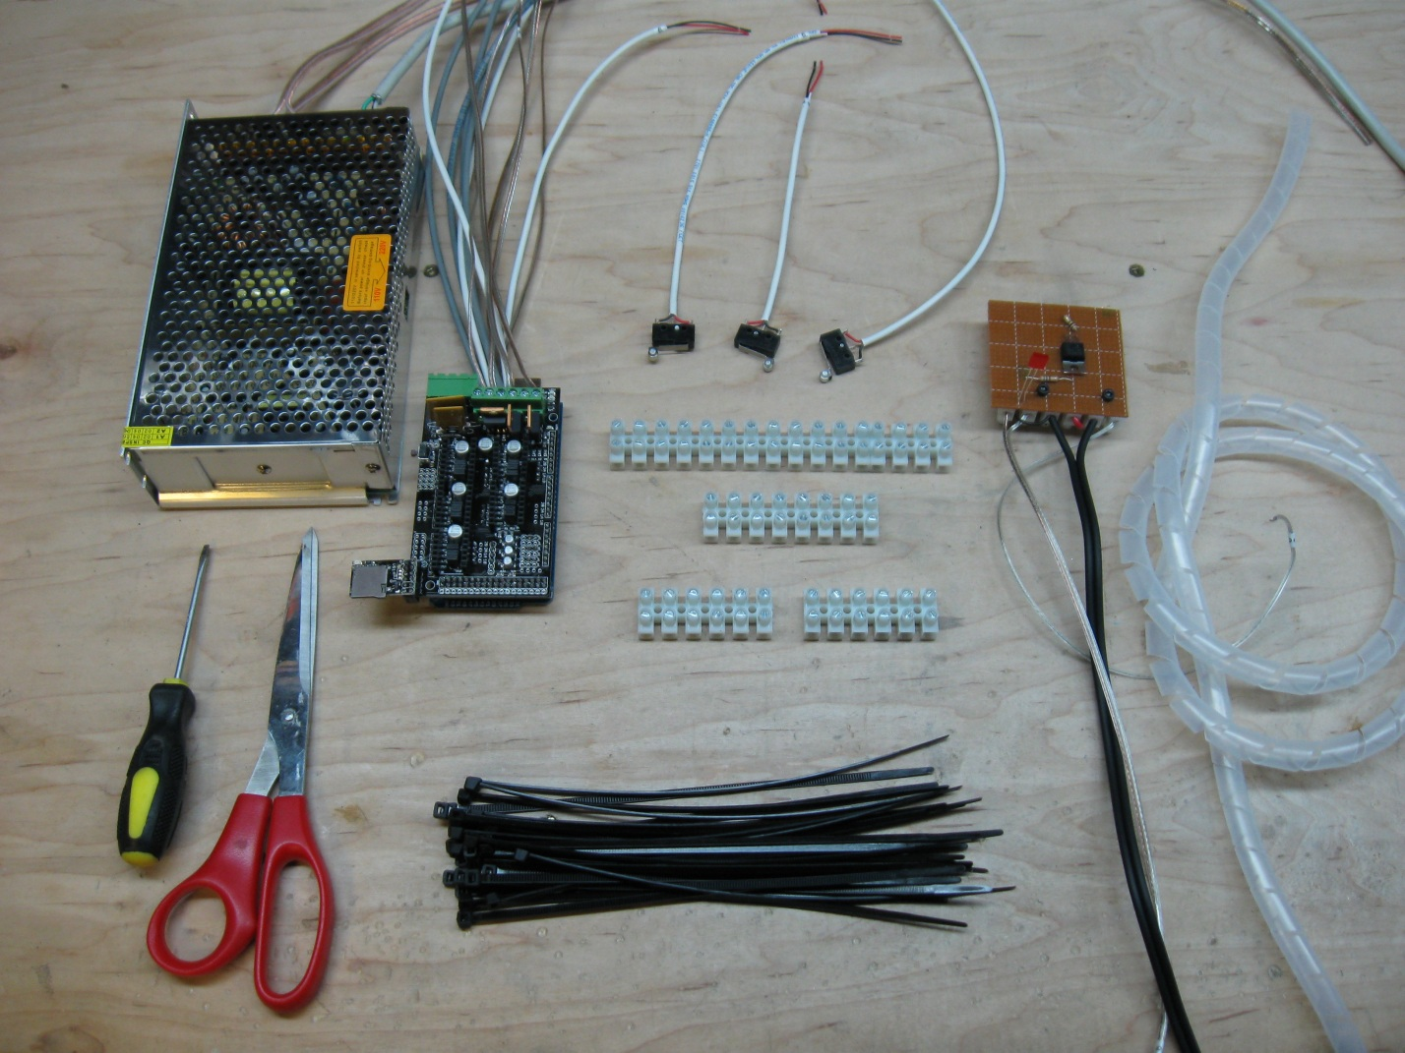

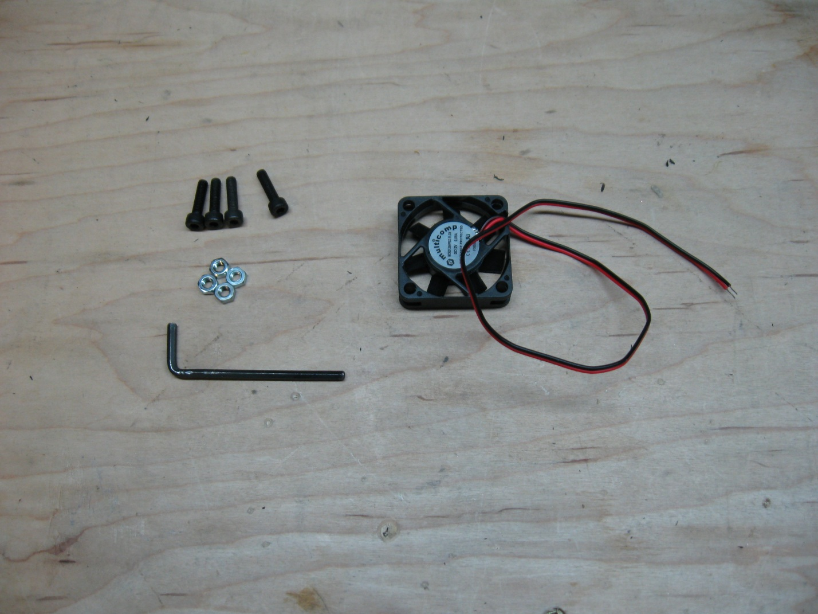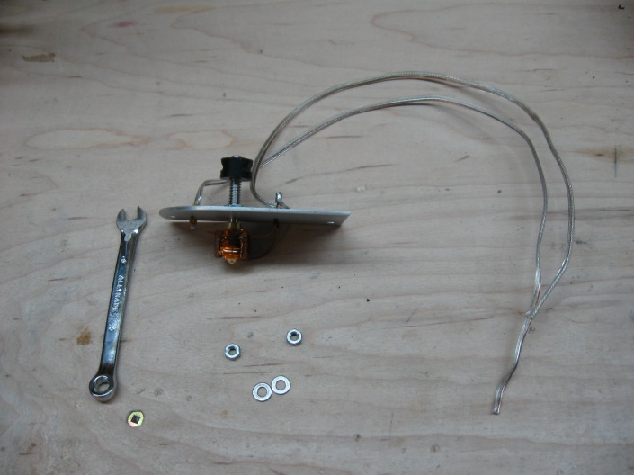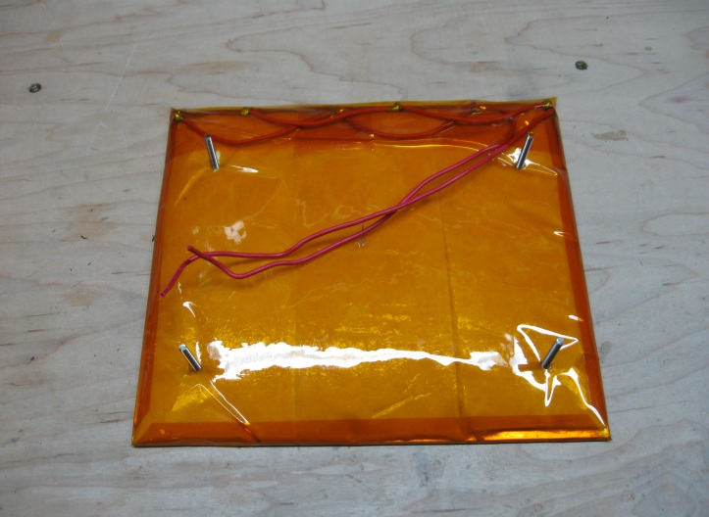

# Step 2 – Attaching Terminal Blocks

Once you have gathered all the required tools and parts, and have a nice flat area to work on, we start the electrical connections by attaching all the terminal blocks. All of the electrical connections for your ecksbot will be made using the provided terminal blocks, no need for any soldering. For this step you’ll need the scissors, terminal blocks and 10 zip ties.

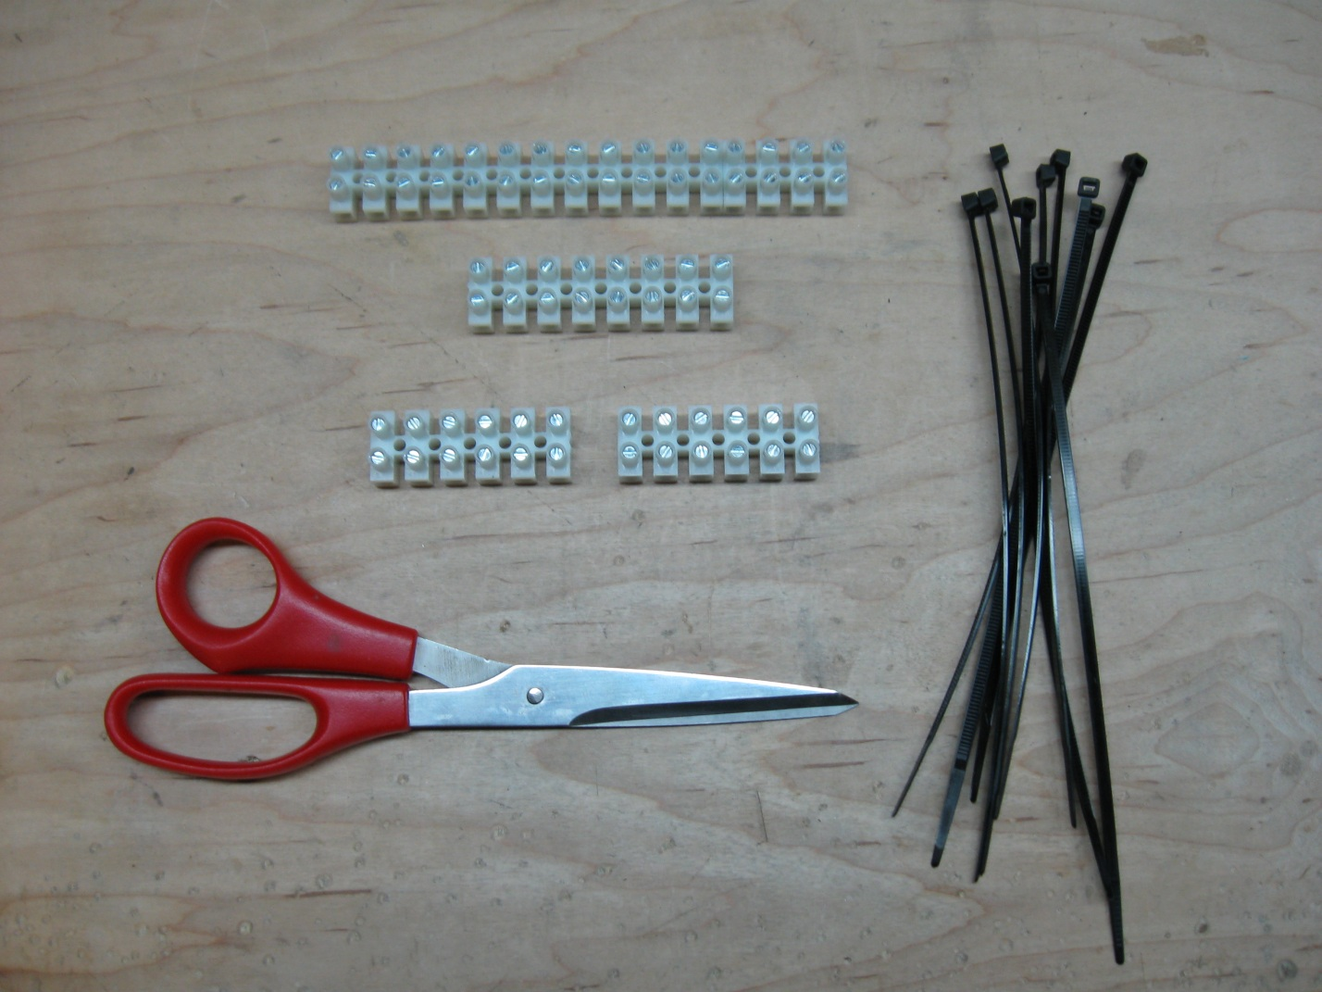

Start by placing your machine as I have in the following picture so that we can attach the X terminal block on the right side.

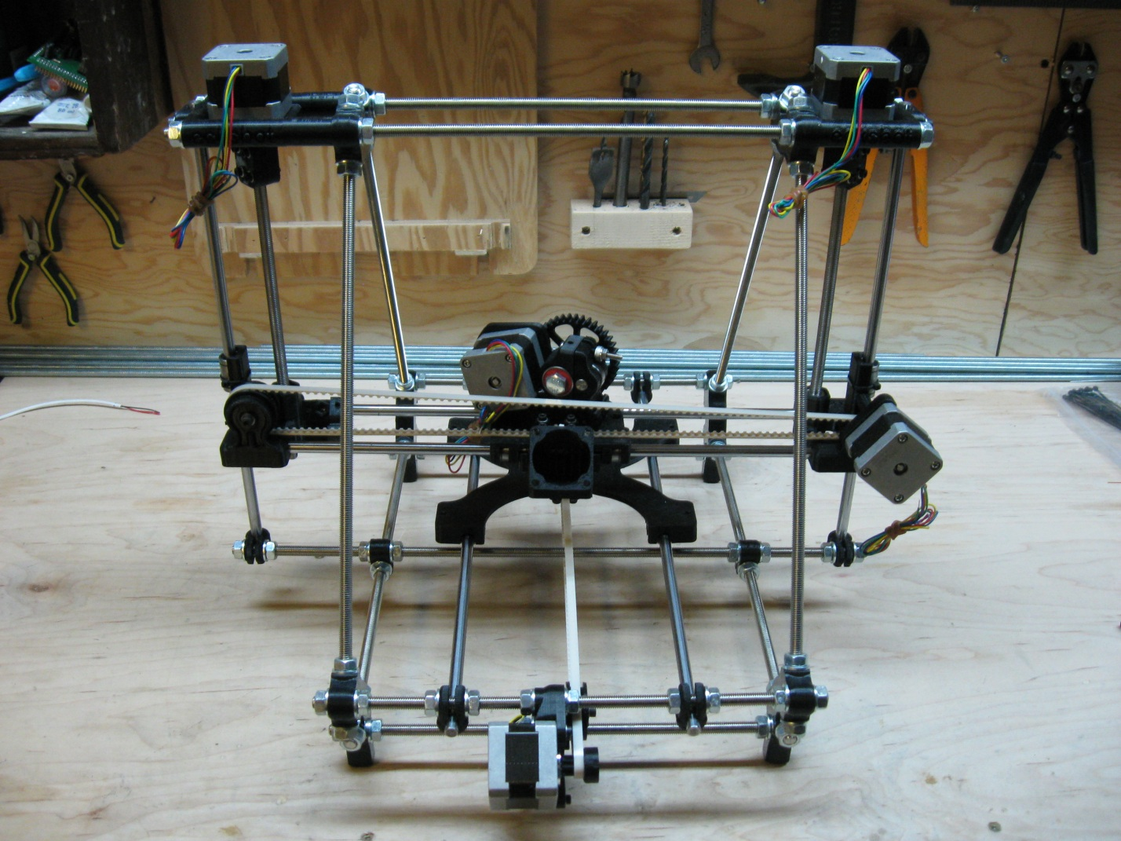

The X terminal block is one of the 6 position blocks and is placed on the right vertex rod as seen in the following picture.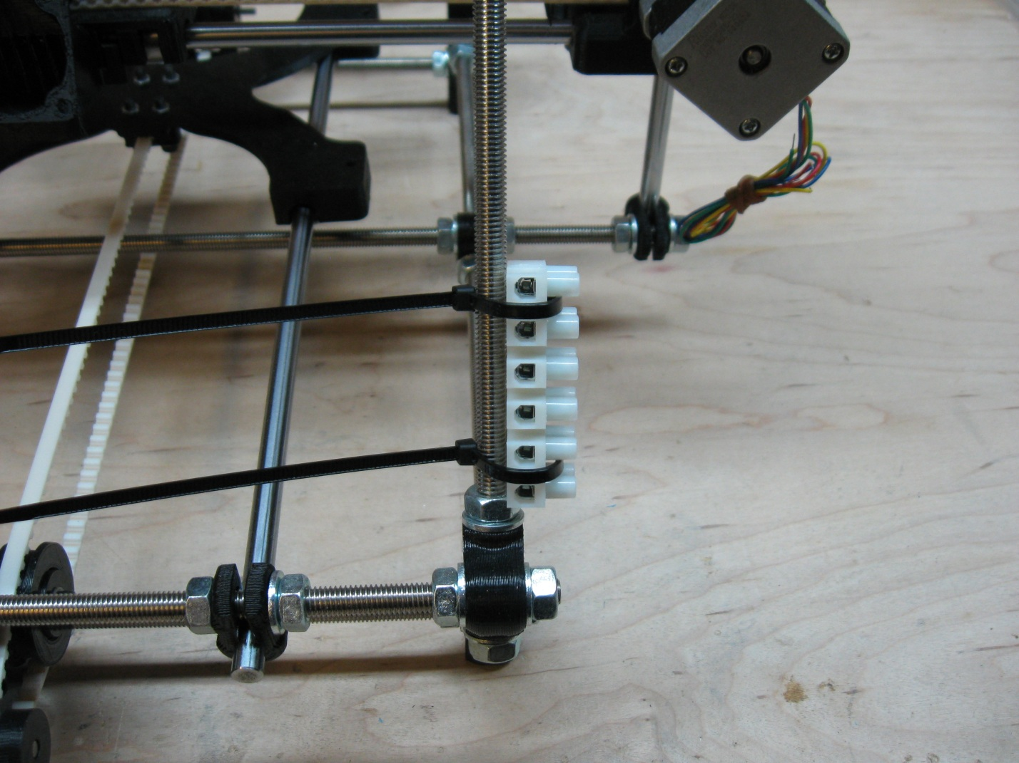

Loosely attach the block using 2 zip ties and adjust the block so that it is just sitting on the bottom 8mm nut and so that the zip ties are parallel to the table surface. Also be sure that the zip ties are placed so that when you tighten them, they will slot between the terminal block wire positions. Once you are happy with the alignment, tighten the zip ties are tight as you can, making sure that the zip ties slot in between the terminal positions tightly. See the next photo for what the final product should look like.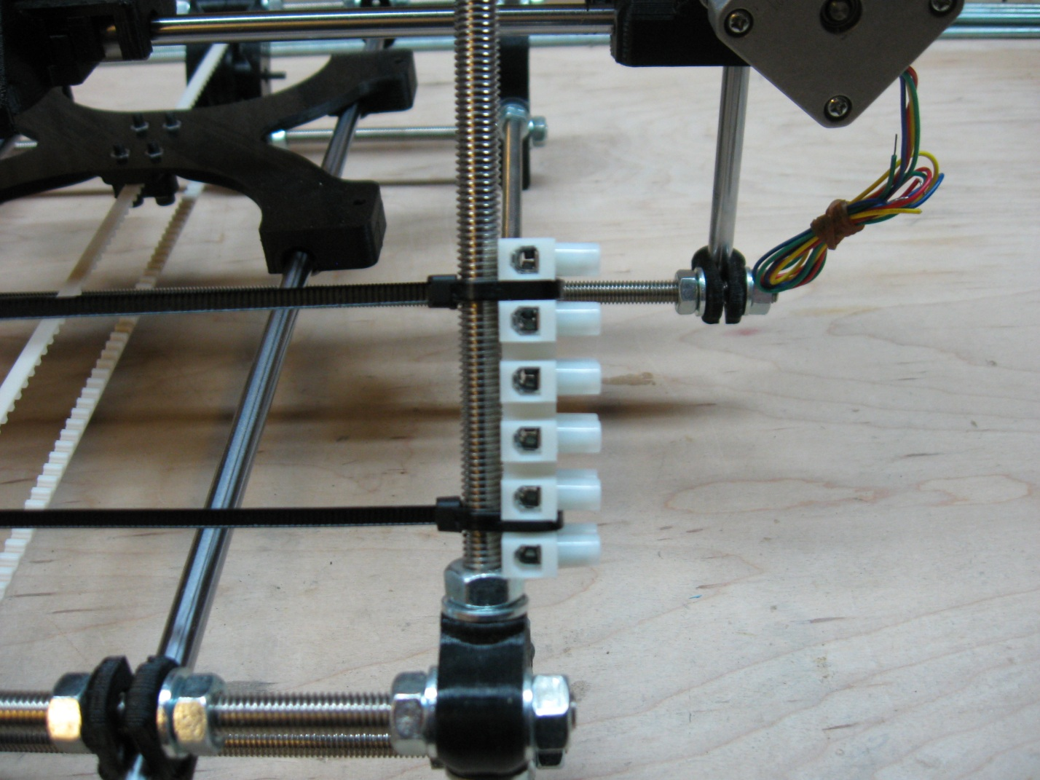

Once you have the zip ties tightened as much as you can, clip them off and you have your first terminal block attached in its final position.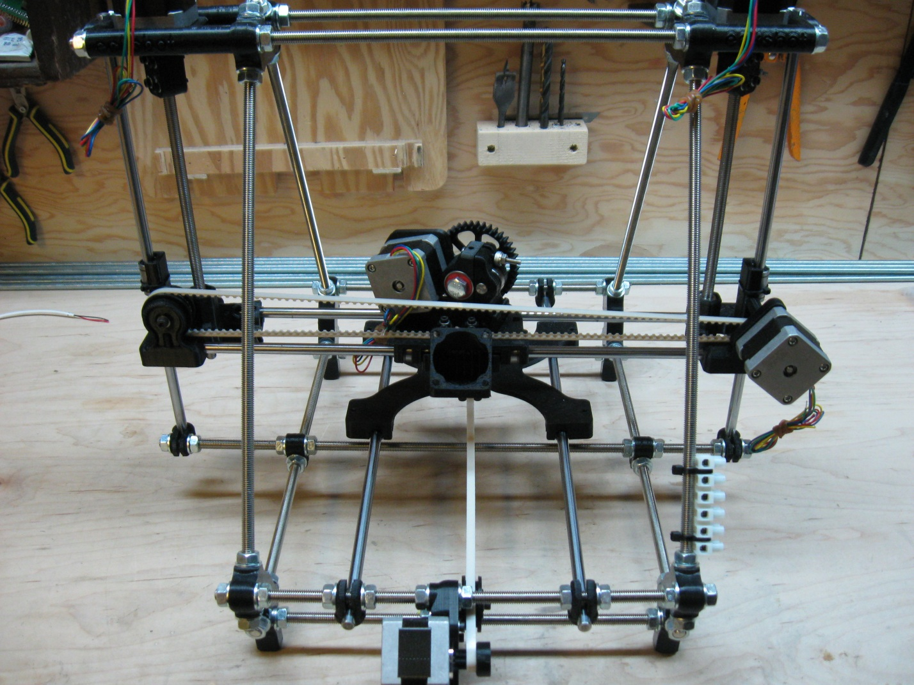

Next we will attach the largest set of terminal blocks that act as the connections for the z motors, extruder motor, and hot-end, thermistor and extruder fan. This terminal block is formed using the 12 position block and the 4 position block. The blocks will be attached to the top threaded rod, closest to you when looking at the printer from the back. Be sure that the 4 position block is on the right hand side and butted up firmly to the 12 position block. The following picture shows where to position the block and the zip ties.

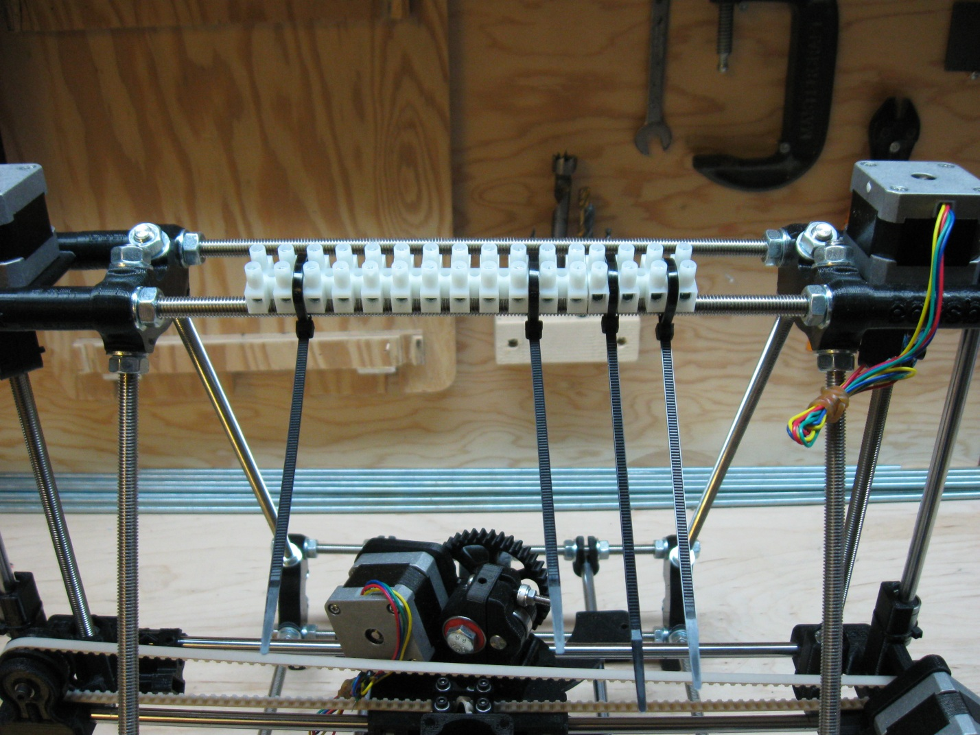

Once you are happy with the positioning of the terminal blocks and the placement of the zip ties, tighten the zip ties as tight as you can and then clip the ends off.

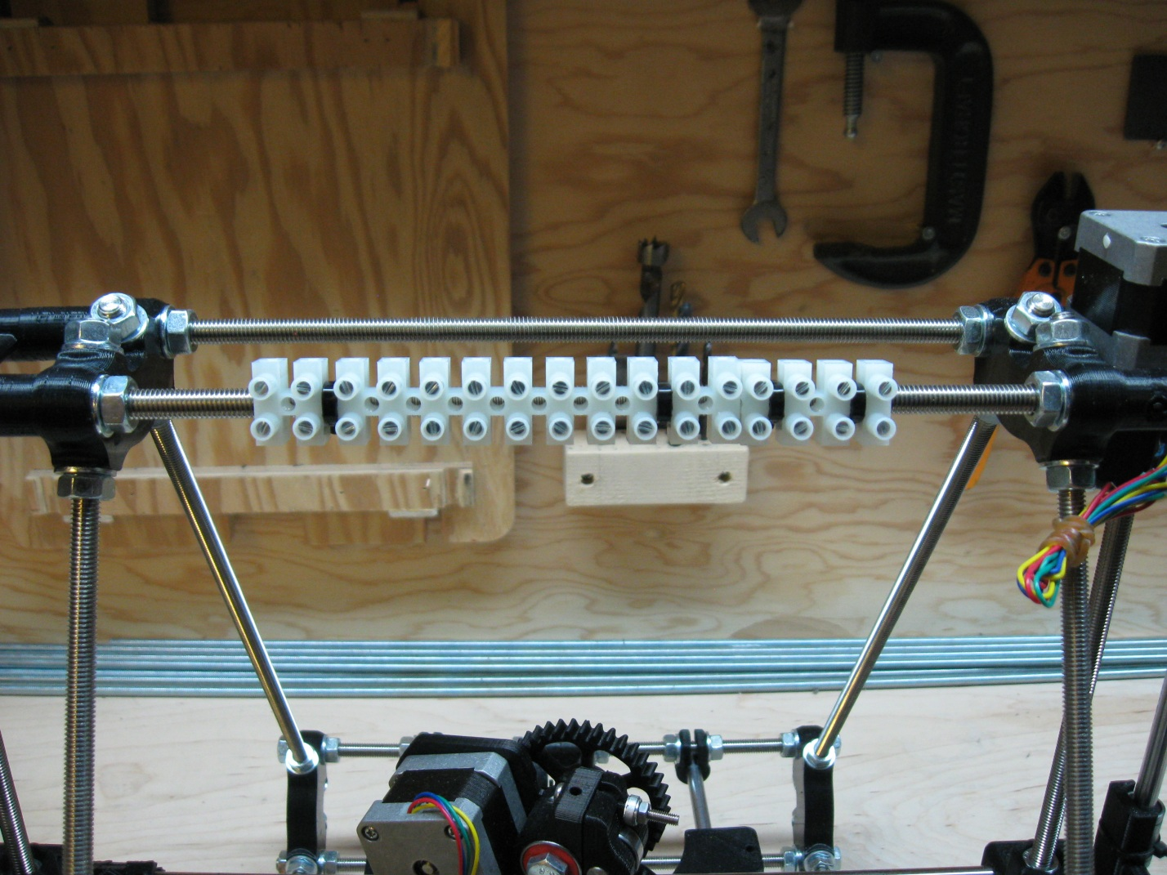

We now tip the printer onto its front so that we can access the bottom Y-Motor threaded rod for placement of the Y-Motor terminal block.

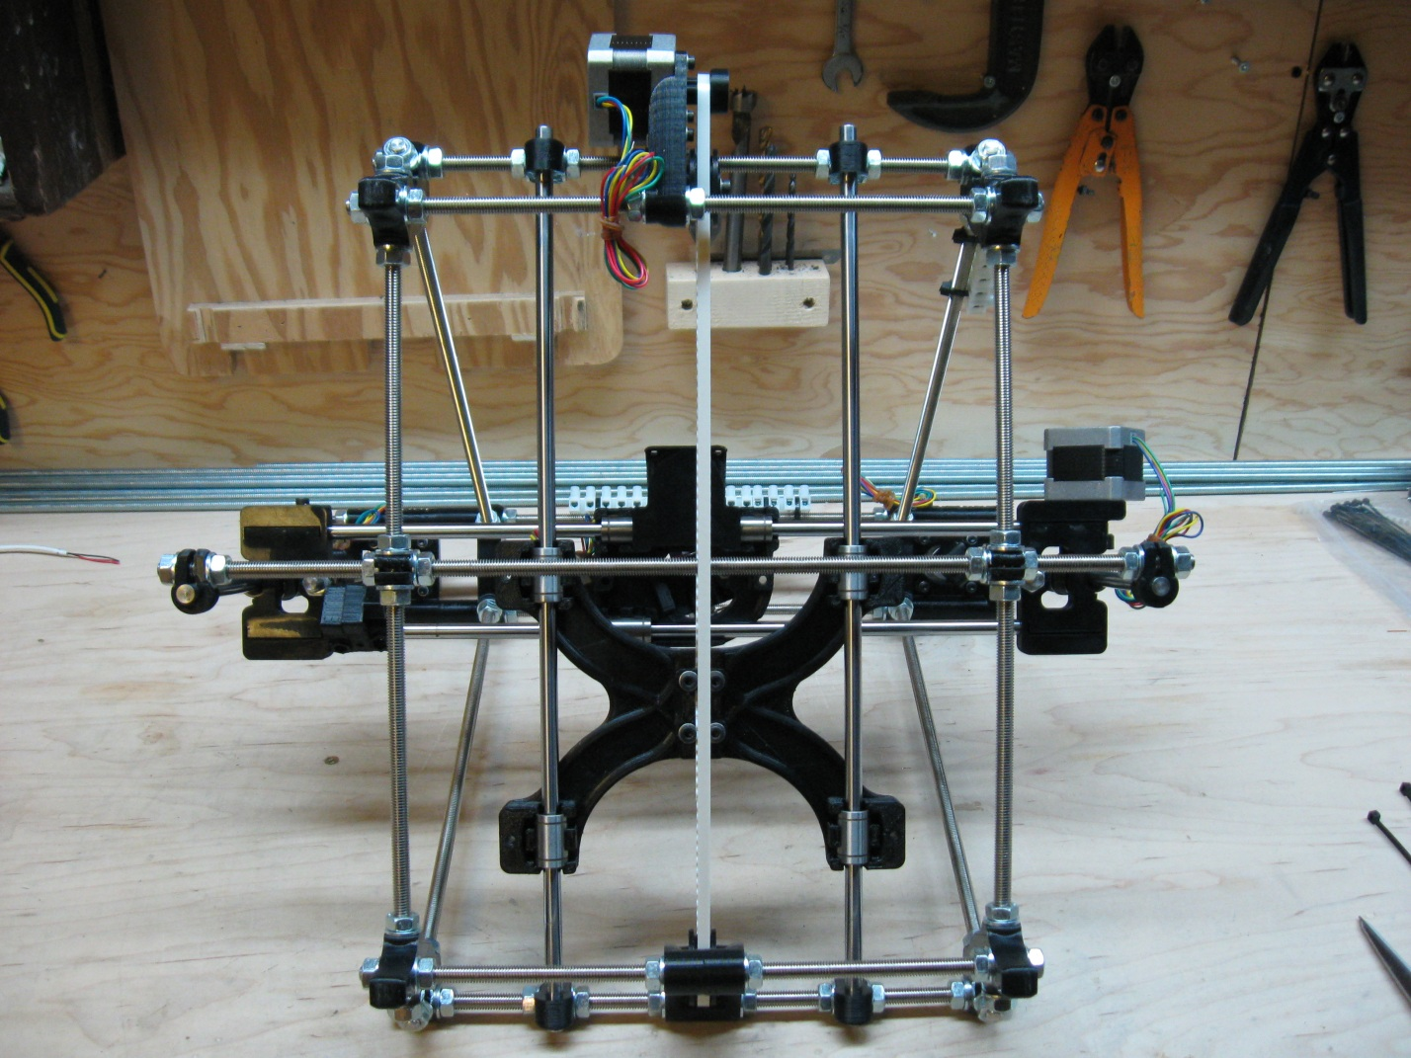

The Y-Motor terminal block is the second of the 6 position terminal blocks, and is placed to the right of the Y-Motor mount when viewed from the position of the printer in the above picture. The block is placed on the bottom threaded rod so that it is out of the way when the printer is right side up. Place the block midway between the Y-Motor mount and the right hand vertex as pictured below. Once you are happy with the placement and position of the zip ties, tighten the zip ties as tight as you can and then clip the ends off using the scissors.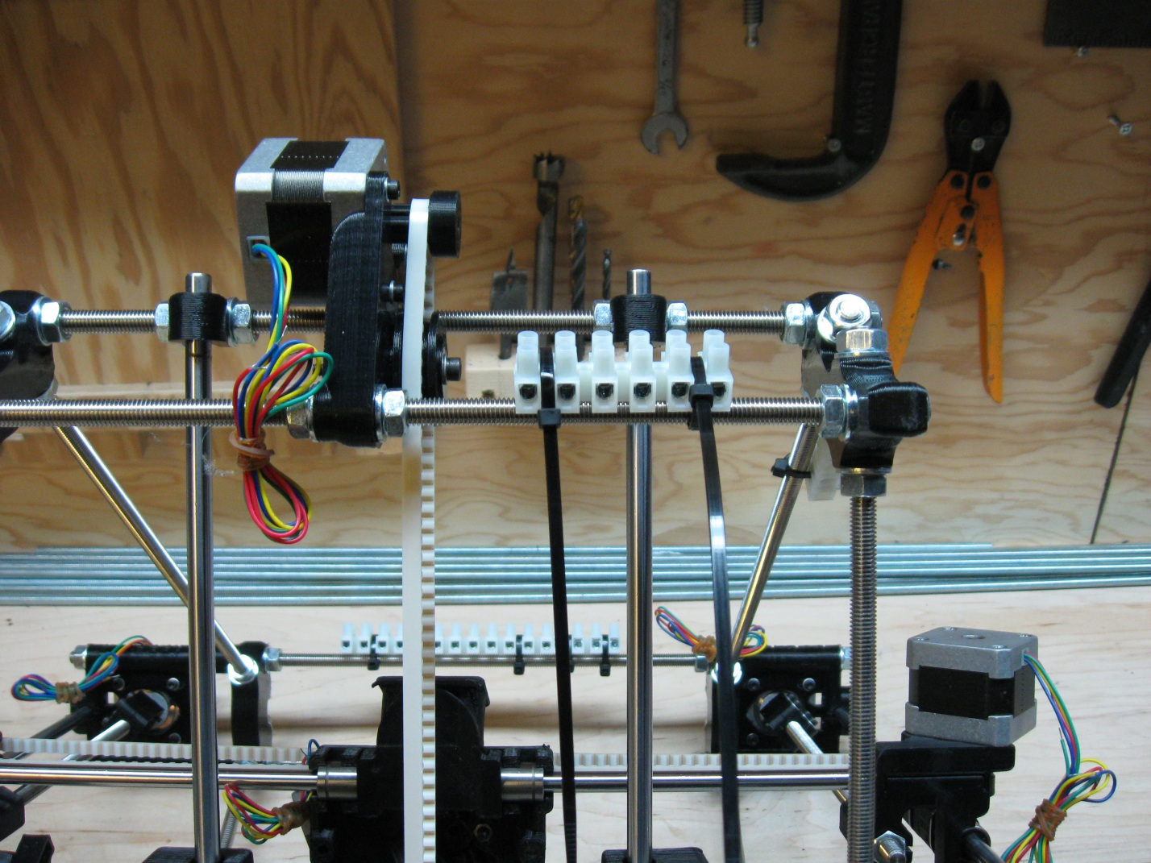

We then turn the machine 90 degrees counter clock wise to position the final terminal block as pictured in the following photo.

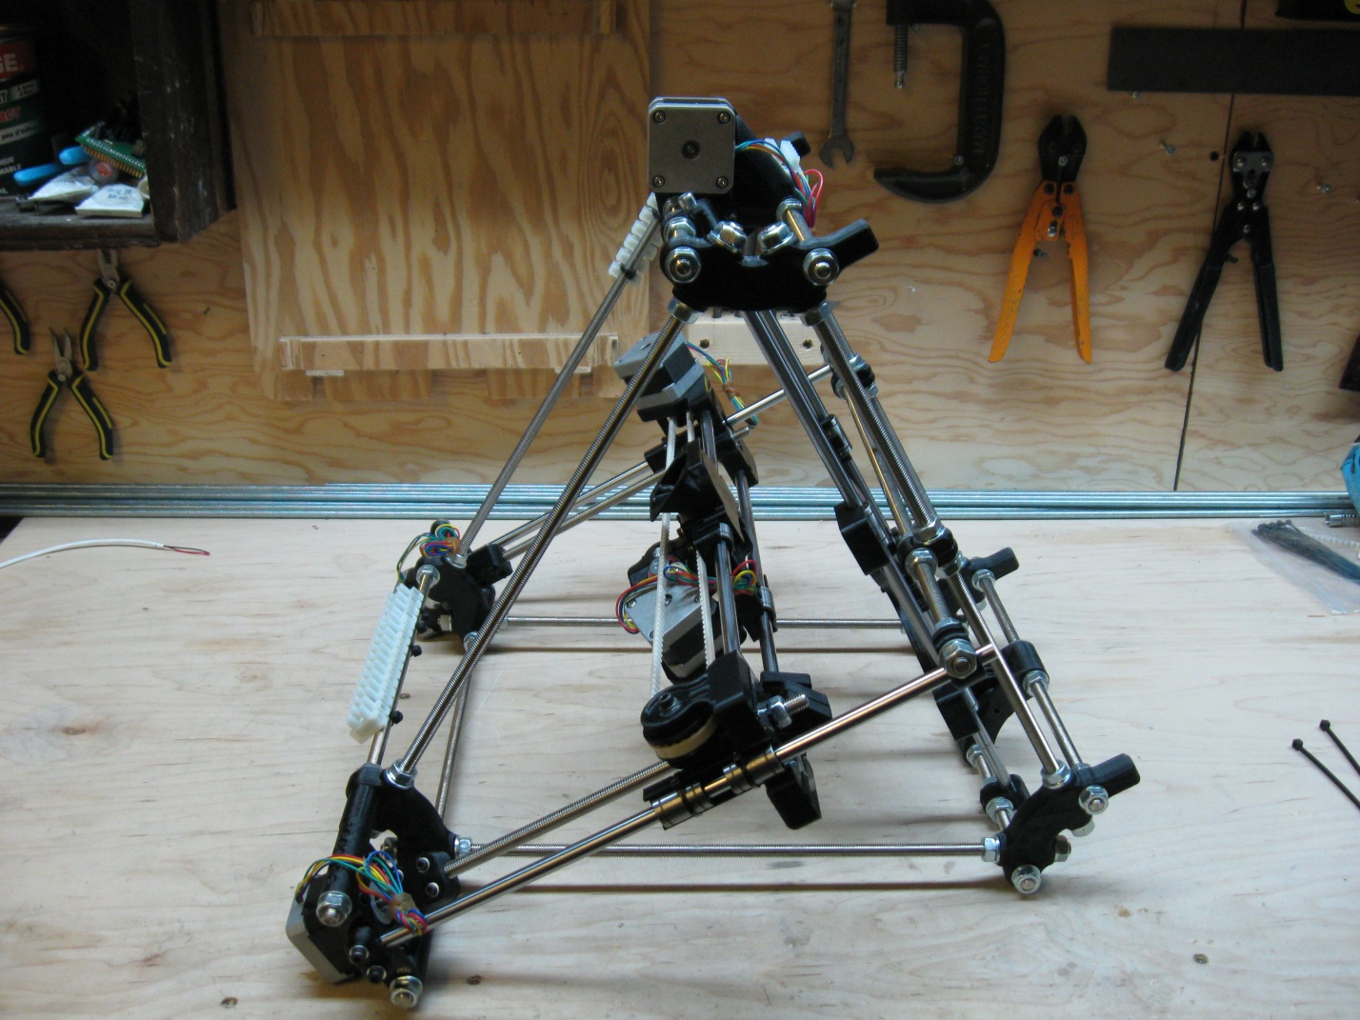

This terminal block is the 8 position block used to connect the heated bed and the Z-Endstop. This block is placed on the bottom vertex rod against the back vertex nut as shown in the following picture.

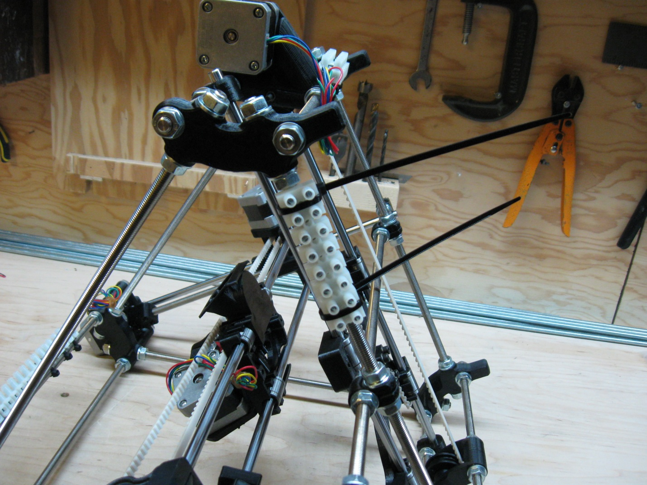

Once you are happy with the blocks placement and the placement of the zip ties, again tighten them as tight as you can and clip the ends.

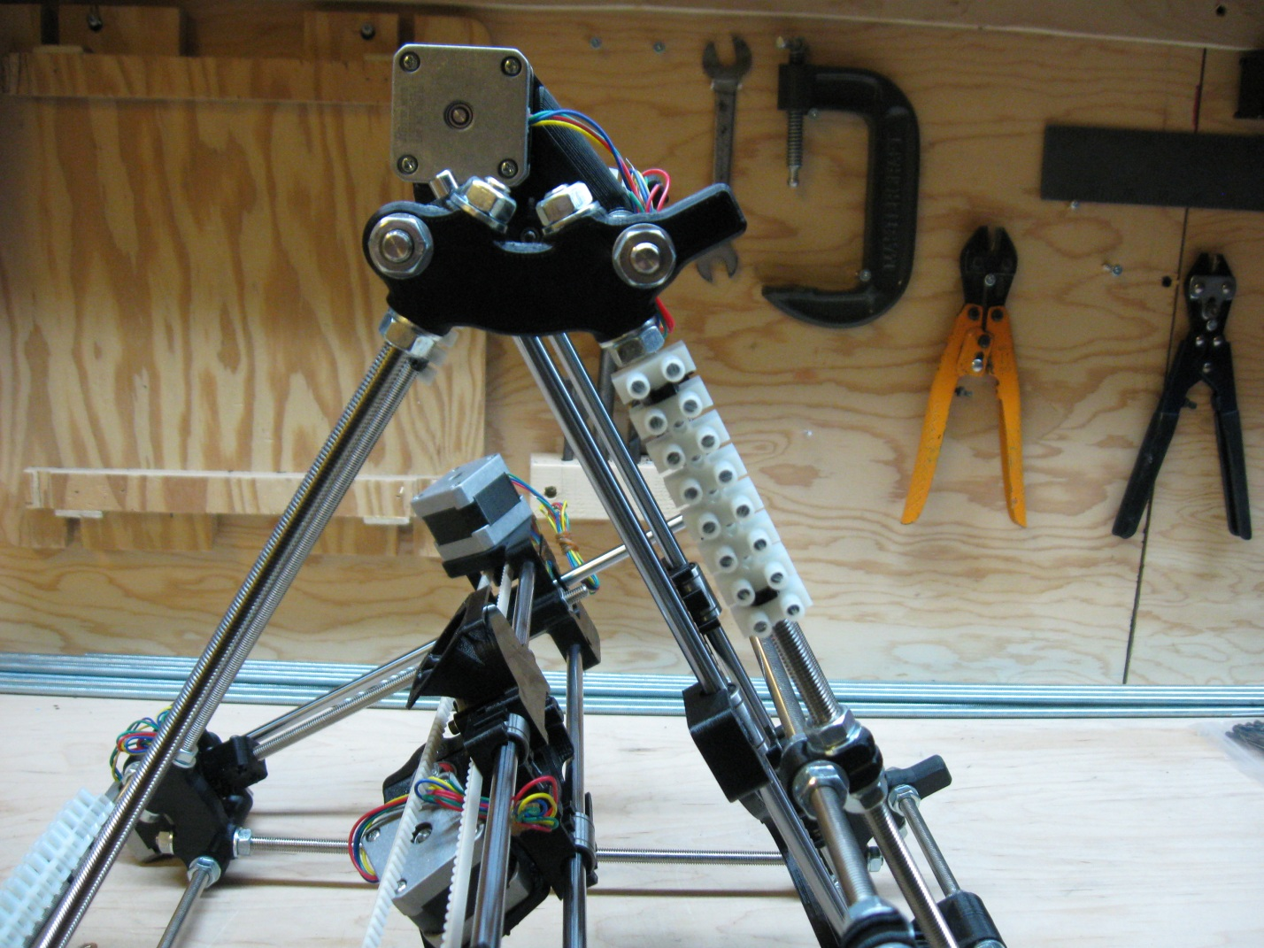

This completes Step 2 now that all your terminal blocks are now placed correctly and secured tightly.

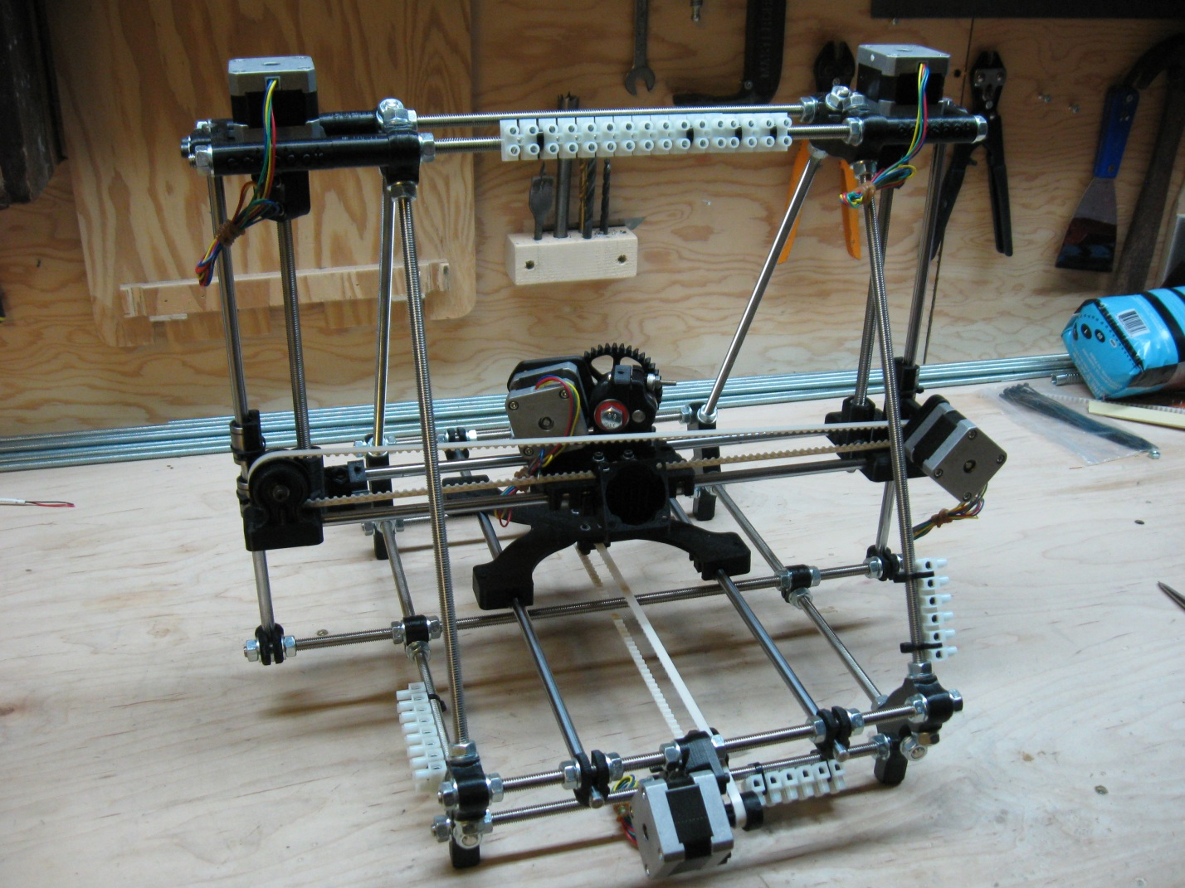

# Step 3 – Attaching the 3 axis End-Stops

(Note: need to take a picture of 3 end stop mounts with the bolts, nuts, and hex wrench

Need a new picture of the tightened Y-Endstop.

Also: some of the following pictures may need to be lightened for better viewing)

The next step is to attach the 3 end-stops for the 3 axes of the printer. For this, you will need the 3 wired and numbered micro-switches. The wires are white sheathed and numbered 2, 4, and 6 and are pictured. You will also need the 3 printed end-stop mounts, 3 holding bolts and nylock nuts (3mm bolts and nuts, also pictured). You’ll also need a 3mm hex wrench to tighten the end-stop mounts in place.

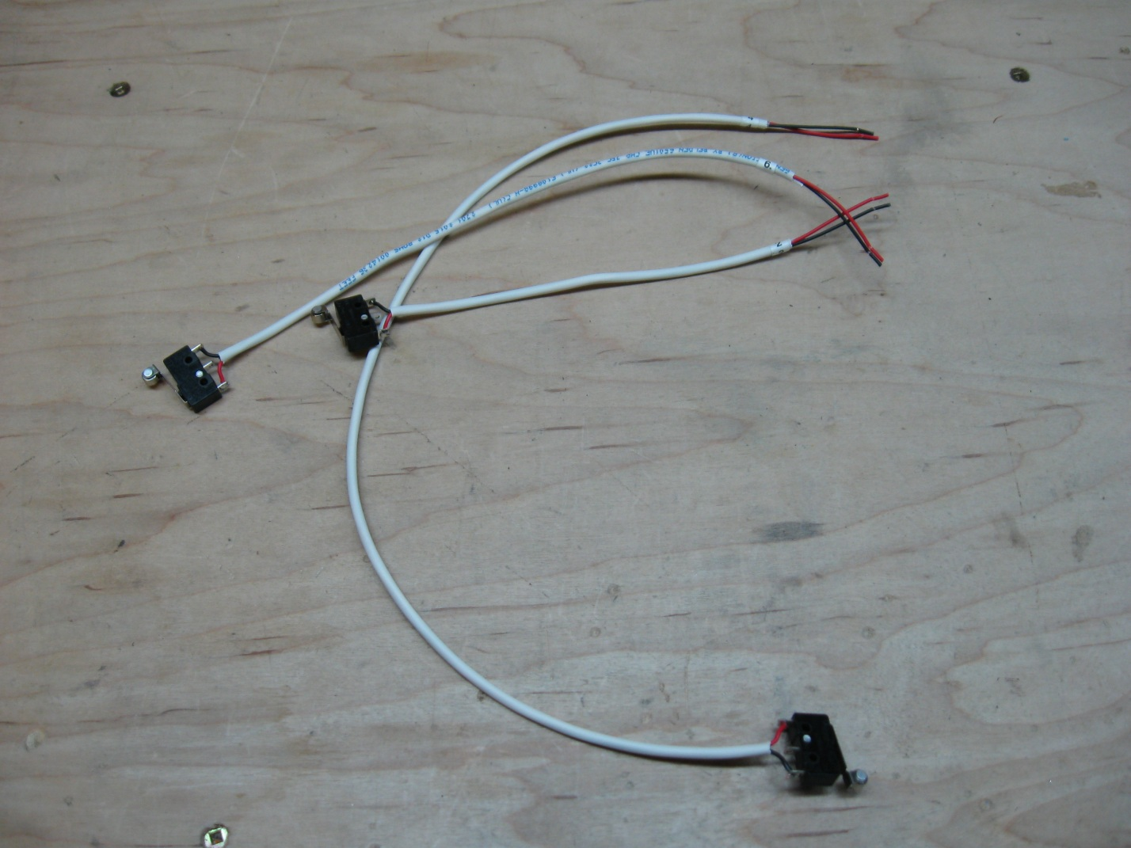

We’ll start with the X-End-Stop numbered (4). You’ll need to start by placing the wired micro-switch into the end-stop holder in the same way that it is pictured below. Notice the direction that the lever of the micro-switch is point in relation to the printed end-stop holder. The nut capture should be on the opposite side to the lever action.

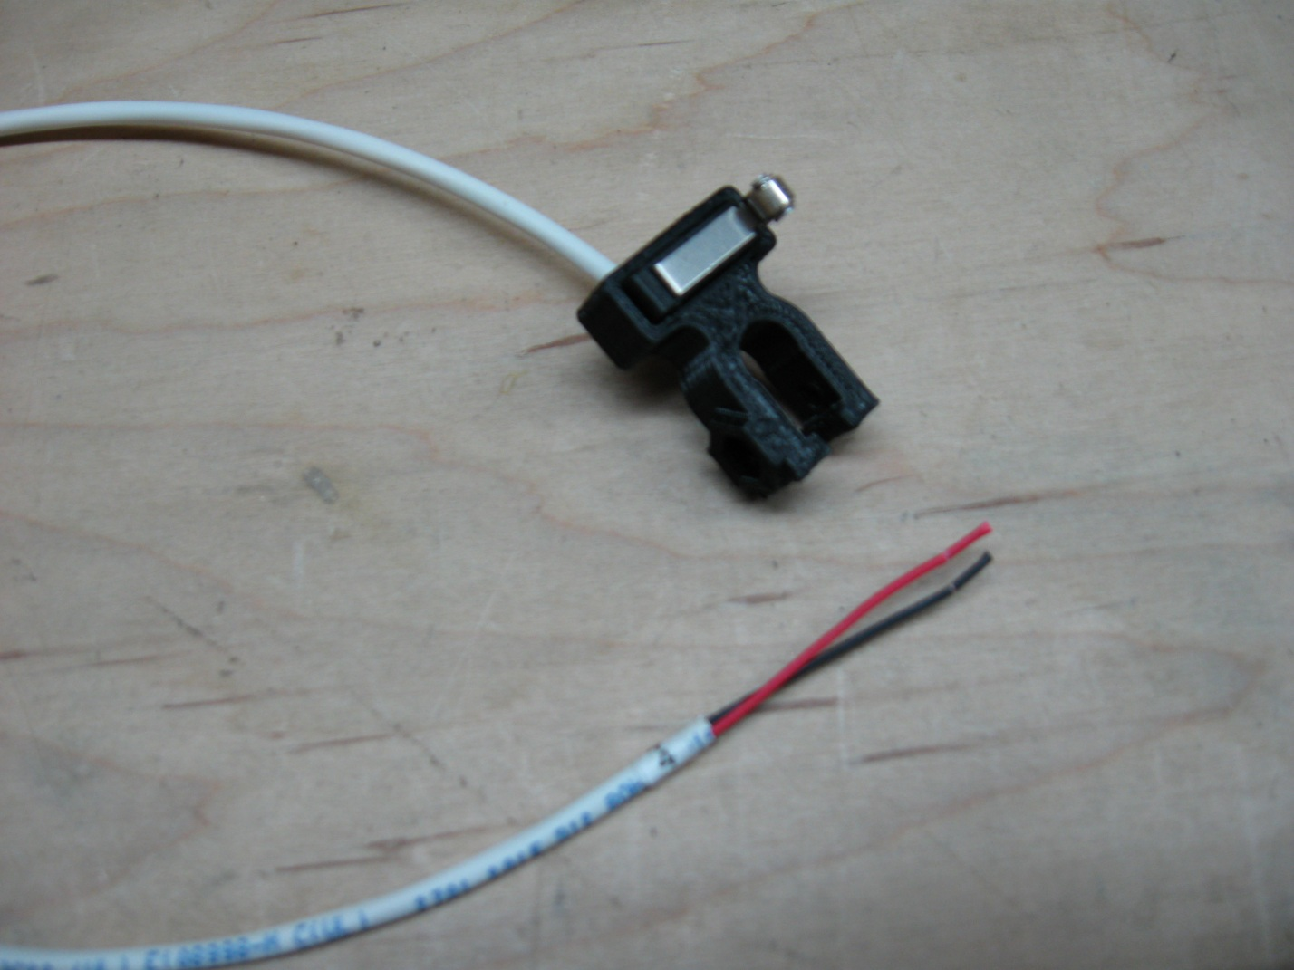

Be sure to firmly press the micro-switch into the holder so that it seats fully into the holder. Once you have the micro-switch in the holder, the combination of the two can be attached to the printer. Again we’ll be working from the back of the printer so place it on its feet, with the front pointing away from you. The printed end-stop holder is then snapped over the X smooth rod closest to you, and the bolt and nut are affixed loosely. Once it is snapped on, and the bolt and nut have been inserted, slide the mount as far right as you can, butting it right up against the X-motor mount (see picture below).

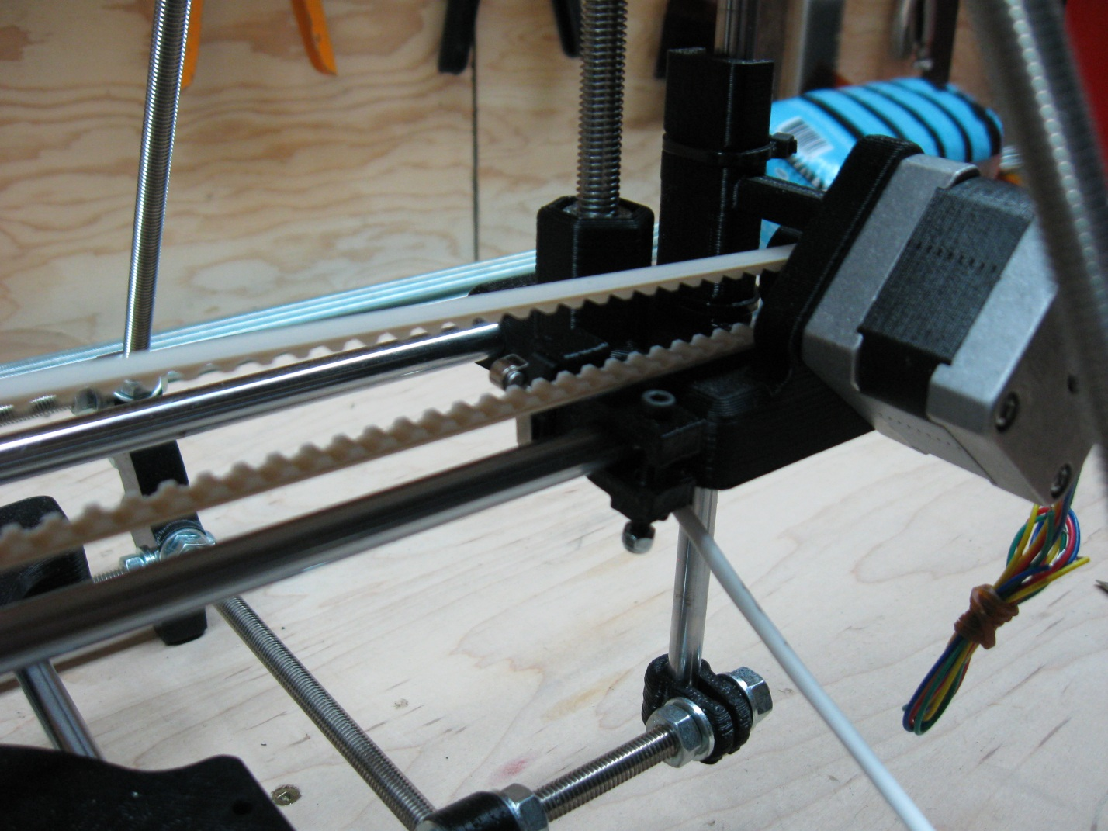

Once the end-stop is positioned in the correct spot, tighten the mounting bolt until the end-stop is difficult to move, but not so tight that the plastic begins to change color. If you tighten the mount too much, you can break the mount. The gap on the mounting block should look something like this:

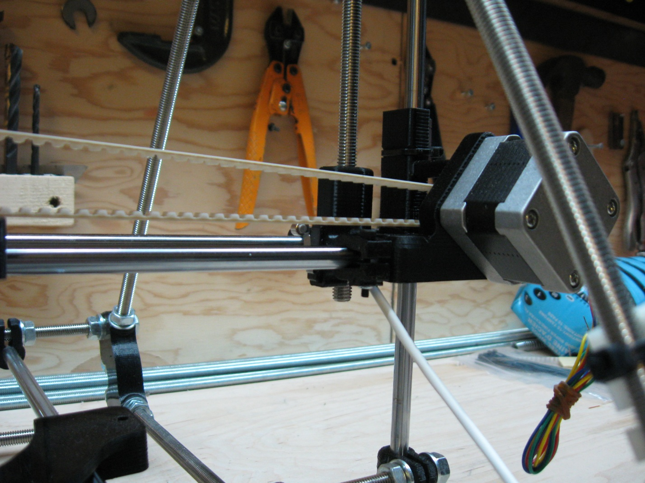

The final configuration should look like the following picture when viewed from the front of the machine.

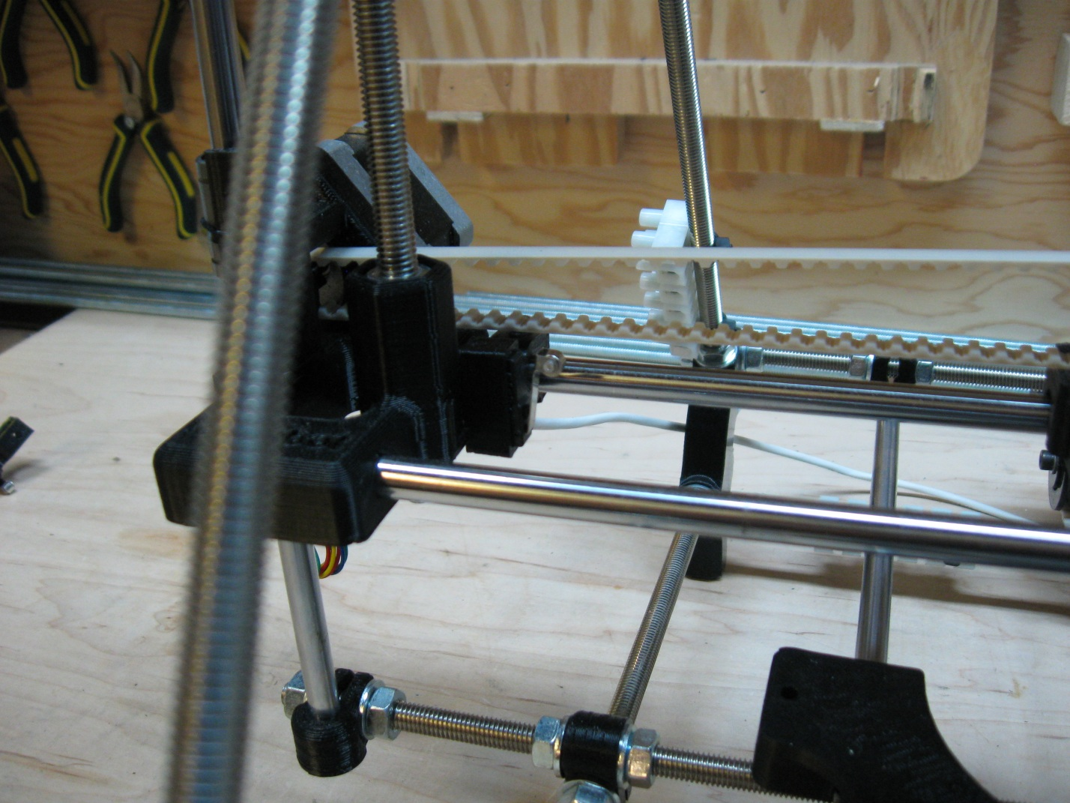

The next end-stop to be attached is the Y-Axis end-stop which will be attached to the machine from the back as well. The micro-switch used for this end-stop is numbered (2) and should be seated into a printed end-stop mount in the same way that the X end-stop was mounted, with the lever action opposite to the nut capture.

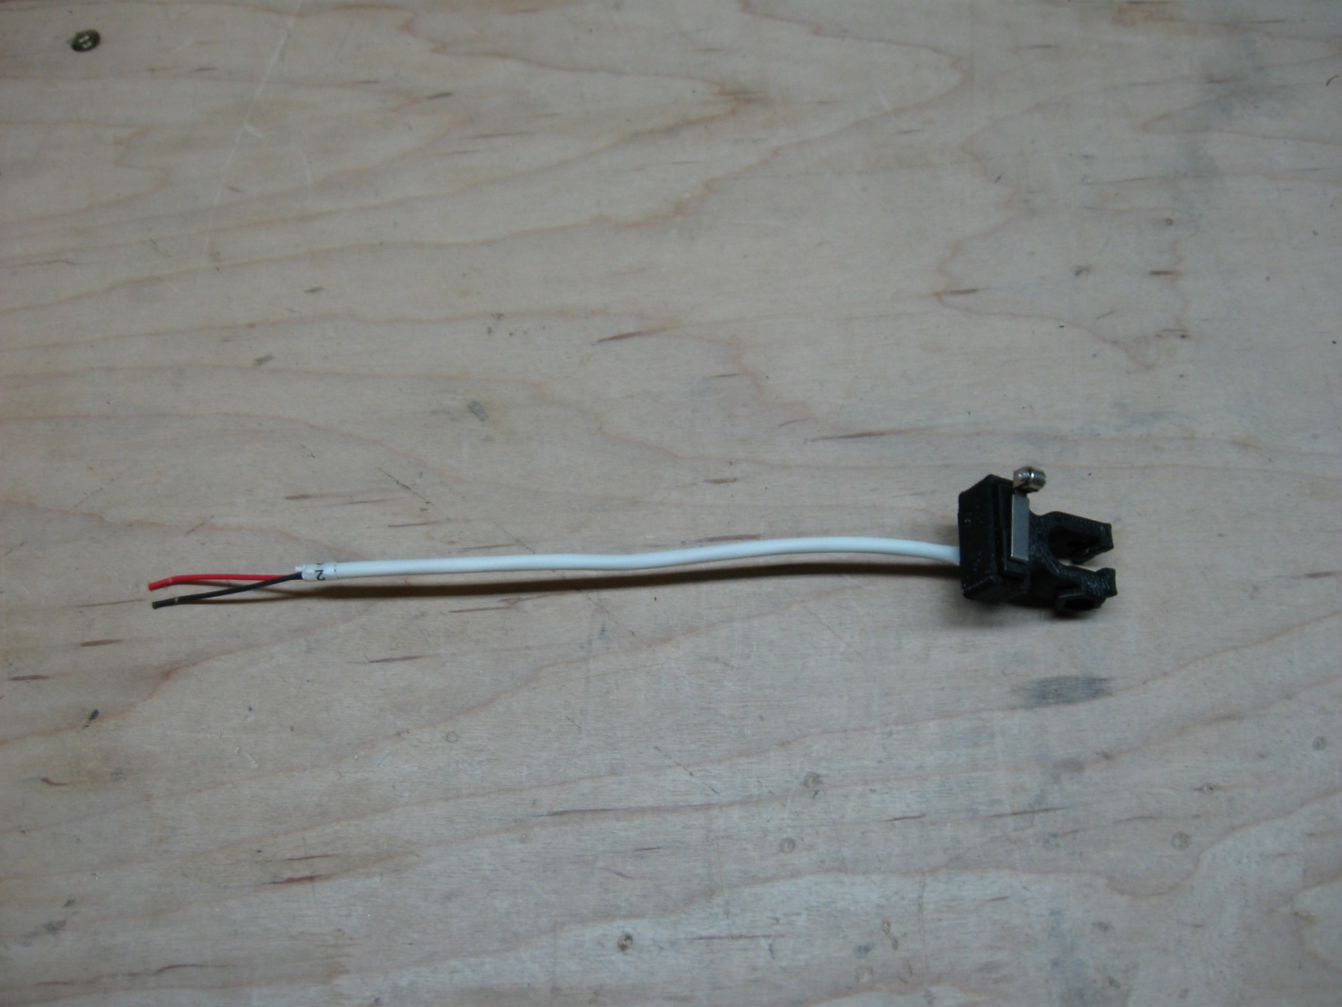

The Y-Axis end-stop is placed on the right hand Y-Axis smooth bar when the machine is viewed from the back. Snap the end-stop onto the bar as pictured, insert the bolt and attach the nylock nut. Then pull the end-stop as far back on the rod as you can.

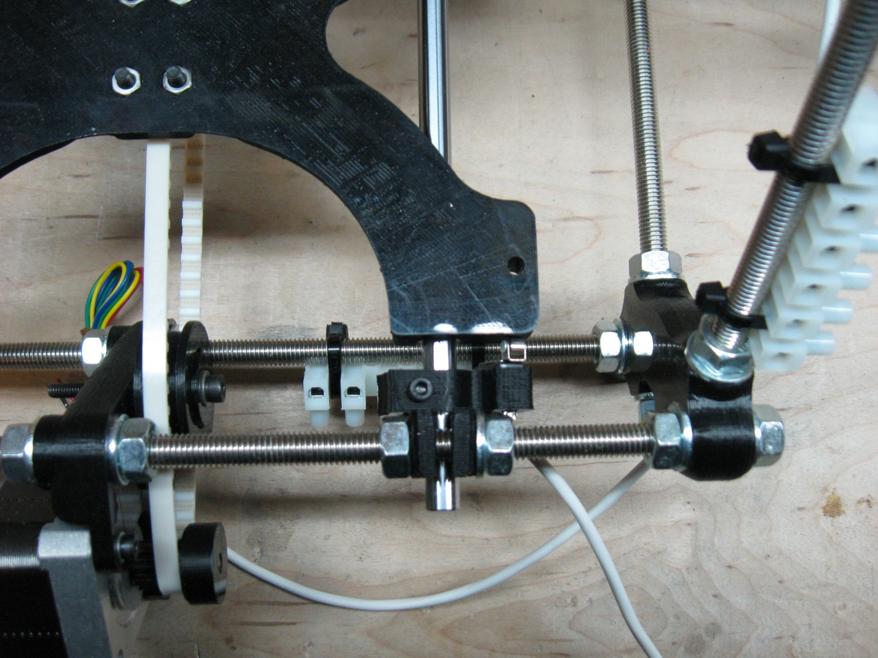

This end-stop is positioned at a slight angle to the bed so that the end of the lever will make contact with the edge of the Y-Carriage and engage the end-stop properly when the carriage is in its home position.

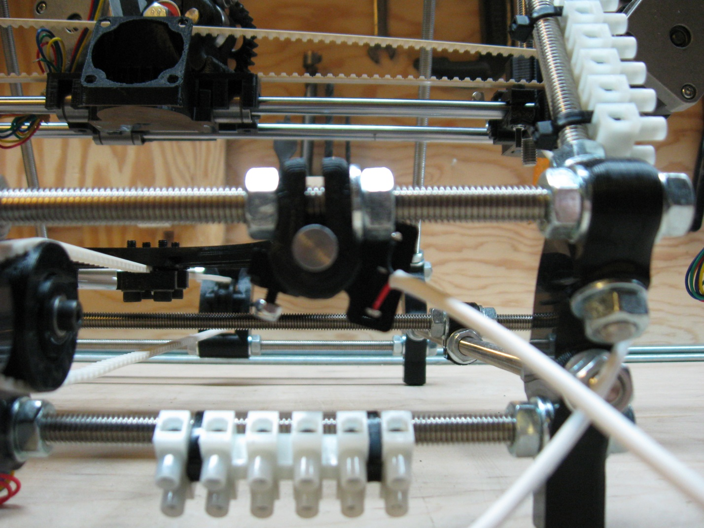

Once you are happy with the positioning of the end-stop, tighten the holding bolt until the end-stop is difficult to move but not so tight as to damage the end-stop holder.

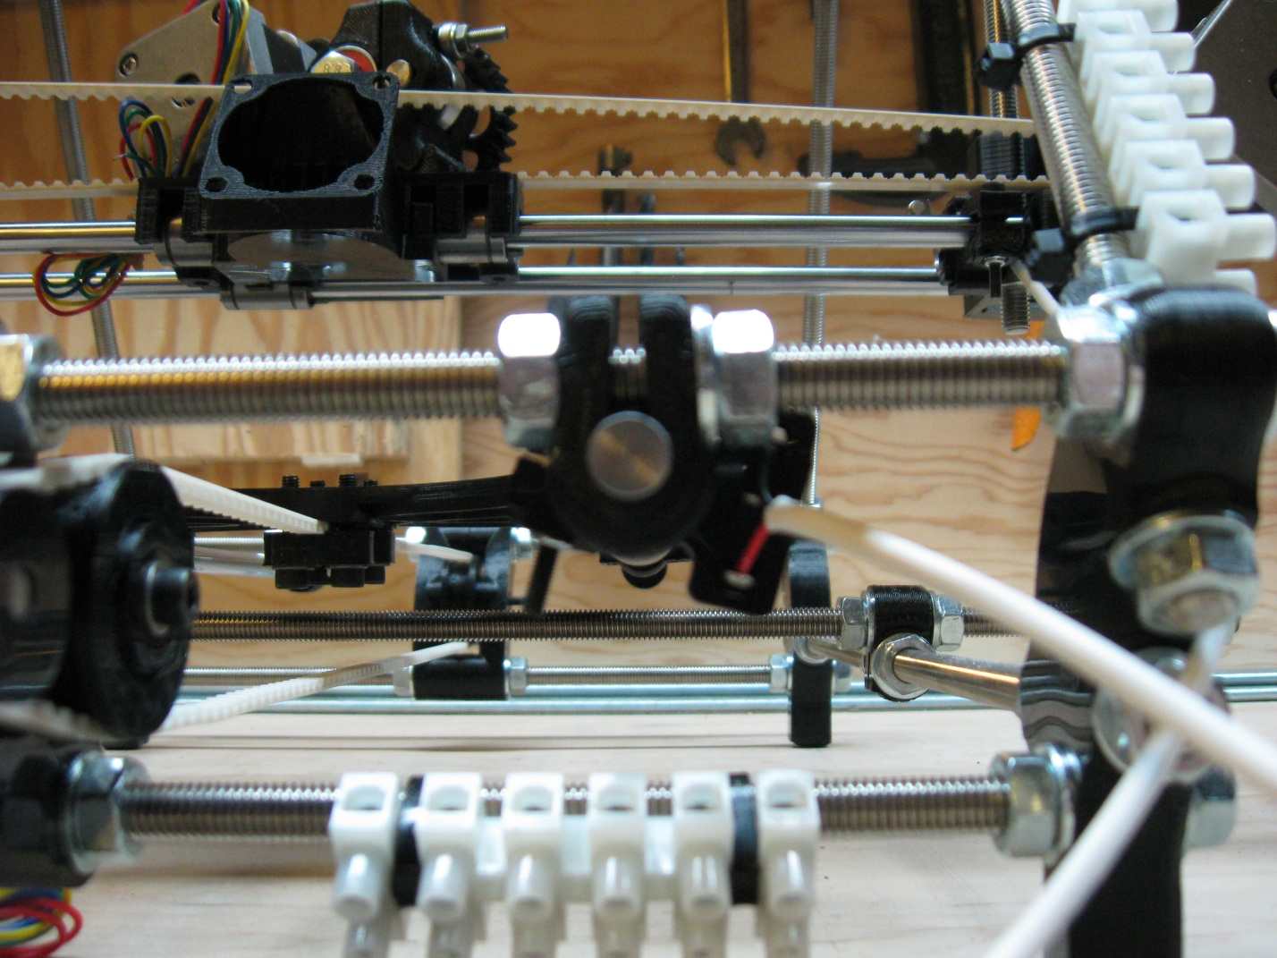

The final end-stop to be attached is the Z-Axis end-stop which will be attached to the machine from the back as well. The micro-switch used for this end-stop is numbered (6) and should be seated into a printed end-stop mount in the same way that the X end-stop was mounted, with the lever action opposite to the nut capture.

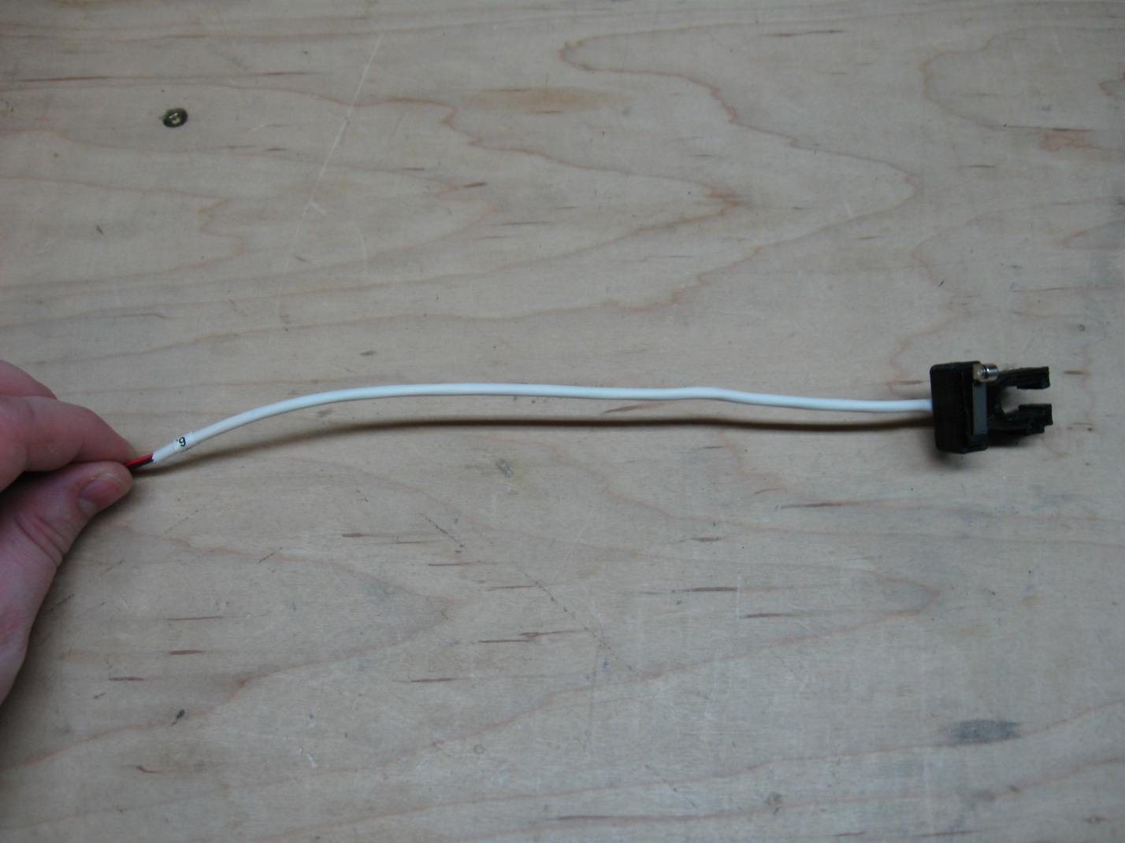

This end-stop is clamped onto the left Z-Axis smooth rod when the machine is viewed from the back. Snap the end-stop onto the smooth rod underneath the X motor mount, insert the bolt and attach the nylock nut. This will not be the final placement for the Z end-stop, but for now it can be placed near the bottom of the X-idler mount, and at an angle so that the end of the micro-switch lever does not pass through the gap in the idler block. You can then tighten the end-stop so that it is firm. But again, we will come back to this end-stop later on when we are doing our final alignment and calibration.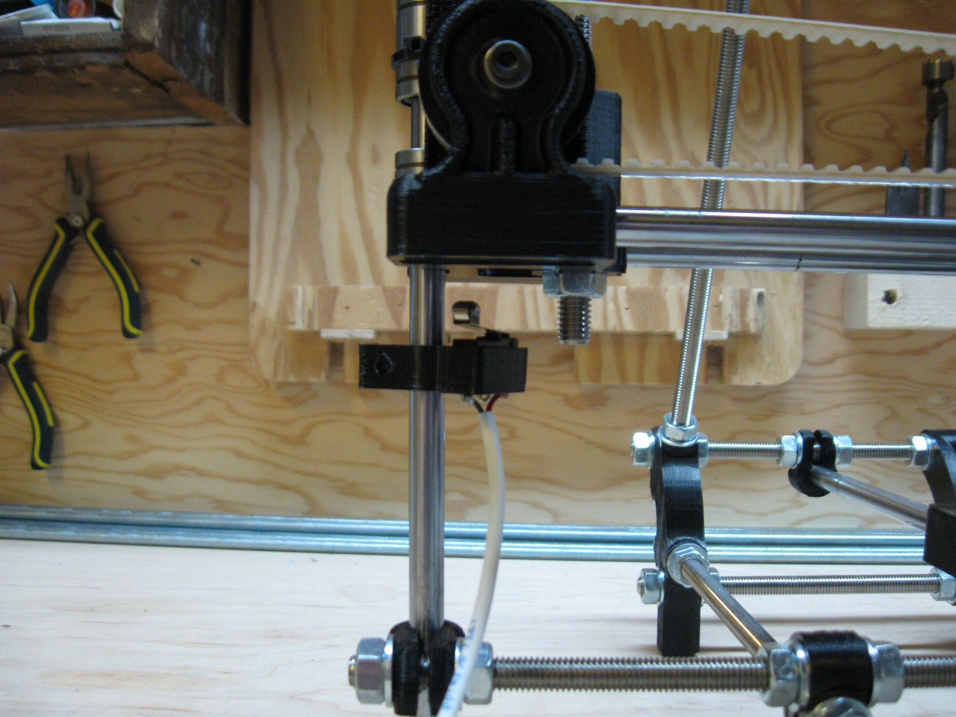

Once you are happy with the placement of the end-stops, step 3 is completed.

# Step 4 – Attaching the Heated Build Platform (HBP)

(Note: the pictures for this section and the instructions will need to be updated in the future)

To attach the Heated Build Platform, you’ll need:

1. The HBP itself
2. The HBP controller
3. A slot screw driver
4. 4mm wrench
5. 8 x 4mm nuts
6. 8 x 4mm washers

Start by placing the HBP upside down on your work surface with the array of shielded wires furthest from you. The 2 array leads are what provide power to the nichrome heating wires on the top of the HBP. These wires may be found on the right of the array, or the left depending on which HBP you get. There is no difference in the functioning of the HBP due to the wire position; it’s just a function of how the HBPs are built. The 2 center wires are the leads for the thermistor that reads the temperature from the HPB.

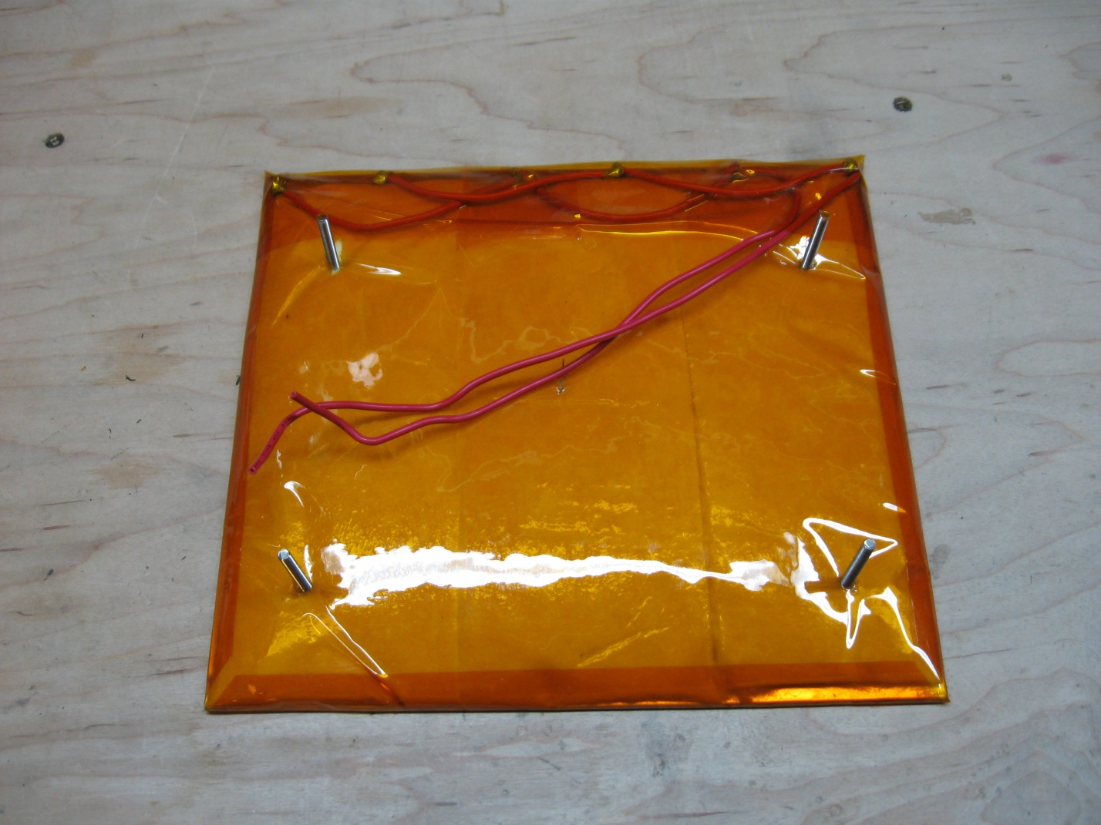

Next attach the heating wires from the array to the terminal block on the HBP controller in the positions that are labeled (B). There should be 2 (B) positions, and it doesn’t matter which of the heating leads goes which (B) position. Then attach the thermistor leads to the positions labeled (T). There should be 2 (T) positions as well, and it doesn’t matter which lead goes to which (T) position.

Picture needs to go here

Once the leads have been attached, place the HBP controlled onto the back left leg of the HBP and secure it down with 1 of the 4mm nuts. Then tape the dangling corner of the HBP controller to the bottom of the HBP as pictured below. With that complete, threaded 3 more 4mm nuts onto the 3 remaining legs to a height comparable to the position of the nut holding the controller on. They don’t need to be perfectly aligned yet, that will take place during final alignment and calibration.

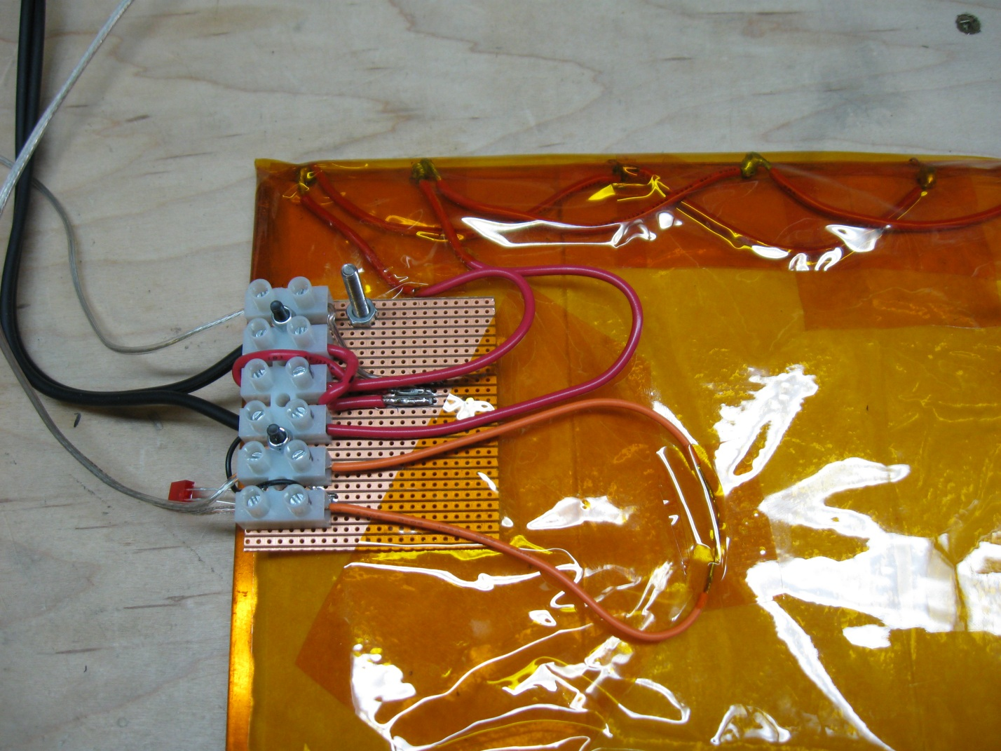

With the controller attached, and the nuts on each leg, the HBP is ready to be attached to your ecksbot. With the ecksbot positioned with its front facing towards you. Pull the Y-Carriage as far forward as you can. The 4 legs of the HBP will be attached to the 4 mounting holes in the Y-Carriage.

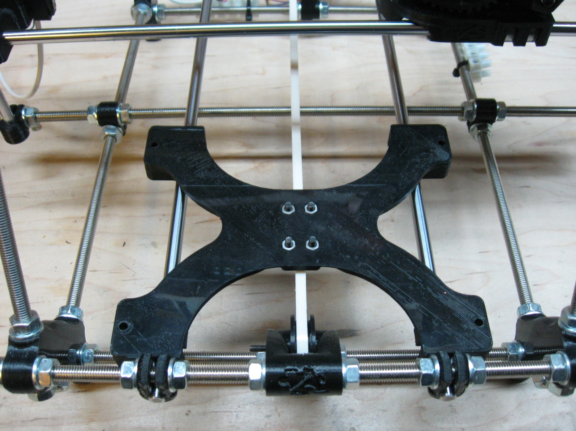

The HBP will be situated with the control block facing to the right when viewing the ecksbot from the front. Each of the 4 legs must have a 4mm washer on it before it enters the mounting hole and as you can see from the next picture, it is tight quarters, so it might take a try or two before you get each leg into its respective hole with a washer attached.

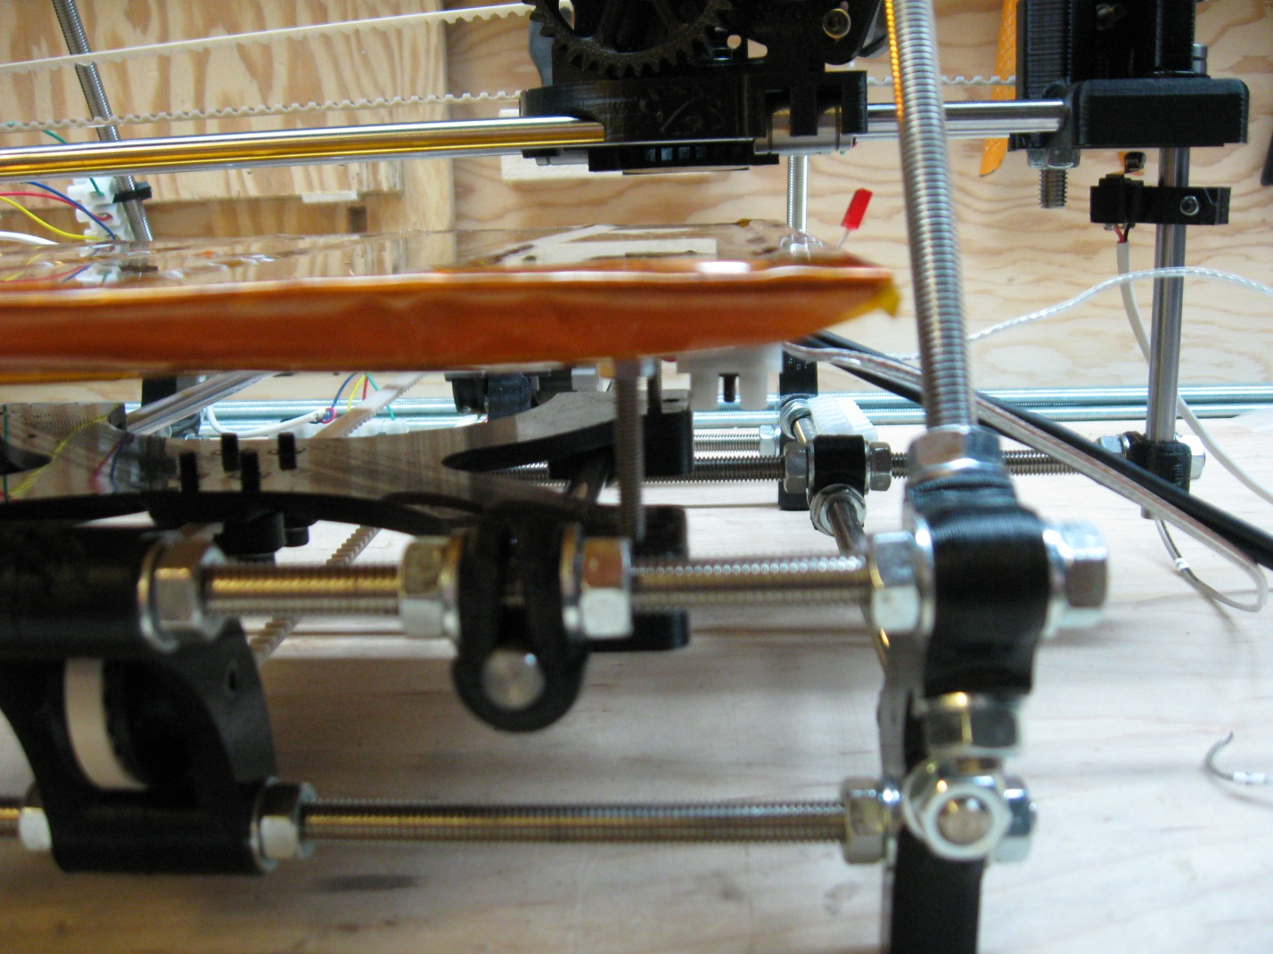

When pushing the HBP onto the carriage, be careful not to push any one side too far in comparison to the other corners as you may accidentally bend the HBP. Once the HBP is seated nicely onto the carriage, add a 4mm washer and 4mm nut to each of the leg bottoms and secure snuggly. We’ll come back to set the height properly once we are ready for the final alignment and calibration.

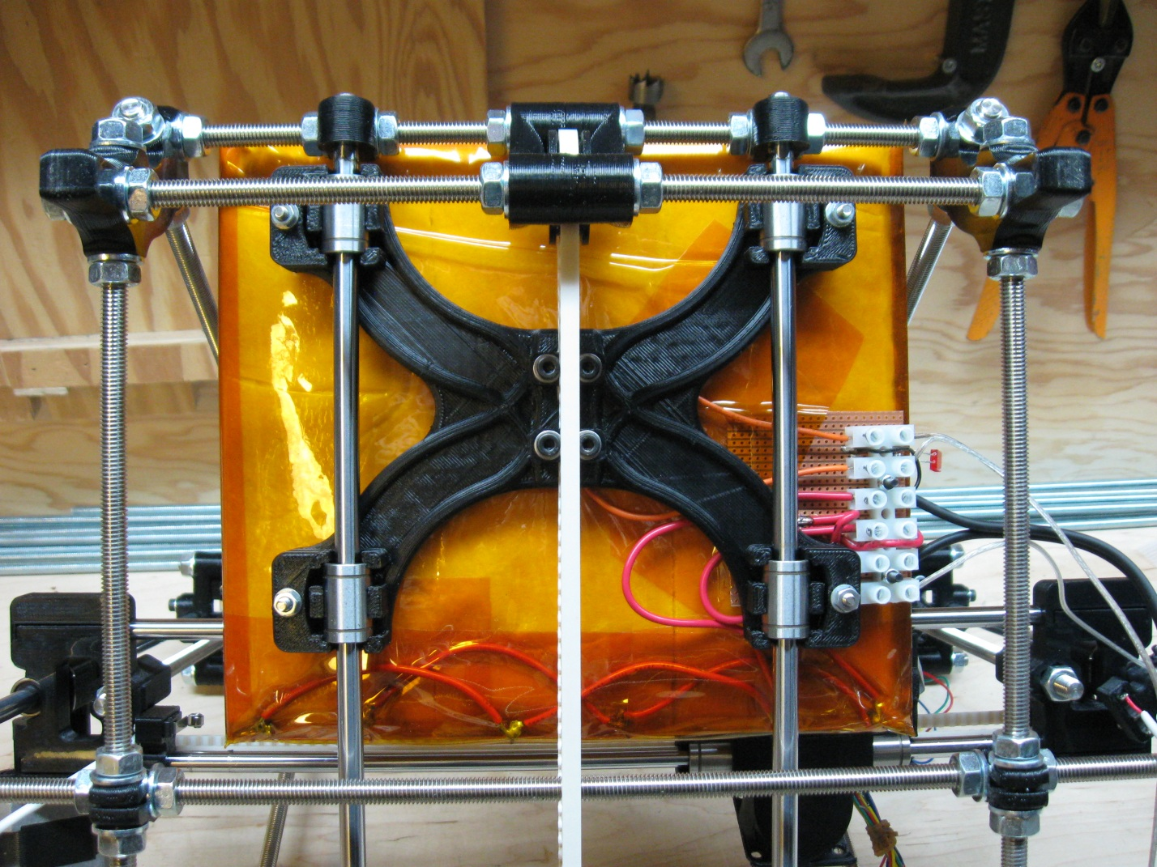

# Step 5 – Attaching the Hot End

To begin attaching the Hot End, we must first attach the heat-sink cooling fan to the fan cowl. For this you’ll need:

* 4 x 4mm bolts 10mm long
* 4 x 4mm nuts
* 1 40mm fan
* 4mm hex wrench.



The fan is placed on the cowl with the directional arrow that indicates the direction of the airflow pointing into the cowl and the wire must be positioned at the top of the cowl. Then fasten the fan in place using the 4 bolts and nuts.

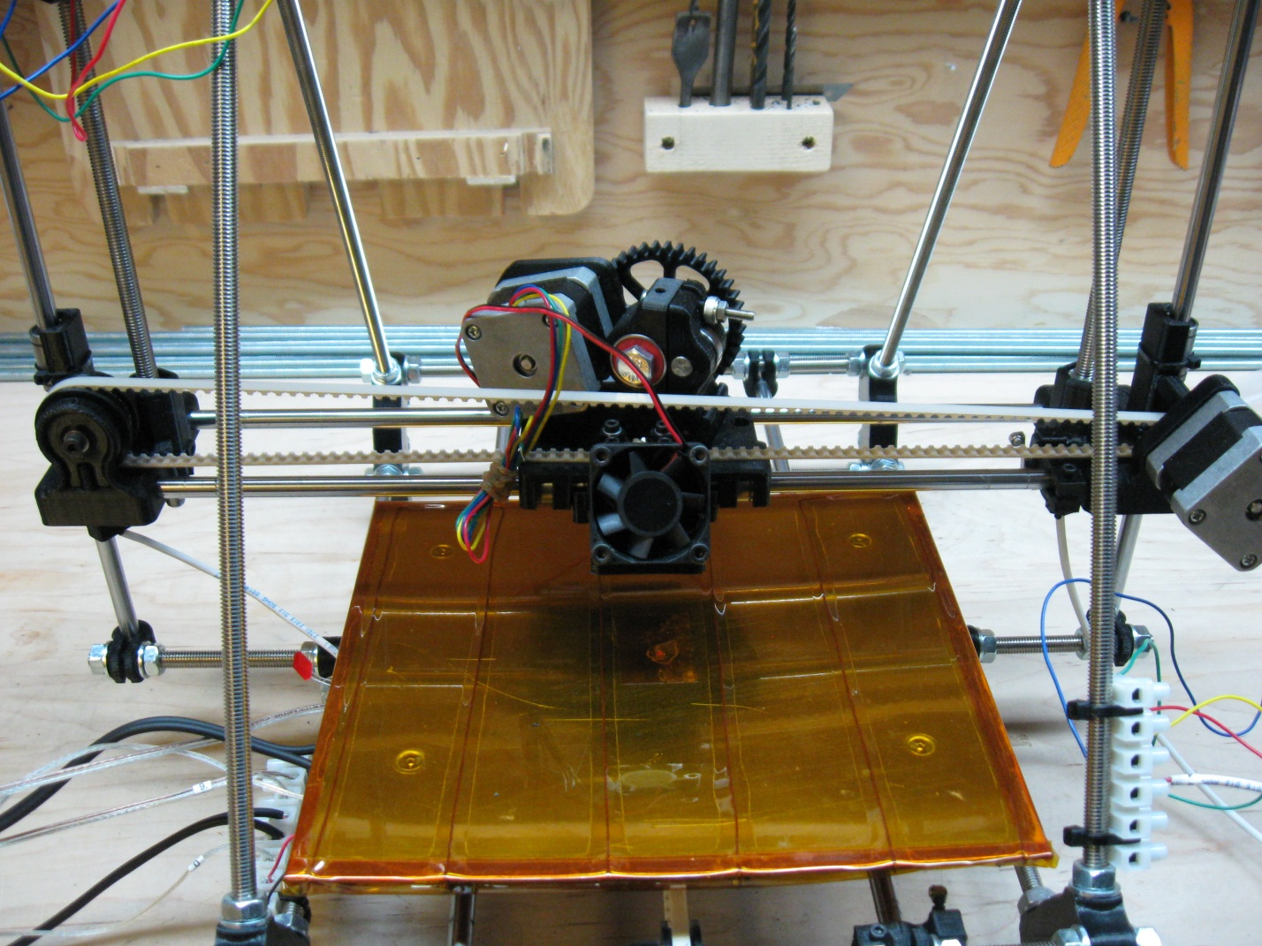

Next to be attached is the Hot-End itself. For this you’ll need:

* 1 x hot-end
* 2 x 4mm nuts
* 2 x 4mm washers
* 1 x 4mm wrench

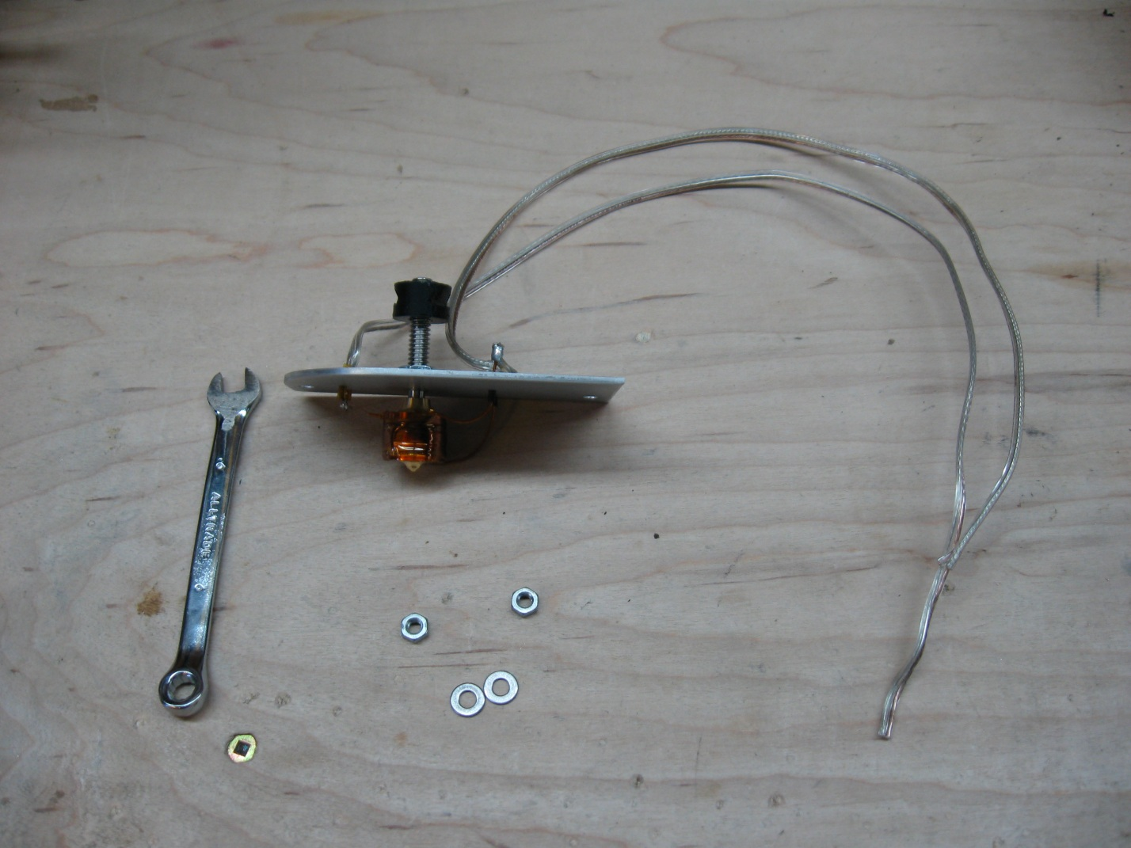

Notice that the hot-end tube has a printed insert attached to it in this picture. Not all ecksbot DIY or fully assembled kits will have this insert. Newer kits have a modified eckstruder that renders this insert unnecessary. The 2 wires that are attached to the hot-end are for the heating element and the thermistor readings. The heavier gauge wire is for the heating element and the thinner gauge wire is for the thermistor.

Start the Hot-End installation by feeding the heater wire and thermistor wires through the x-carriage behind the eckstruder when viewing the ecksbot from the front. See the following pictures for a top and rear view of the positioning of the 2 wires in relation to the x-carriage and eckstruder.

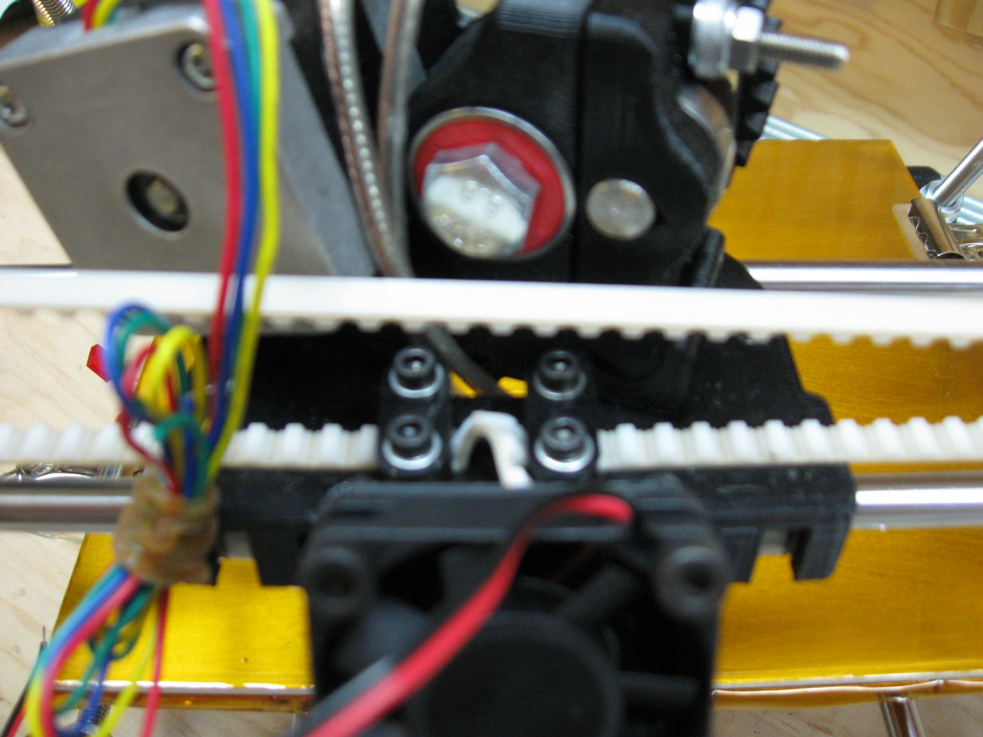

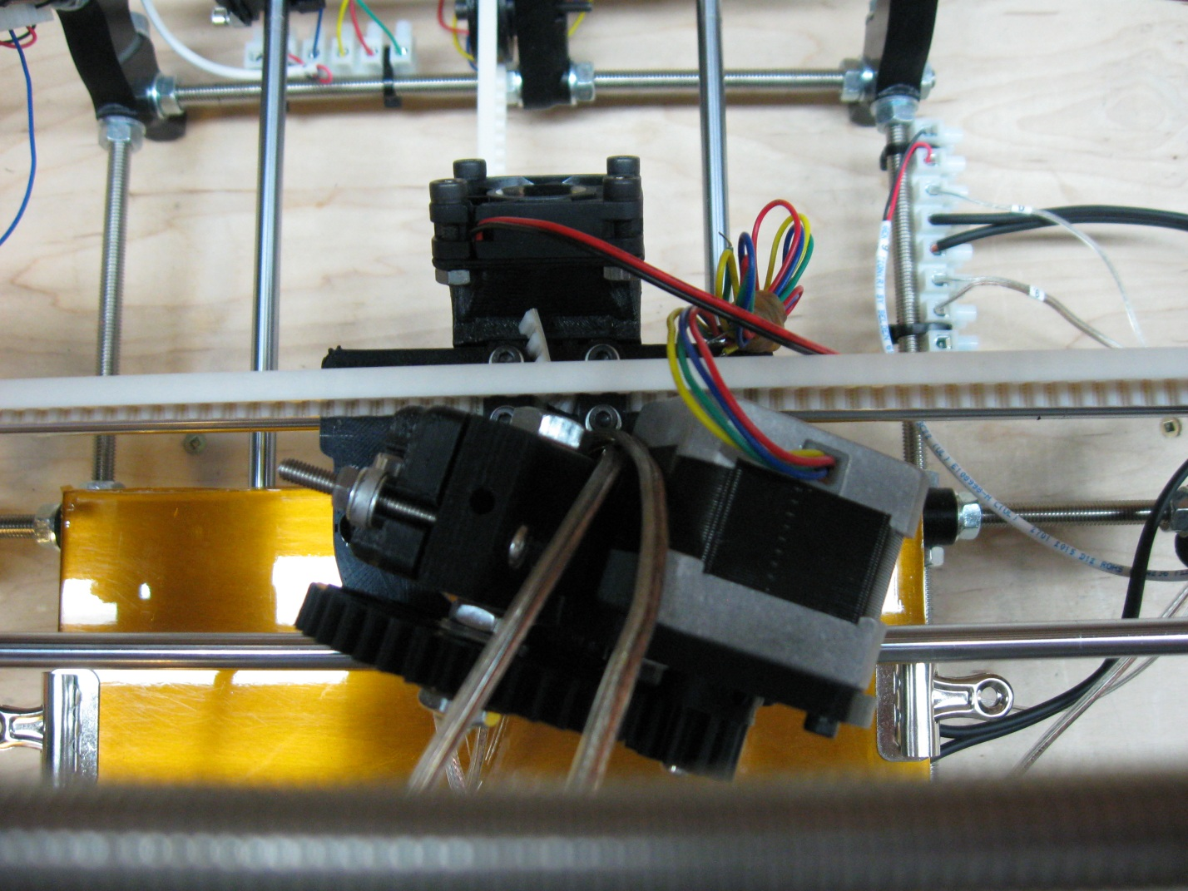

Once you have begun feeding the wire through the proper hole, continue pulling gently on the 2 wires while moving the hot-end into place. The rounded portion of the heat-sink is rounded to match the round on the front of the x carriage. Once the hot-end is near to its final position, use the 2 mounting bolts as a guide to help you find the correct position for the plastic insert. It might take a bit of wiggling, but once you find that the insert is in the correct position, push the hot-end the rest of the way in, until the heat-sink seats flush to the x-carriage mounting points. Finally, secure the hot-end using the 2 washers and 2 - 4mm nuts. Tighten the nuts very snuggly so that they will not vibrate loose when the machine is running.

Note: when seating the hot-end into its final position, be sure that the wires do not become kinked. If you look carefully between the heat-sink and the carriage, you will be able to see the wires and will be able to pull them gently while watching to prevent and kinks.

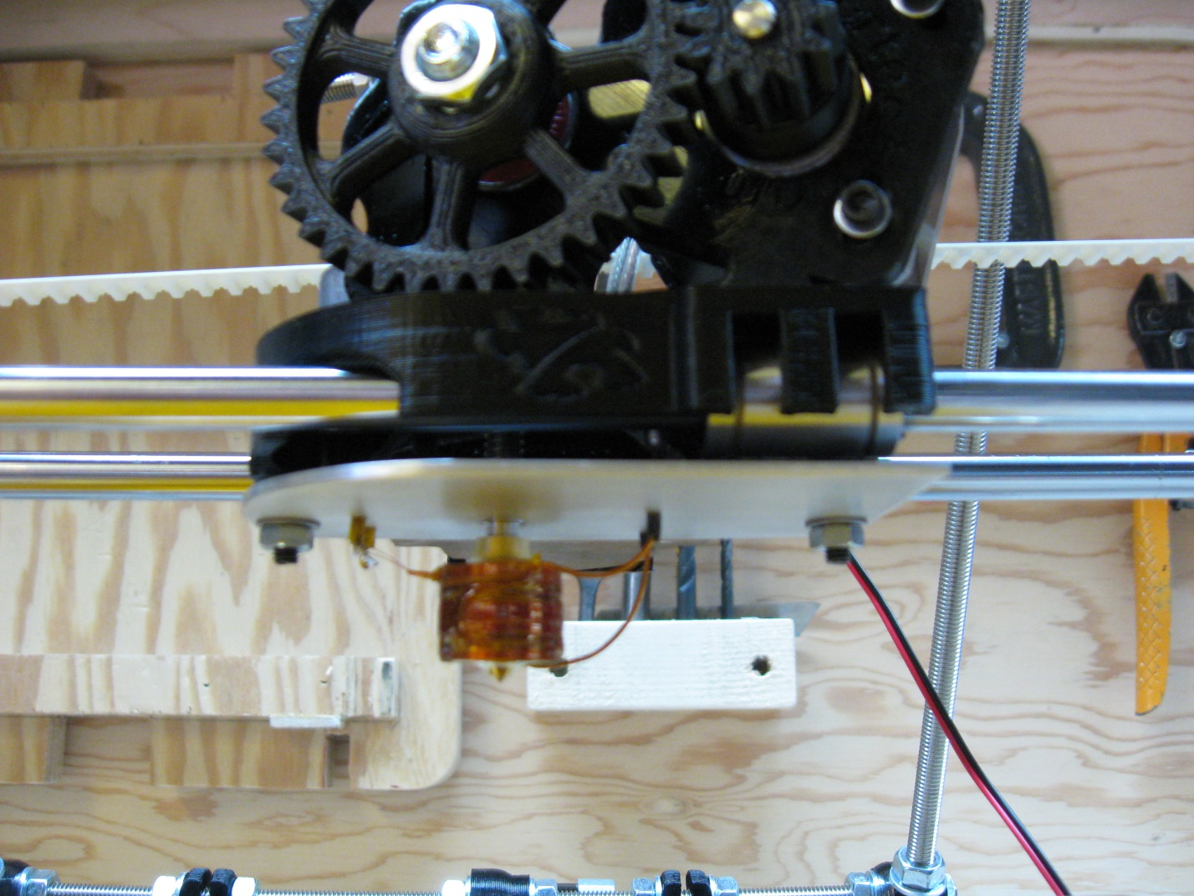

# Step 6 – Attaching the wires Part 1 (Component wiring)

The wiring of the ecksbot is done in 2 parts, component wiring and electronics wiring. We will first wire all the motors, end-stops, heaters, controls, thermistors and fans to the terminal blocks while zip tying any points that we can along the way. This will make is much easier to do the final wiring where the electronic controls are wired to their end components via the terminal blocks. For Part 1 you will need:

* A few zip ties
* A pair of scissors
* A slot screwdriver that fits the screws in the terminal blocks

#### Step 6-1 – Wiring X

Wiring the X-Motor and the X End-Stop to the X-Terminal block is accomplished by first turning your ecksbot so that you are looking at its back. Although the zip ties on the terminal blocks have been tightened as tightly as possible, the terminal block is still moveable. I find the easiest way to attach the wiring is to temporarily turn the terminal block 90 degrees so that the screw positions are facing you. The wires are then inserted into the right hand side of the terminal block and tightened in the following order from Top to Bottom:

* Top/1st position: green (motor)
* 2nd position: red (motor)
* 3rd position: yellow (motor)
* 4th position: blue (motor)
* 5th position: red (4) (end stop)
* 6th position: black (4) (end stop)

When attaching the wires, first make sure that the wires are loose and untangled. Be sure to tighten the screws as tightly as you can without stripping them or wrecking the screw head. Also be sure that the wires are secure and aren’t easily pulled out.

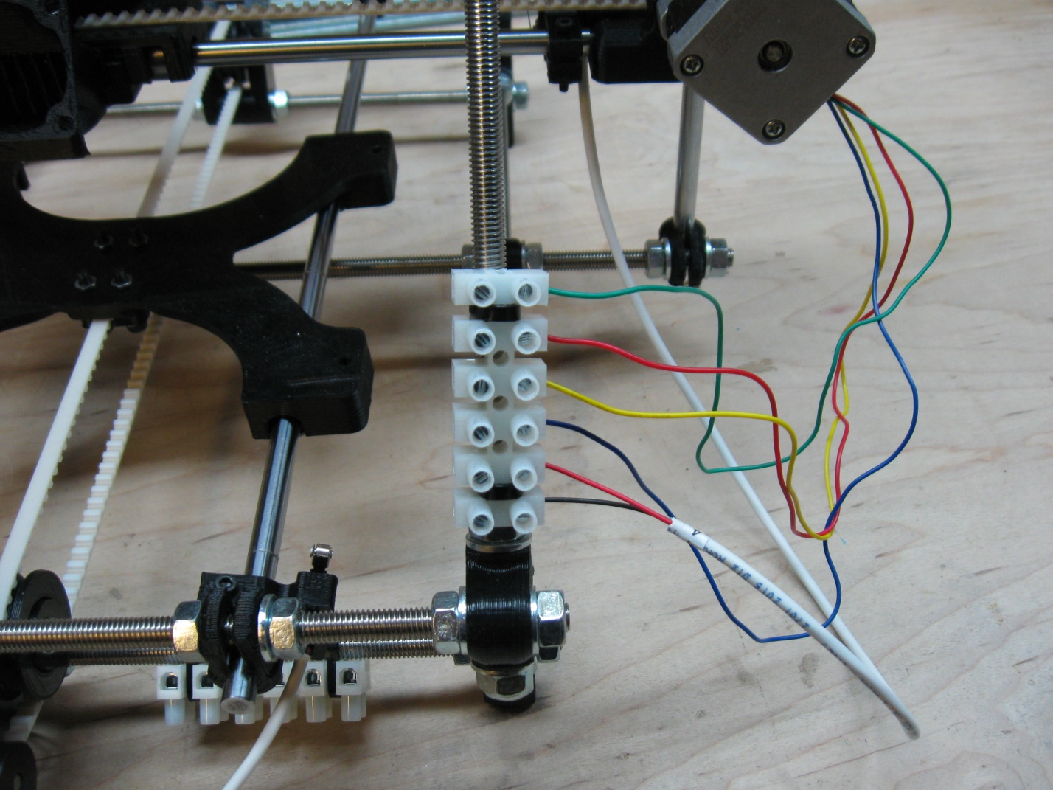

#### Step 6-2 – Wiring Y

Next, tilt your ecksbot onto its front so that you can access the Y-Terminal block. Tilt the block so that it is easy to access, and then insert and secure the wires in the same way as you did for the X-Terminal block. In this case, you will be inserting the wires into the top of the terminal block. The wires are inserted and attached in the following order from Left to Right:

* Left/1st position: green (motor)
* 2nd position: red (motor)
* 3rd position: yellow (motor)
* 4th position: blue (motor)
* 5th position: red (2) (end stop)
* 6th position: black (2) (end stop)

Again, before attaching the wires, make sure that the wires are loose and untangled. Be sure to tighten the screws as tightly as you can without stripping them or wrecking the screw head. Also be sure that the wires are secure and aren’t easily pulled out.

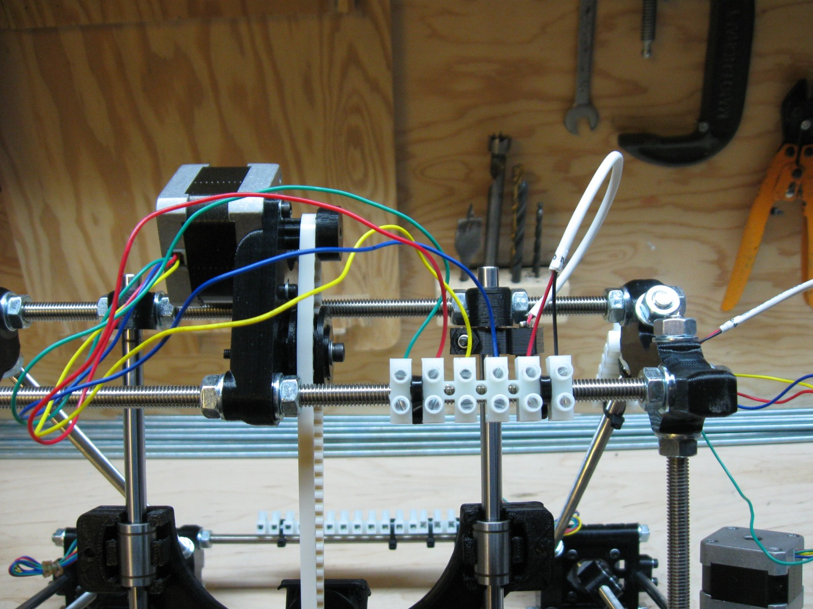

#### Step 6-3 – Wiring Z, eckstruder, and hot-end

Now tilt your ecksbot back onto its feet but still facing backwards. The ecksbot uses 2 motors to raise the Z-Axis. This is accomplished by wiring the 2 motors in parallel so that a single stepper driver can run both motors. To wire the motors together, we’ll start by making sure that all the wires are loose and untangled. Then, take the yellow and green wires from the right hand motor and attach them to the first 2 position on the terminal block along the top row as pictured. Be sure to secure them tightly the same way that you did for the X and Y terminal blocks.

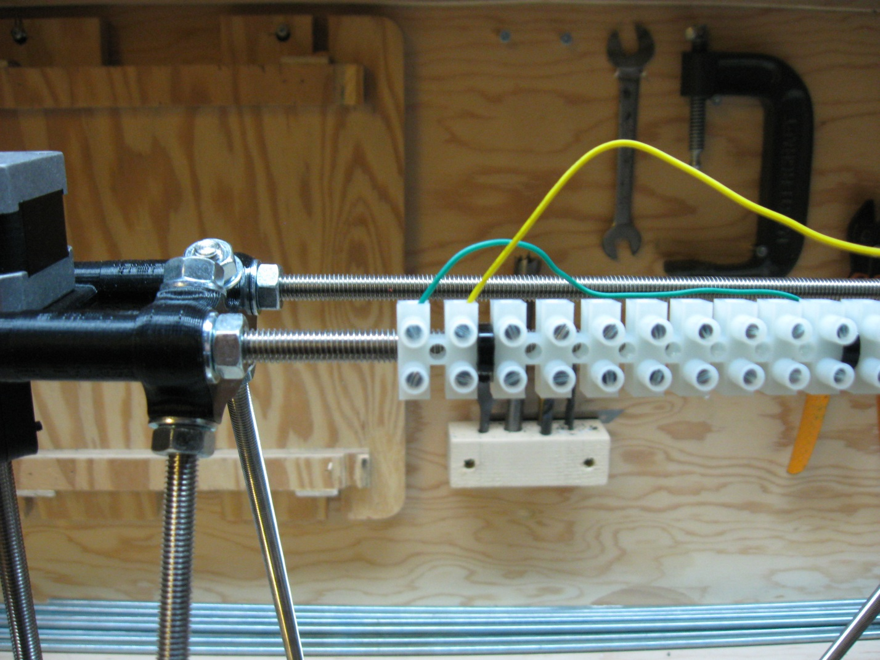

Now to complete the parallel connection, take the red and blue wires from the left hand motor and connect them to the first 2 positions of the terminal block, but this time on the bottom; see photo below. Again be sure to secure them tightly.

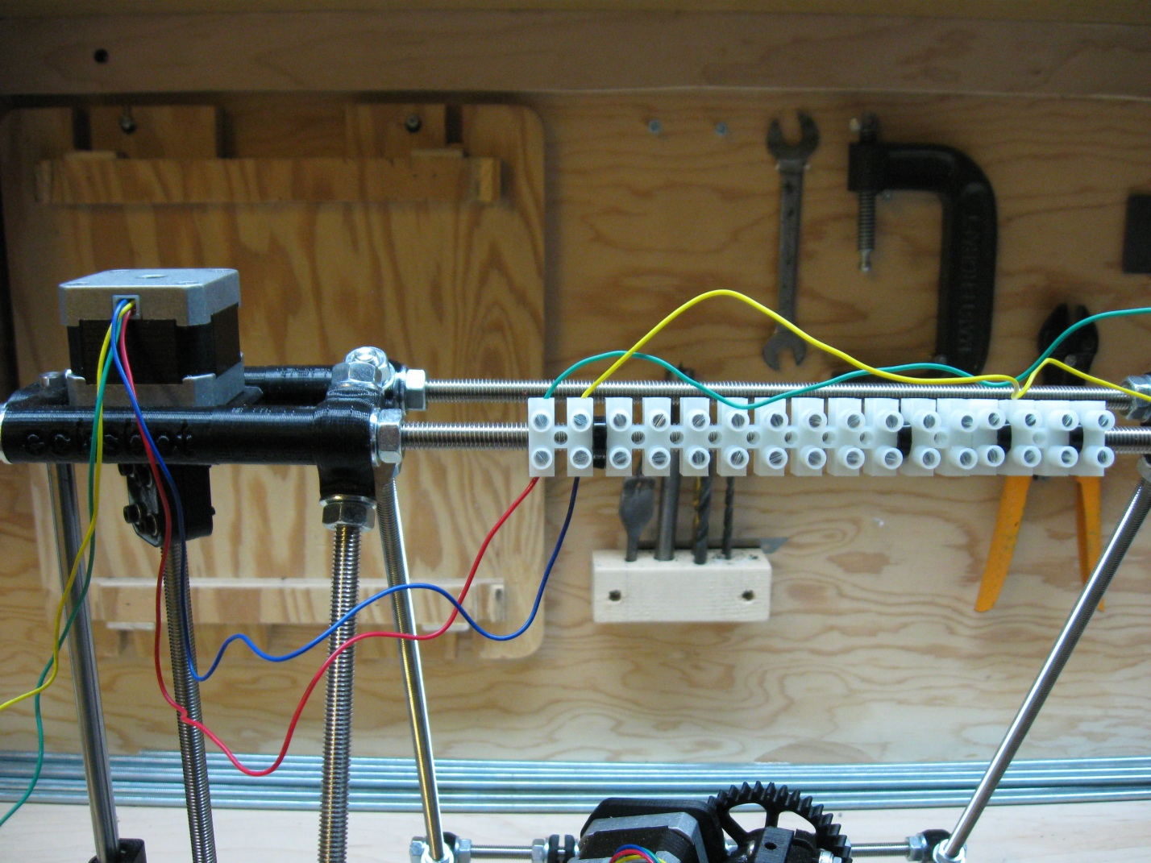

You are now left with a green and yellow wire on the left motor and a red and blue wire on the right motor. This gives you the same combination of wires of a single motor (green, red, yellow, blue). Connect them in that order from left to right in the top positions of the terminal block starting at the 3rd position.

* Left/3rd position: green (motor)
* 4th position: red (motor)
* 5th position: yellow (motor)
* 6th position: blue (motor)

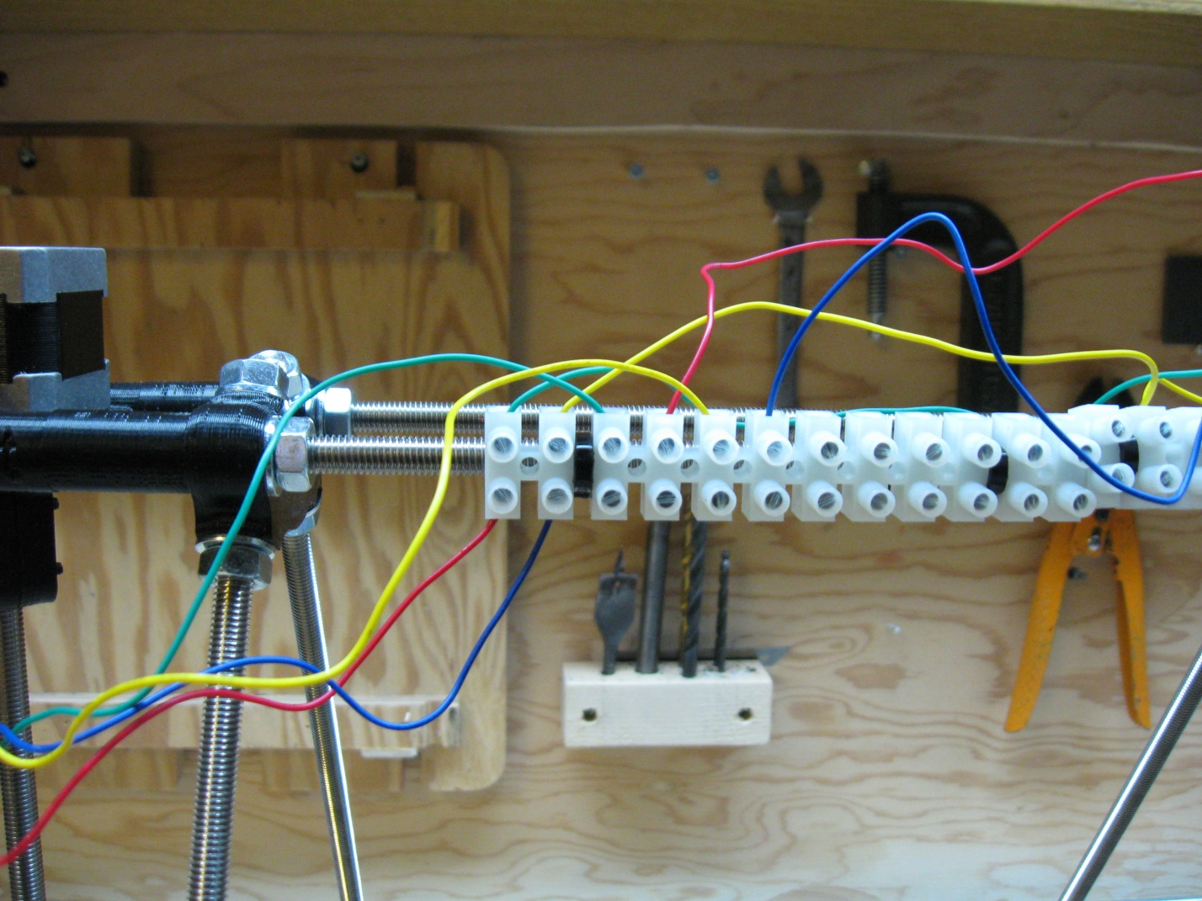

Once these wires are secured tightly, you can carefully arrange the wires from the right hand motor and run them between the screw positions so that they are out of the way, and then zip ties them on the threaded rod, just beyond the right hand side of the terminal block. The reason is that no other wires will be run to that side, and this way, the wires are out of your way and cannot get tangled with the wires that are attached next.

Note: Be careful when attaching zip ties directly to wires as pictured below. You must leave a slight bit of slack in the sire on either side or the zip tie so that the wire is not stretched or even possibly broken when you tighten the zip tie.

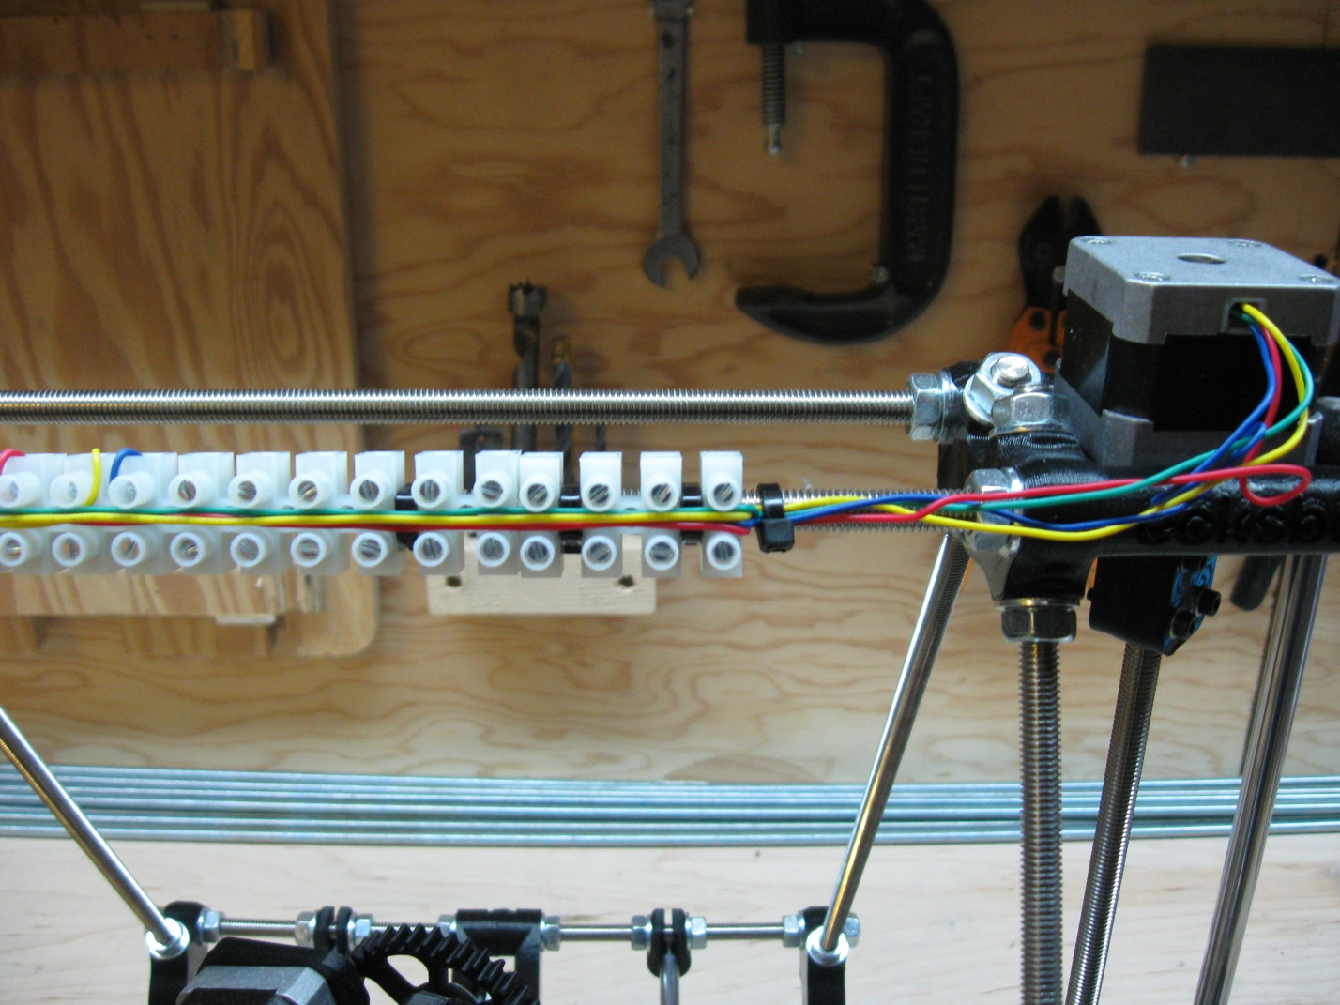

With the Z-Motors attached, you can now attach the eckstruder motor, hot-end heater, thermistor and heat-sink fan to the terminal block. Remember that the thin gauge wire from the hot-end is the thermistor wire, and the thicker gauge wire is the heating element. The wires are connected from left to right in the following order:

* 7th position: green (motor)
* 8th position: red (motor)
* 9th position: yellow (motor)
* 10th position: blue (motor)
* 11th position: red (fan)
* 12th position: black (fan)
* 13th position: thin gauge (thermistor)
* 14th position: thin gauge (thermistor)
* 15th position: thick gauge (heater)
* 16th position: thick gauge (heater)

Note: The thermistor and heater wires can be inserted in either position; there is no polarity requirement for either of them.

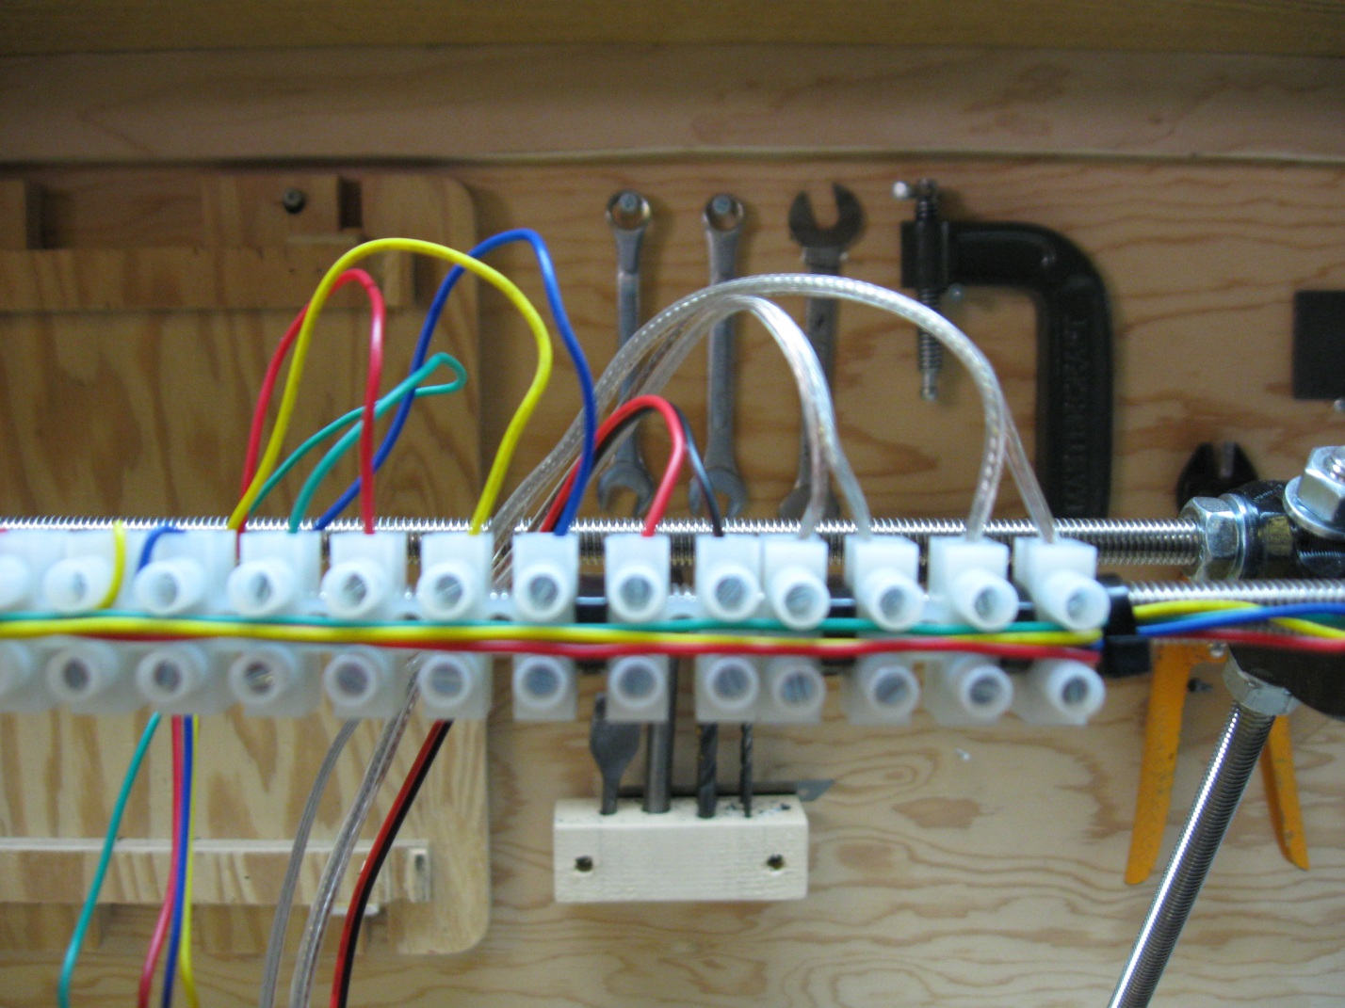

#### Step 6-4 – Wiring the HBP and the Z end-stop

The final components to be connected to their terminal block are the HBP and the Z End-Stop. The thermistor for the HBP is labeled (9), the control wire is labeled (0), the heater wire is the black wire and has a positive (+) and negative (-) side as labeled on the terminal block attached to the HBP controller, and the Z End-Stop is labeled (6). For this terminal block, we do not use the first position on the left; therefore the wires are connected in the following order from left to right:

* 2nd position: clear (9) (thermistor)
* 3rd position: clear (9) (thermistor)
* 4th position: black heavy gauge (+) (heater)
* 5th position: black heavy gauge (-) (heater)
* 6th position: clear (0) (control)
* 7th position: red (6) (end stop)
* 8th position: black (6) (end stop)

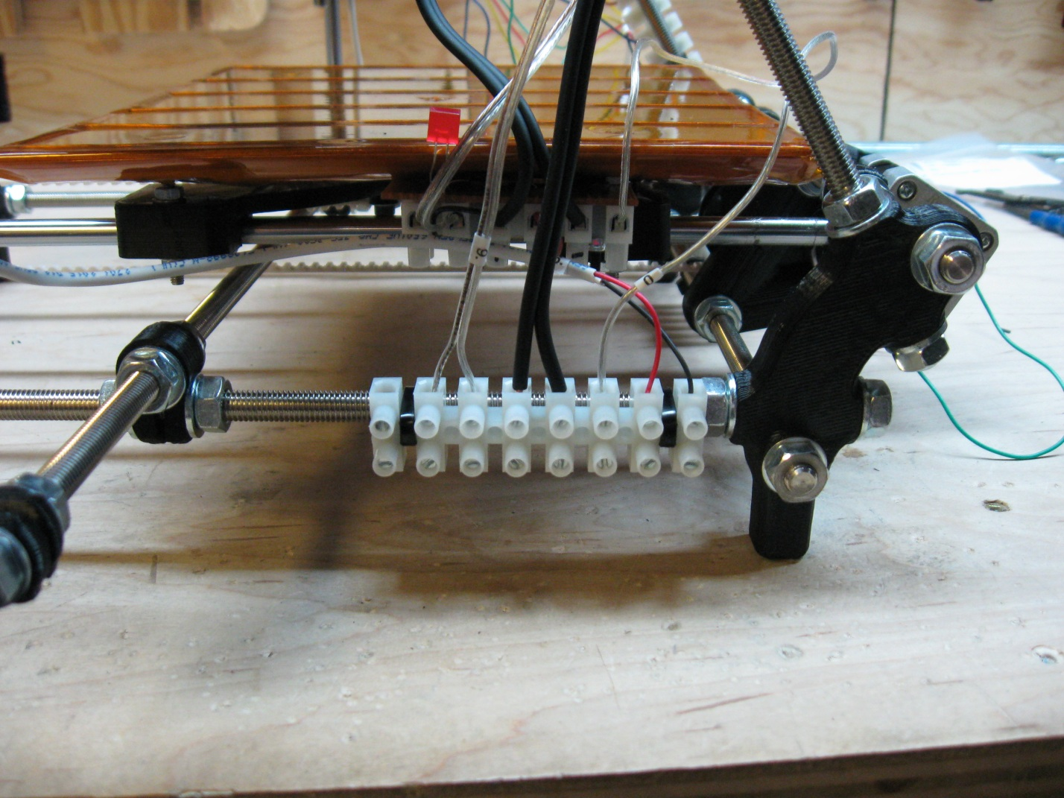

This completes all of the component side wiring. Next up, connecting the electronics!

# Step 7 – attaching the wires Part 2 (Electronics wiring)

Next up is the connection of the RAMPs 1.4 electronic controller to your ecksbot. Connecting the electronics to your ecksbot is much easier than most RepRap assemblies. We have put a lot of work into making the ecksbot build as simple and straightforward as possible. In this case, the attachment of the electronics, we’ve done all the soldering and wire stripping for you, all that you need to do is connect the wires to their respective positions in a paint-by-numbers kind of way. For this stage you will need:

* The RAMPs 1.4 complete kit with attached ecksbot wiring.
* A few zip ties
* A pair of scissors
* A slot screw driver that fits the screws in the terminal blocks

Notice that the RAMPs 1.4 with ecksbot wiring comes with a number of different length wires sticking out of one end. To reduce clutter and provide an easier assembly we attach all of the connections in house using underside wiring. We find that it makes for a cleaner install, with less clutter, while at the same time, reducing assembly time considerably. Also notice that almost all of the wires are numbered except for the hot-end heater wire and fan control wire. The numbers are used to indicate where each wire will ultimately be attached. The hot-end heater wire and the fan control wire can be traced by hand and thus aren’t numbered.

|  |  |  |  |
| --- | --- | --- | --- |
| Wire No. | Connection | Wire No. | Connection |
| 1 | Y-Motor control | 6 | Z-Axis End-Stop |
| 2 | Y-Axis End-Stop | 7 | eckstruder motor control |
| 3 | X-Motor control | 8 | Hot-End thermistor |
| 4 | X-Axis End-Stop | 9 | HBP thermistor |
| 5 | Z-Motor control | 0 | HBP Control |
| Thick Gauge | Hot-End Heater | Thin Gauge | Hot-End heat-sink fan |

#### Step 7-1 – Wiring Z, eckstruder, and hot-end

For this stage in the wiring, we’ll begin at the top of the machine and work our way down. For most of the electronics wiring we’ll be working from the back of the machine, so place your ecksbot on your workbench with its front facing away from you. We’ll be working with the top terminal block for this section and we will be attaching wires (5), (7), (8), and the 2 unnumbered wires for the Hot-End heater and heat-sink fan.

Please make note that the electronics side of the motor connections have 4 wires that are connected in the order from left to right of green, red, white, and black. This corresponds to the motor wires themselves which are green, red, yellow, and blue. What this means is that the green connects to green, the red connects to red, the white connects to yellow, and the black connects to blue. This goes for all motor connections on the ecksbot, so keep that in mind when connecting any of the motors.

Start by making sure that the wires are completely untangled and free so that you can easily attach them without any crossing. Then starting from the left, 3rd position on the bottom of the terminal block, begin attaching the Z-Motor control wire (5), and the eckstruder motor control wire (7). Remember that the motors control wires are inserted in the order (green, red, white, black). Be sure to secure the wires as tightly as you can without stripping the screw terminals or damaging the screw heads.

* Left/3rd position: green (5)
* 4th position: red (5)
* 5th position: yellow (5)
* 6th position: blue (5)
* 7th position: blue (7)
* 8th position: blue (7)
* 9th position: blue (7)
* 10th position: blue (7)

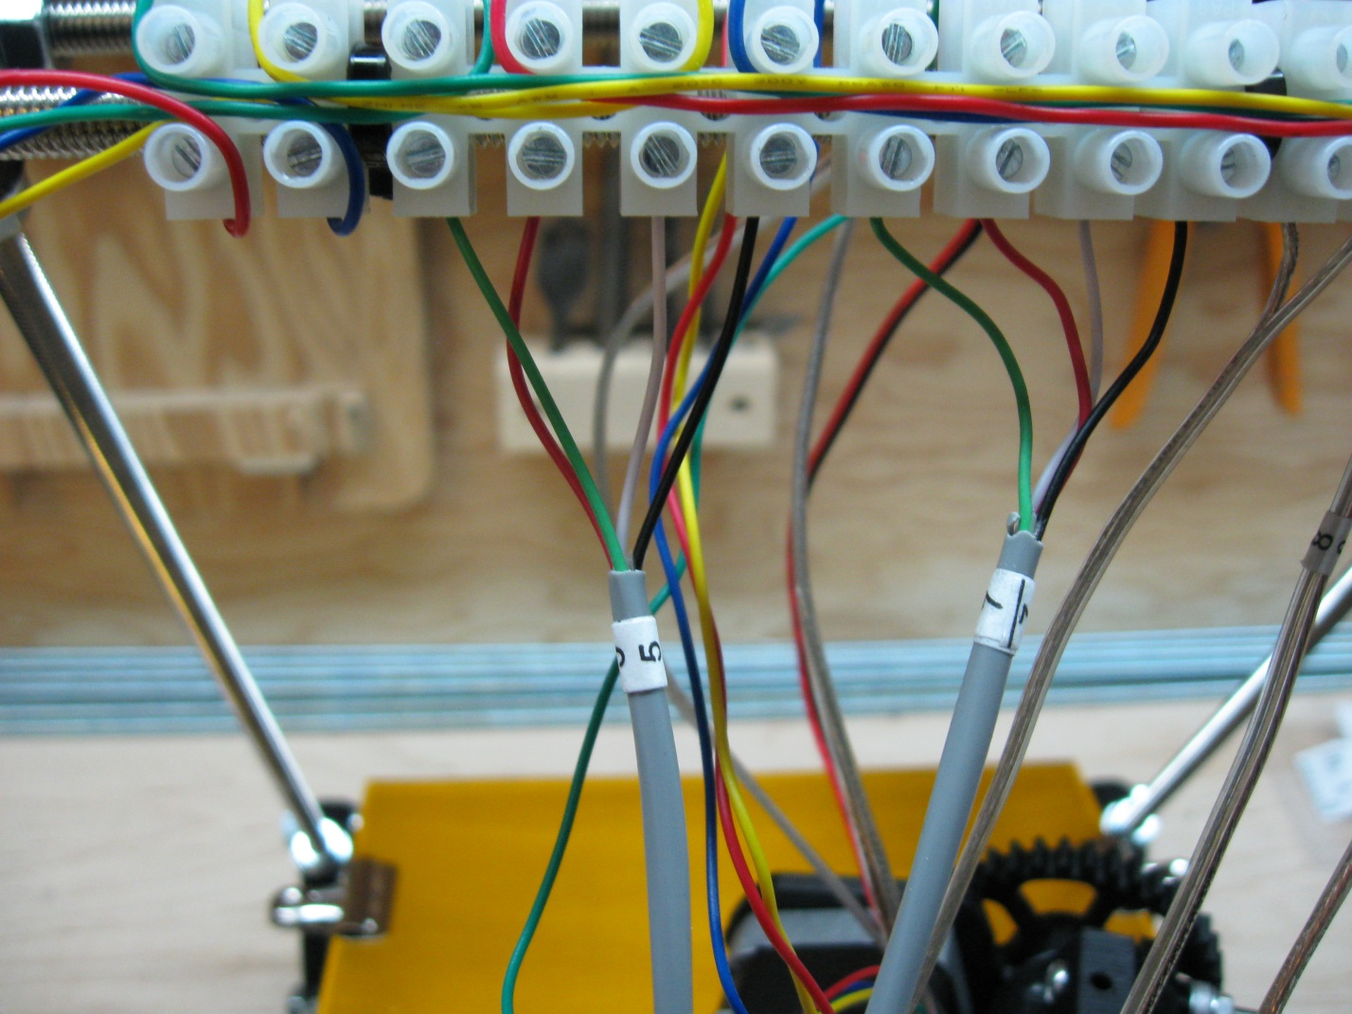

The next 6 connections to be made are 2 for the heat-sink fan, 2 for the Hot-End thermistor, and 2 for the Hot-End heater in that order. The fan connection is the only one where polarity is important, the thermistor and heater can be connected in any polarity (any order). To connect the fan we will use the unmarked thin gauge wire; make sure that the copper colored wire is connected to the red wire and the silver colored wire is connected to the black wire. Next is the thermistor wire numbered (8) in positions 13 and 14. Finally attach the Hot-End heater wire into positions 15 and 16. It’s the unmarked heavy gauge wire.

* 11th position: unmarked thin gauge copper colored
* 12th position: unmarked thin gauge silver colored
* 13th position: blue (8)
* 14th position: blue (8)
* 15th position: unmarked thick gauge either color
* 16th position: unmarked thick gauge either color

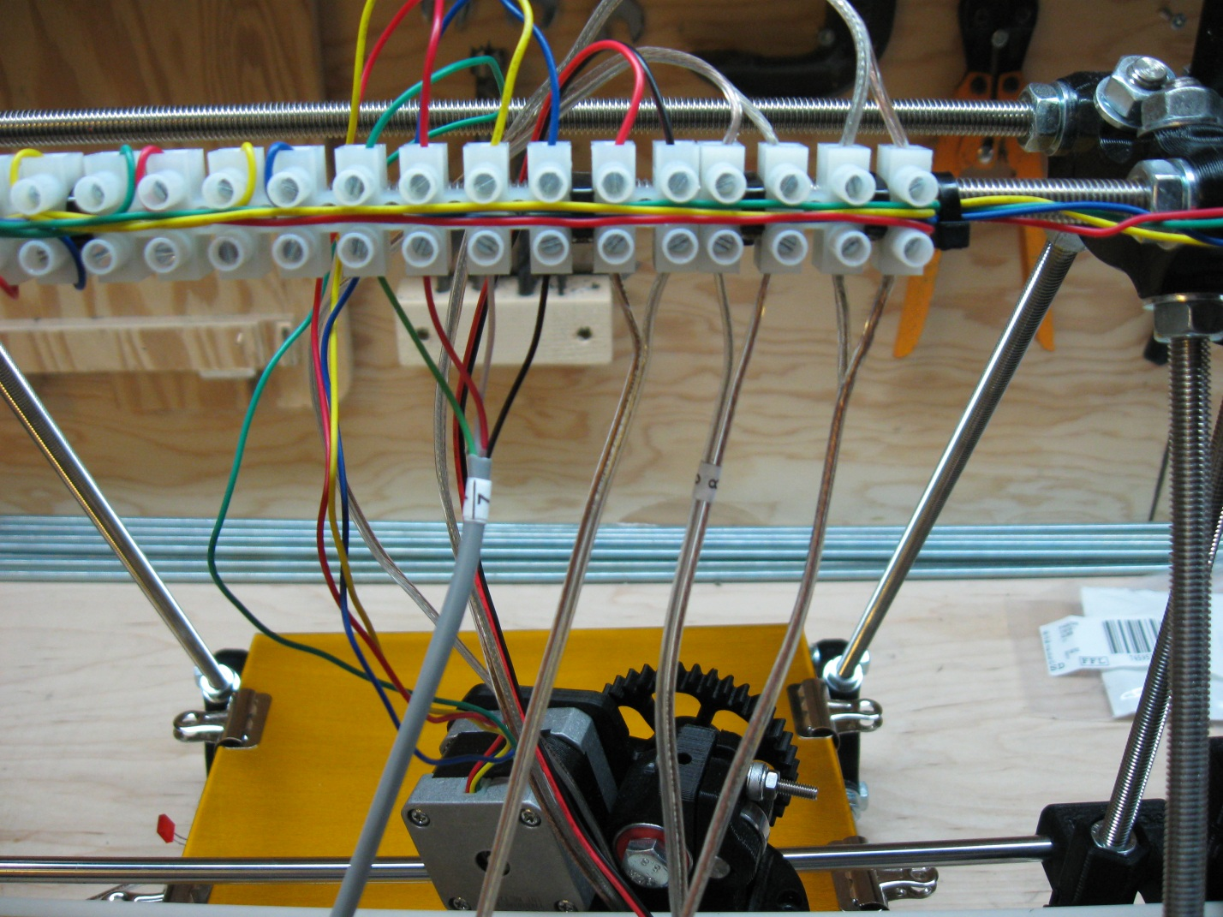

Note: If you can’t tell the difference between the wire gauges for the fan control wire and the Hot-End heater wire, you can trace them from the RAMPs 1.4 boards itself. Both wires are connected to the green terminal block on the top right of the RAMPs board. The heater wire is the one connected to the very right 2 positions and the fan control wire is connected to the center 2 positions.

#### Step 7-2 – Wiring X

Next up is the connection of the X-Axis of your ecksbot. For this step, you will need the wires numbered (3) and (4). Start by making sure that the wires are free and untangled. The wires are going to run under the machine along the back threaded rod, so run them loosely in that direction and position so that it will be easier to zip-tie them later. From top to bottom, the wires are connected in the order:

* Top/1st position: green (3)
* 2nd position: red (3)
* 3rd position: yellow (3)
* 4th position: blue (3)
* 5th position: red (4)
* 6th position: black (4)

Be sure the wires are correctly inserted and tightly fastened.

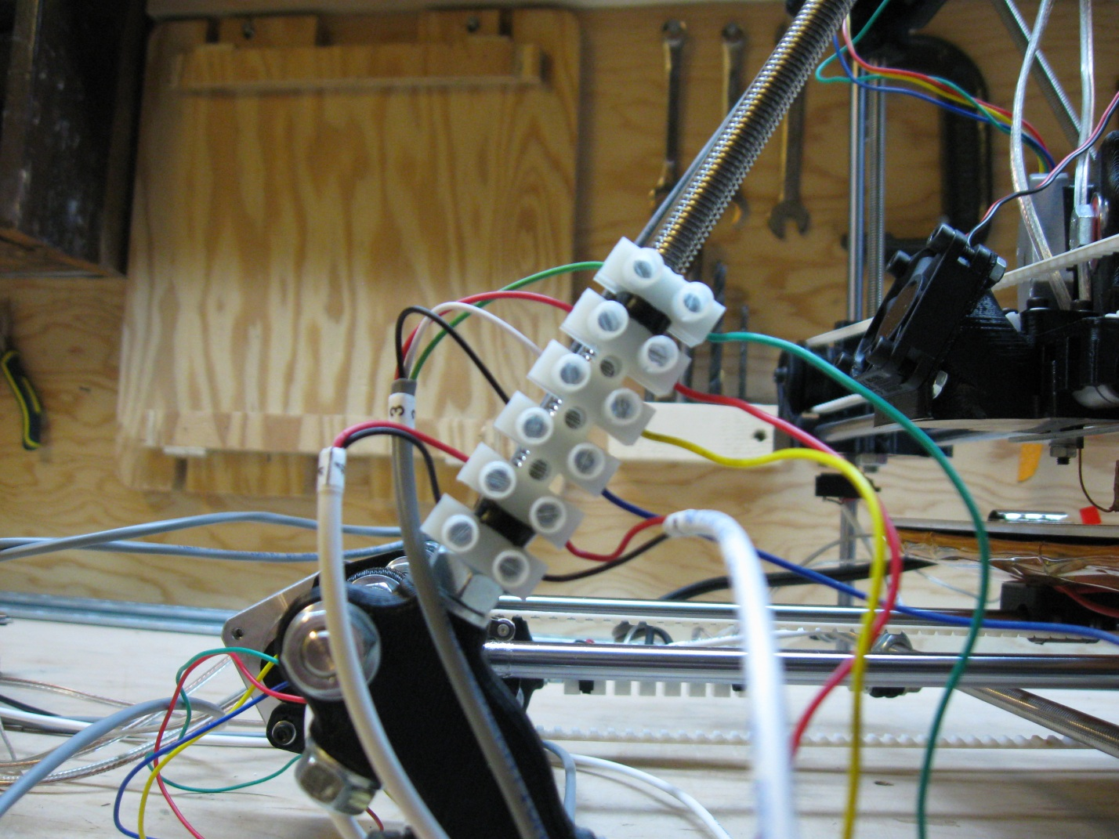

#### Step 7-3 – Wiring Y

Next up is the connection of the Y-Axis of your ecksbot. For this step, you will need the wires numbered (1) and (2). Start by making sure that the wires are free and untangled. You may need to tip your ecksbot onto its front so that you can easily access the Y-Terminal block. The wires are going to run under the machine along the back threaded rod, so run them loosely in that direction and position so that it will be easier to zip-tie them later. From left to right, the wires are connected in the order:

* Left/1st position: green (1)
* 2nd position: red (1)
* 3rd position: yellow (1)
* 4th position: blue (1)
* 5th position: red (2)
* 6th position: black (2)

Be sure the wires are correctly inserted and tightly fastened.

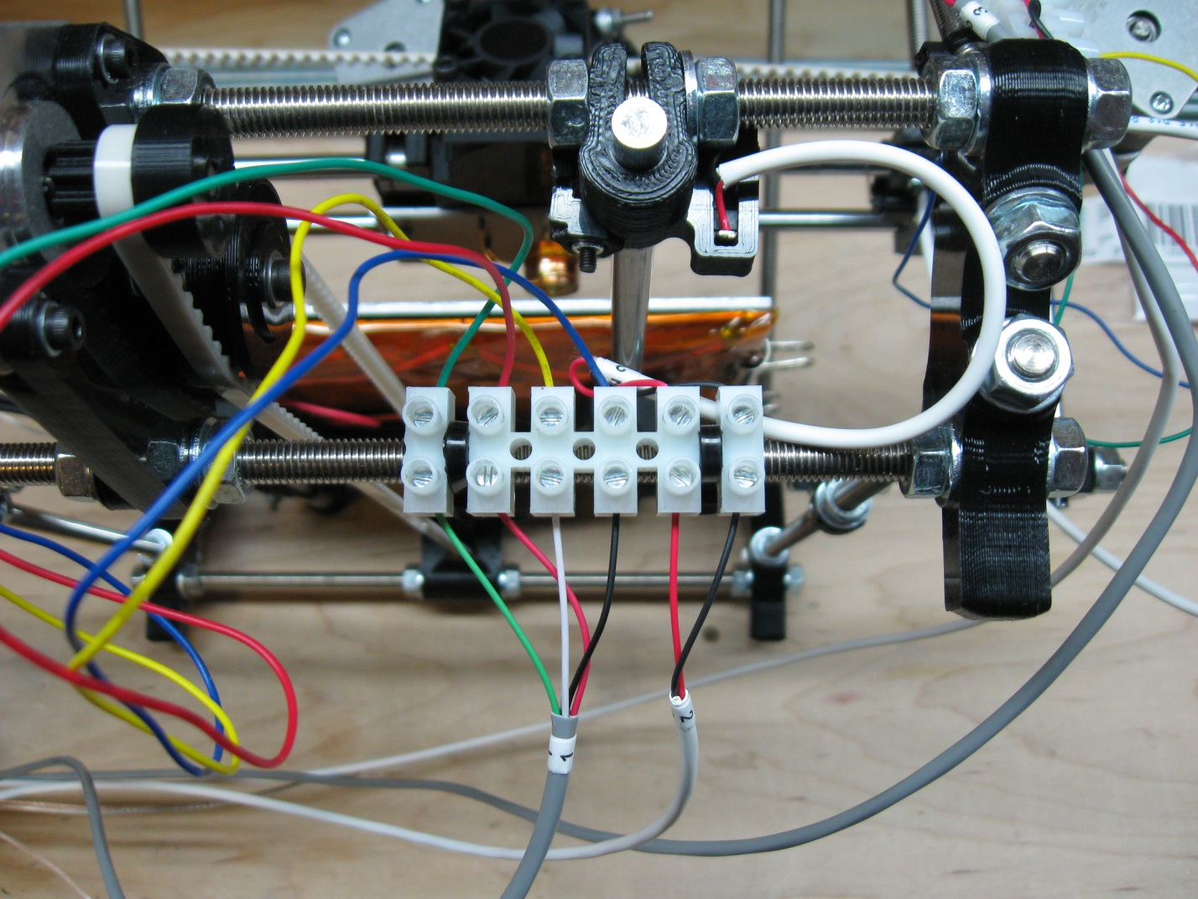

#### Step 7-4 – Wiring the HBP and the Z end-stop

The final wiring is completed by connecting the HBP power and controls and the Z end-stop. This will be completed in 2 parts. First we’ll connect the control portion from the RAMPs 1.4. You’ll need the remaining wires that are numbered (6), (9), and (0). Start by making sure that the wires are loose and untangled. You may need to tilt your ecksbot onto its side to better access the HBP terminal block. (Note: The 1st position of the terminal block is unused.) Starting from position 2, we connect the wires from left to right in the following order:

* 2nd position: clear (9) (thermistor)
* 3rd position: clear (9) (thermistor)
* 4th position: unconnected
* 5th position: unconnected
* 6th position: clear (0) (control)
* 7th position: red (6) (end stop)
* 8th position: black (6) (end stop)

Notice that the 4th and 5th positions remain unconnected at this point. The reason is that the power for the HPB is provided via a heavy gauge wire directly from the PSU.

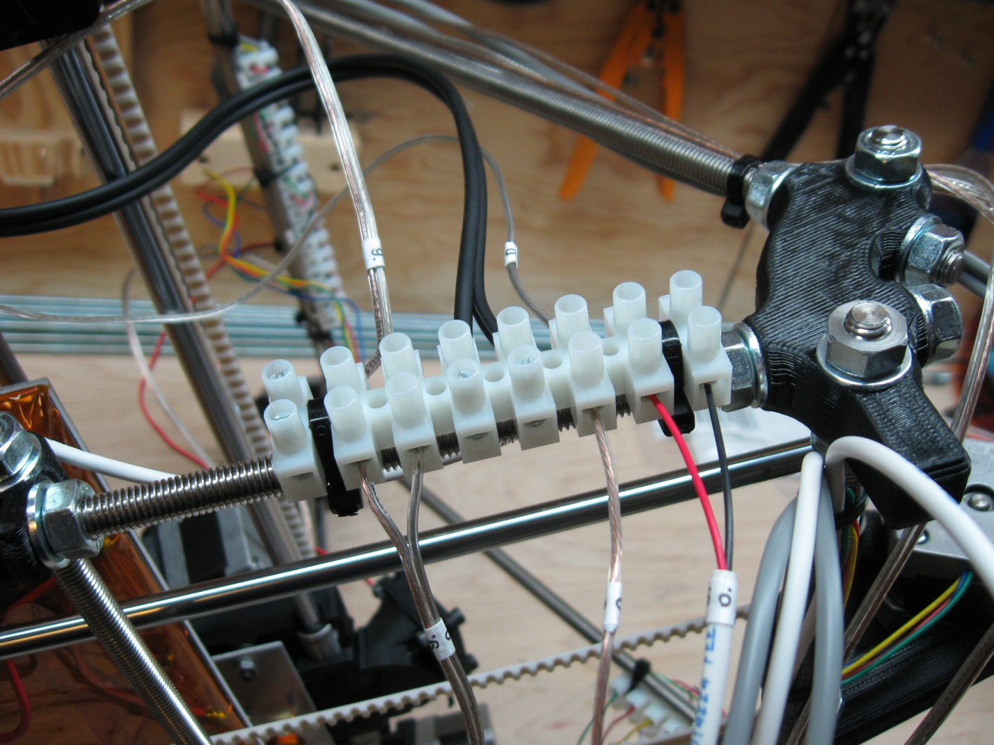

#### Step 7-5 – Connecting the PSU

With the electronic controls attached to the HBP terminal block we can now connect the 12V power from the PSU directly to the HBP terminal block and to the RAMPS 1.4 board itself. The PSU was 3 wire connections. On the left hand side is the main power connection that gets plugged into the wall. The other 2 connections provide 12V power to the ecksbot. The one 12V wire has a green terminal connector attached to its end and is used to connect to the RAMPs 1.4. The other 12V wire is what provides power to the HBP. Notice that the 12V wires have a white stripe to indicate which wire is negative. This indicator is very important when connecting the HBP. If you connect the HBP is reverse polarity it may ruin the HBP controller, so be very careful to double check the connection before connecting the power.

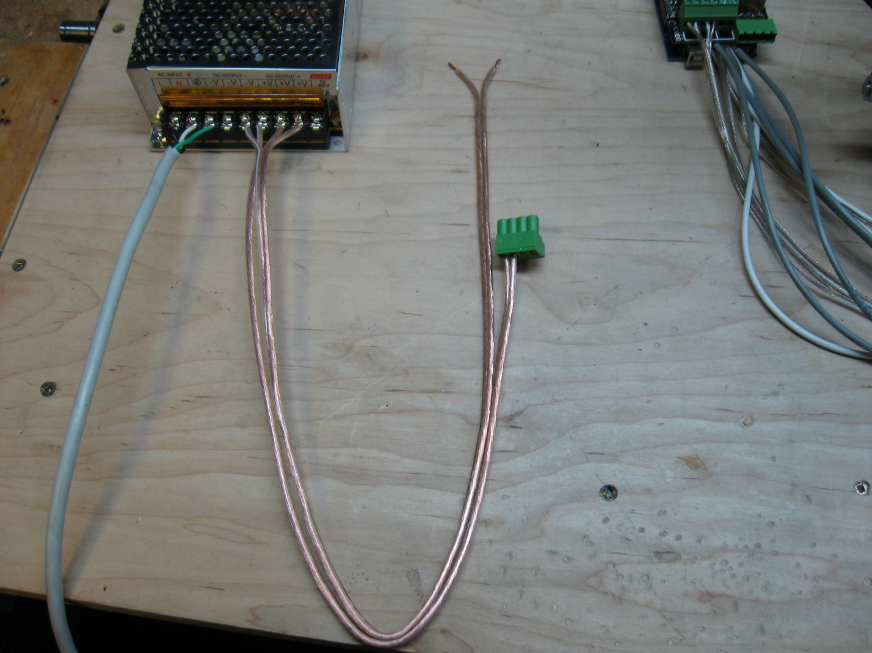

To connect the HBP, first make sure that the PSU is unplugged and the green LED indicator inside the PSU is not lit. Once you are sure that the machine is unpowered, connect the 12V power lines to the HBP terminal block with the positive connection on the left and the negative connection (the one with the white stripe) on the right. Secure the 2 leads tightly in the terminal block. These 2 lines provide approximately 14amps to the HBP, so ensuring that they are securely fastened is imperative.

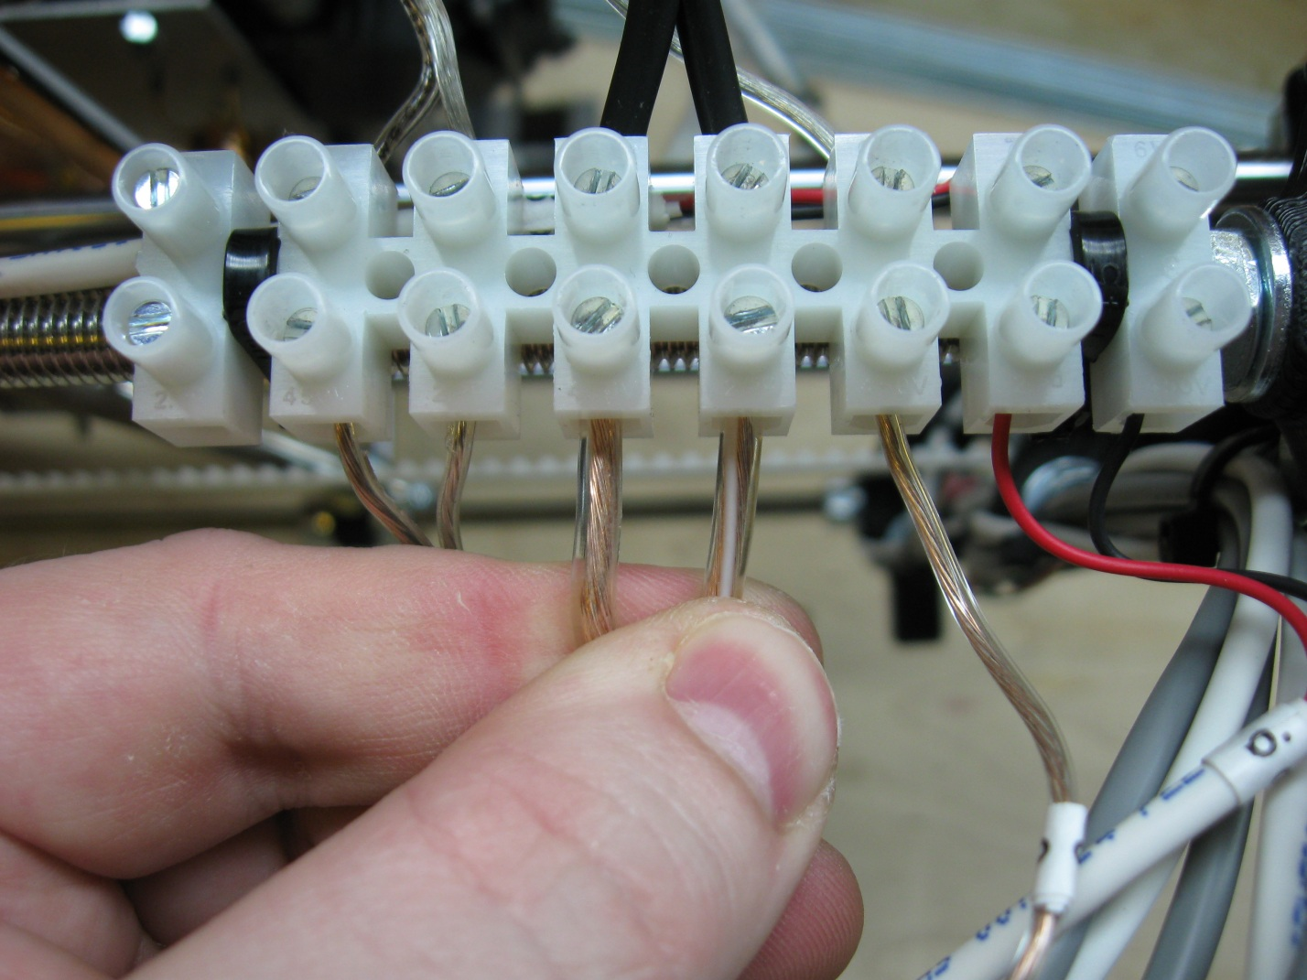

To connect the 12V line to the RAMPs 1.4, simply plug the green terminal connector directly and firmly into the green terminal receptacle on the RAMPs 1.4 board.

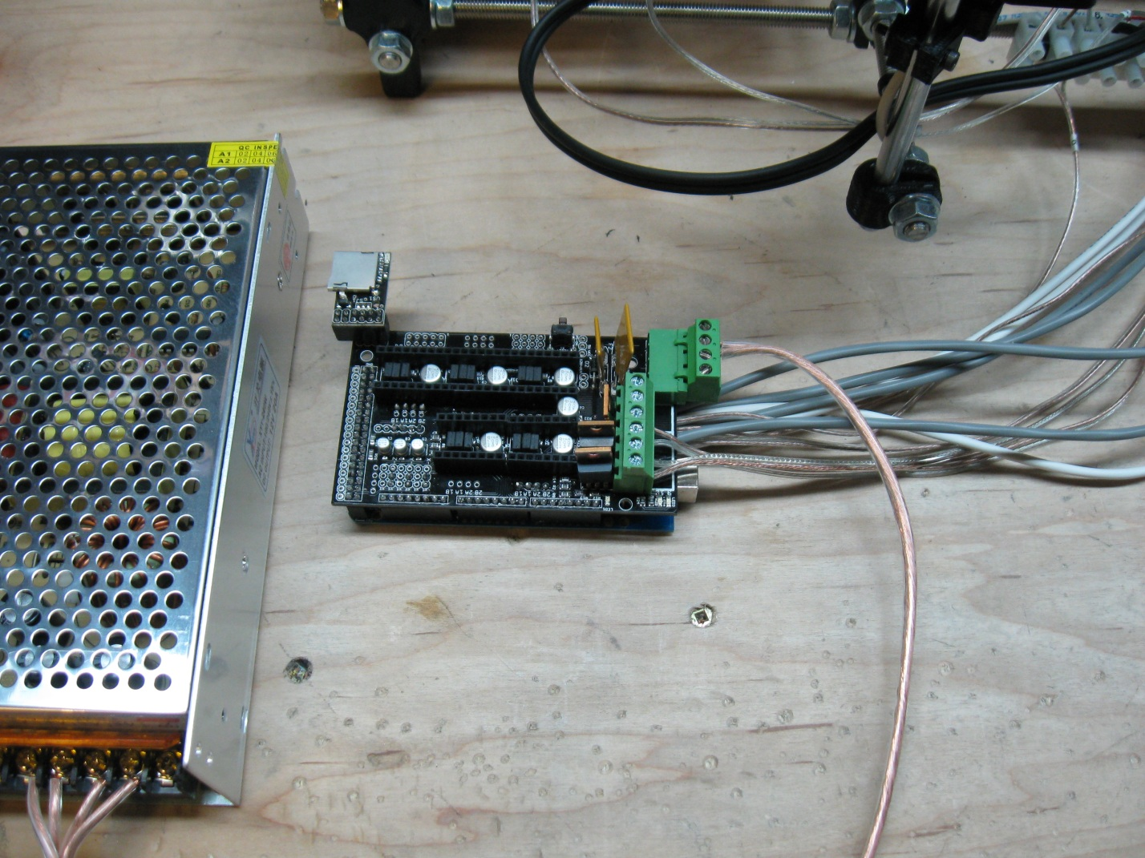

This completes the wiring stage of building your ecksbot.

# Step 8 – Zip Ties and Spiral Wrap

Now that all the wires are connected all that is left to do is to tidy up the wires by tying the wires to the machine securely and adding some spiral wrap for both looks and protection. For this final set of steps you will need:

* The remaining zip ties
* 1 long length of spiral wrap (to be cut into usable lengths)
* A pair of scissors

#### Step 8-1 – Zip-Tying the Z-Motors, eckstruder, and hot-end

As in previous steps we again begin at the top of the machine with the front facing away from you. Gather all of the wires that are heading to the electronics and carefully bend them to the left of the machine as pictured. The wires to be gathered are:

* z-motor control
* eckstruder motor control
* fan control
* Hot-End thermistor wire
* Hot-End heater wire

With the wires gathered on the left, loop a zip-tie loosely around the wires and the threaded rod. Don’t tighten the zip-tie just yet; simply use it as a helping hand to keep the wires organized as you arrange them into a nice configuration. I like to run the eckstruder motor control wire along the front of the terminal block and tuck all of the remaining wires just behind the terminal block and up against the threaded rod. This is just my preference, the goal here is to tidy up the wires and keep them snug and secure away from the rest of the machine.

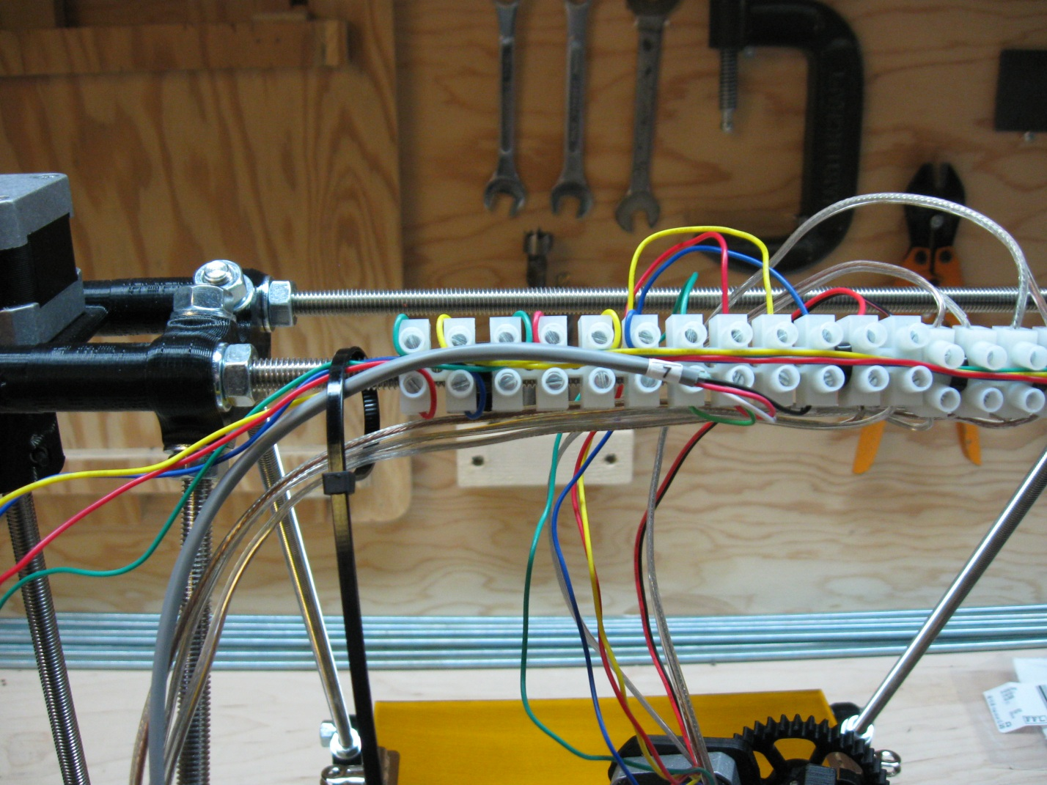

Once you are happy with the way the wires are arranged, hold the wires to the left of the loose zip-tie and make sure that all of the wires are taught. With the wires held taught with you left hand, use your right hand to snug up the zip-tie tightly, but not so tight as to harm the wiring. You may also want to apply a second zip tie between the 6th and 7th positions on the terminal block as pictured below, but it is not absolutely necessary.

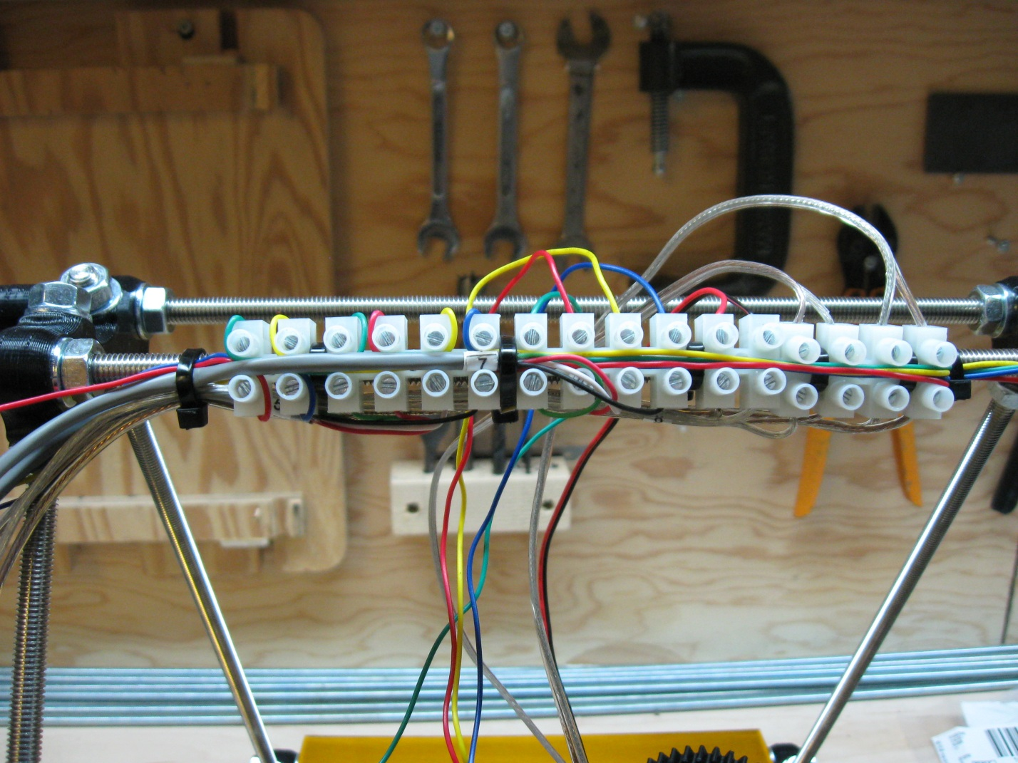

The left hand Z-Motor will have a lot of extra wire attached; you can fold these wires back and forth upon themselves and then secure them to the printed spacer as shown below.

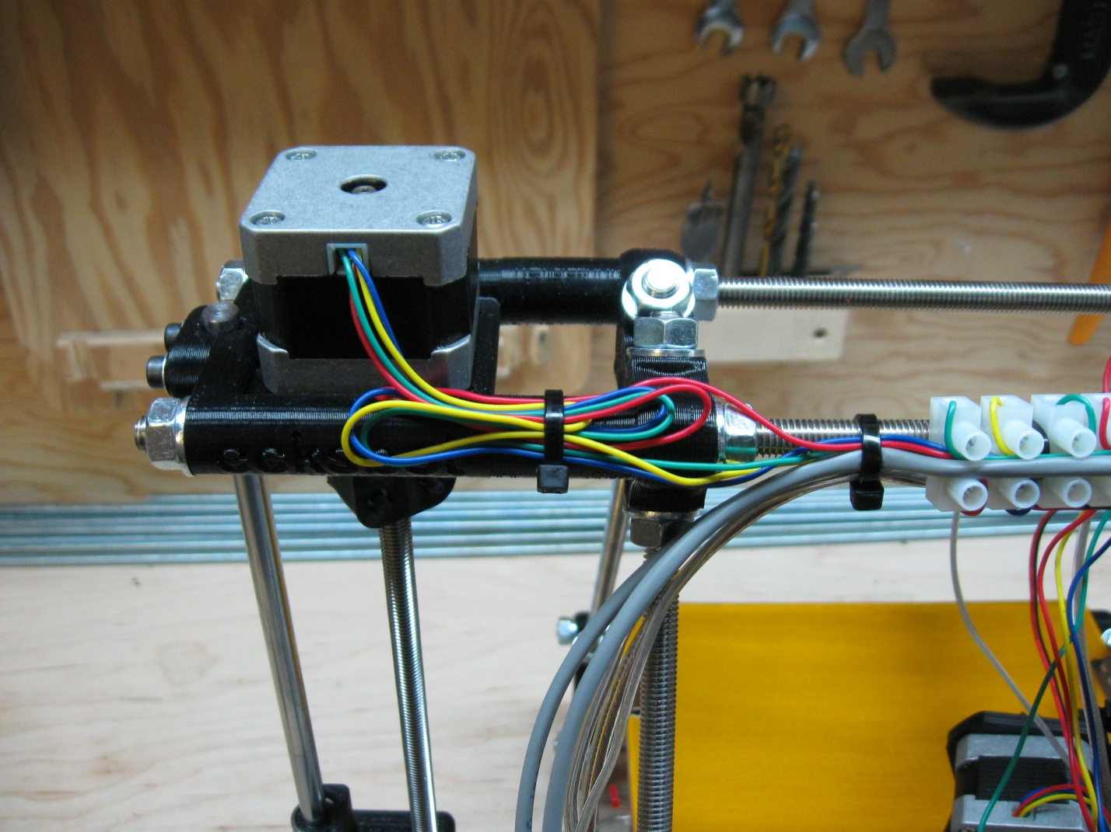

Now all that is left is to secure the rest of the TOP wires down the left hand vertex threaded rod. First attach the wires at the top as shown below.

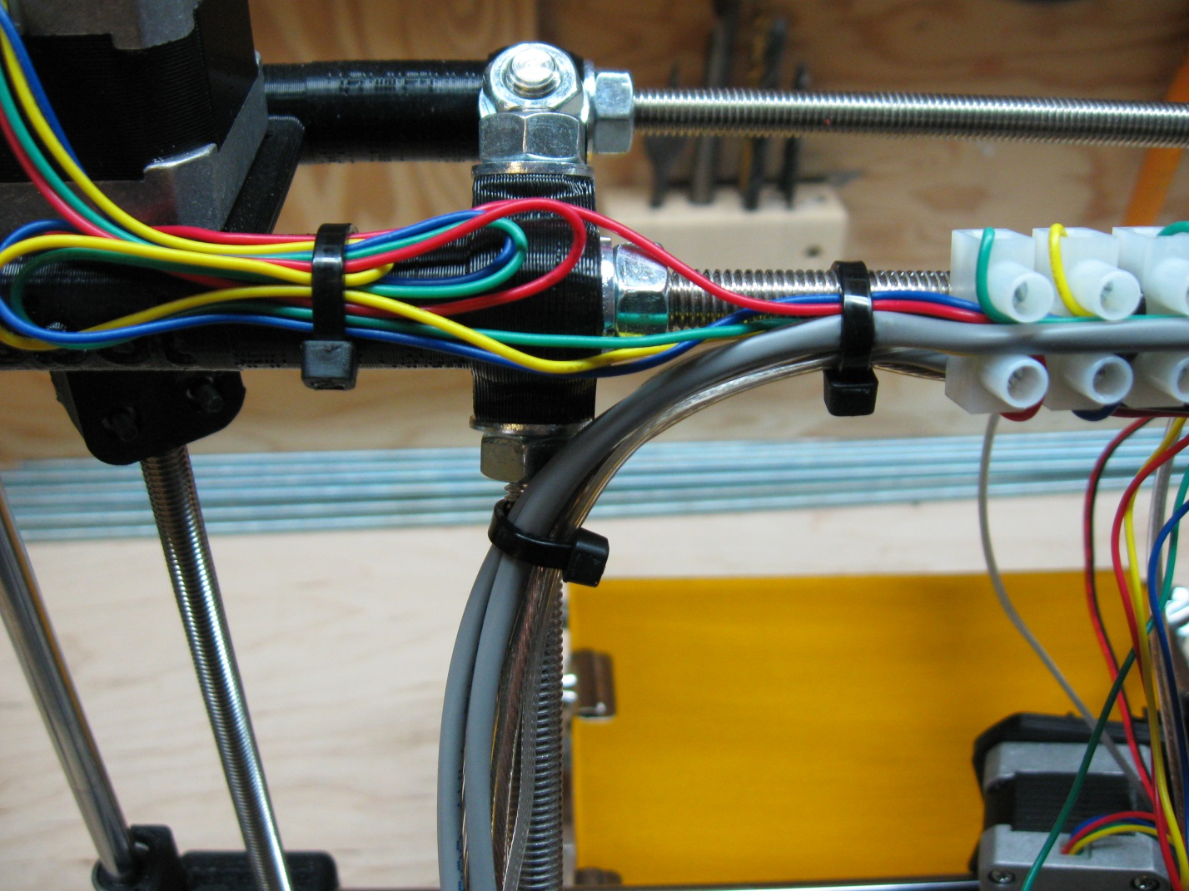

Then attach them to the bottom of the vertex threaded rod as shown in the following picture.

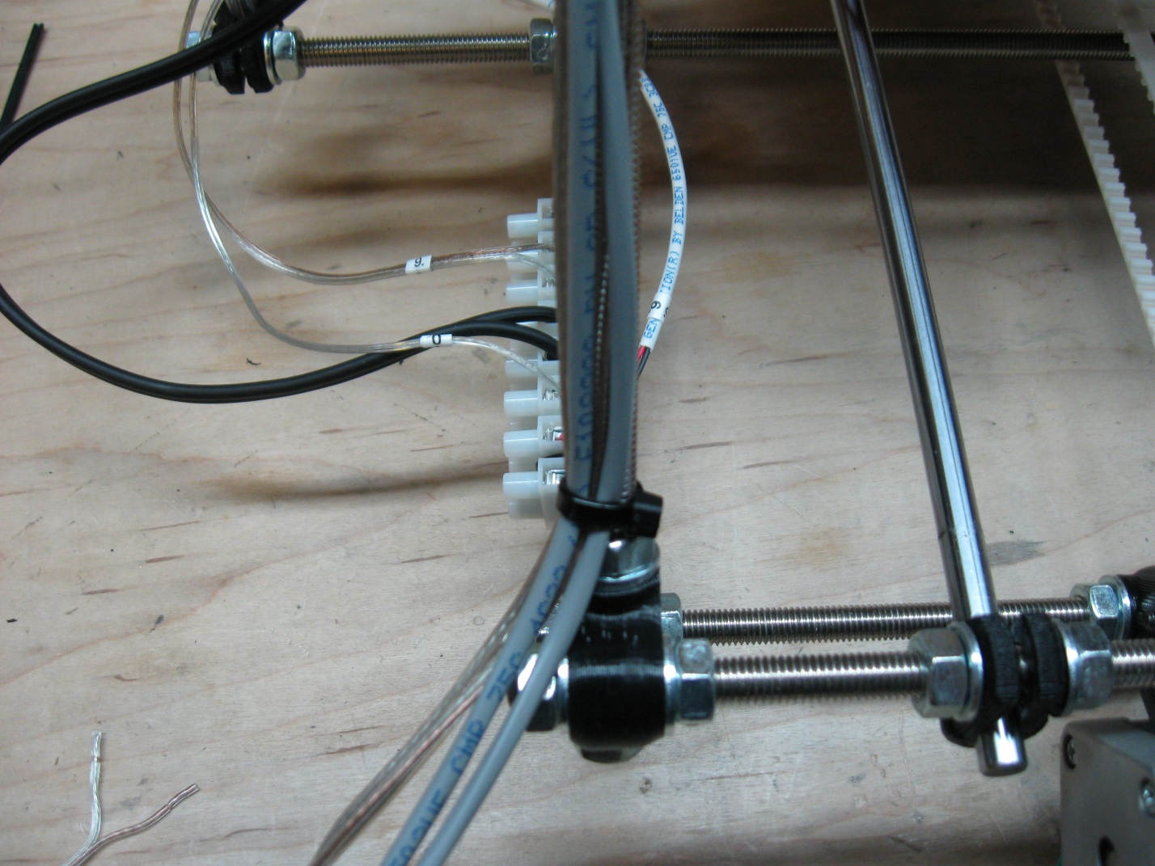

And then finally, attach the group of wires directly to the vertex foot by wrapping the zip-tie around the center of the foot and securing the wires as shown in the following photo.

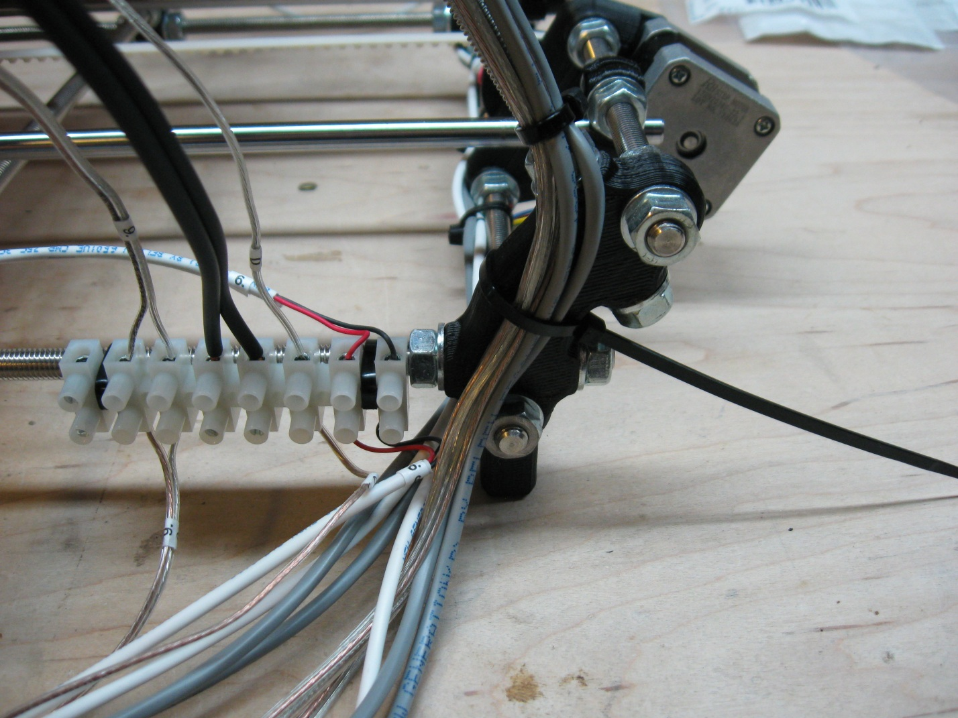

Once you are happy with the tightness of all of the zip-ties you just affixed, snip all the ends off with the scissors.

#### Step 8-2 – Zip-Tying the X and Y Motor controls

This step is easiest to perform with the ecksbot sitting on its front, so tip it forward until is resting on its face. Zip tying the X and Y axis wires into place is relatively easy; start by gently bending the X-motor control wire and the X End-Stop wire downward and under the edge of the terminal block. These 2 wires will then run along the outside of the printed footed vertex, and under the frame of the machine. At the same time, position the Y End-Stop wire along the inside of the printed footed vertex. Loosely attach a zip tie around the vertex middle, being sure to encompass the X wires on the outside and the Y End-Stop wire on the inside.

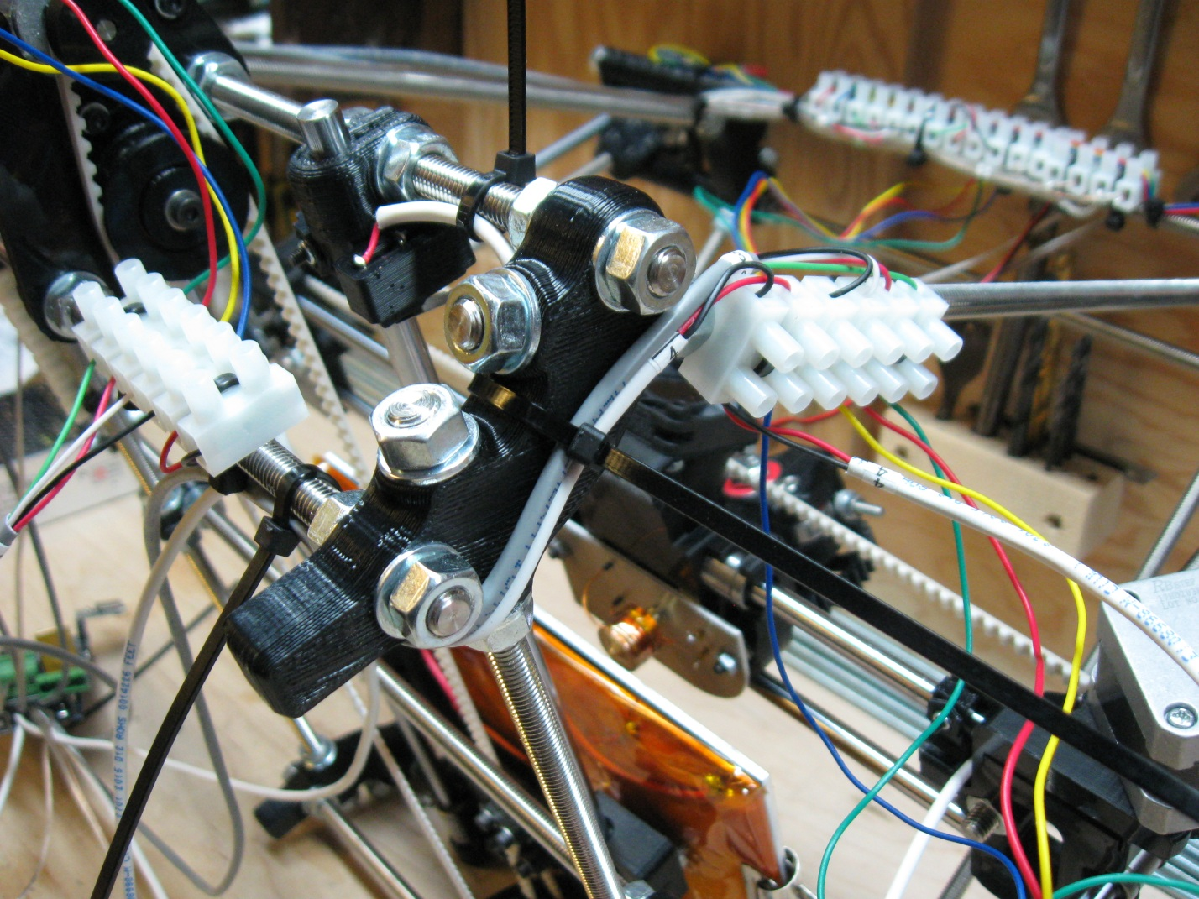

With the 3 wires loosely held in place, loosely zip-tie the Y End-Stop wire to the nearest top threaded rod as pictured. Then gently bend the 2 X wires under the vertex threaded rod, and along the bottom back rod as picture. Align the bottom of the Y End-Stop wire with the 2 X wires and loosely zip tie all 3 so the bottom threaded rod as pictured.

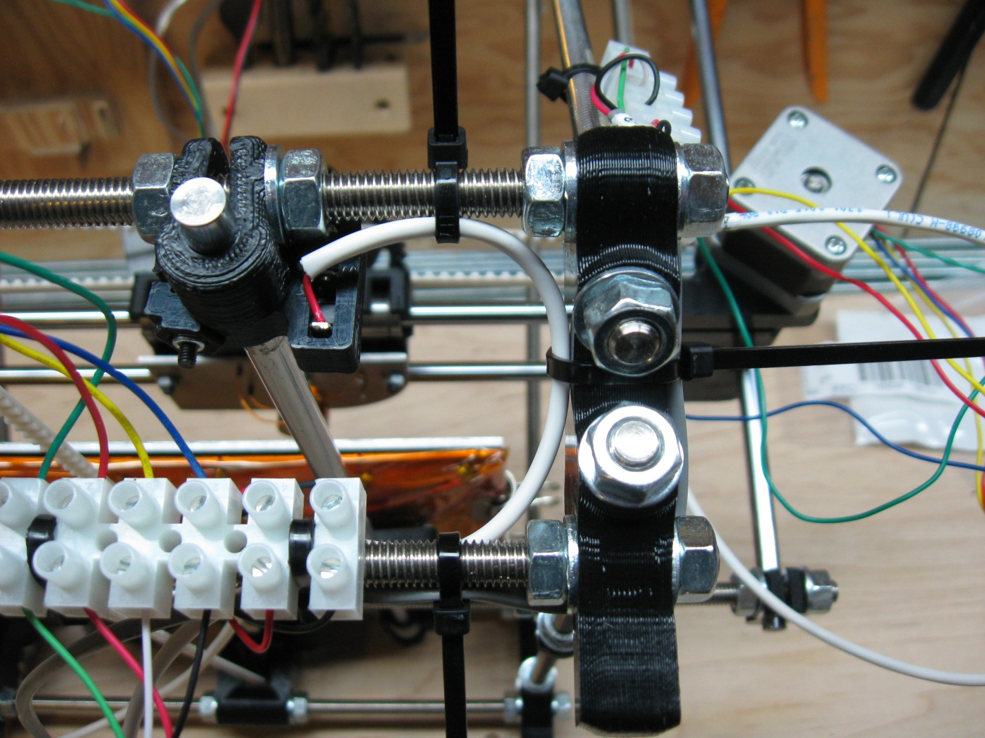

When you are happy with the alignment of the wires, make sure to pull them semi-tight, and then tighten the zip-ties firmly. Then clip the ends of the zip-ties.

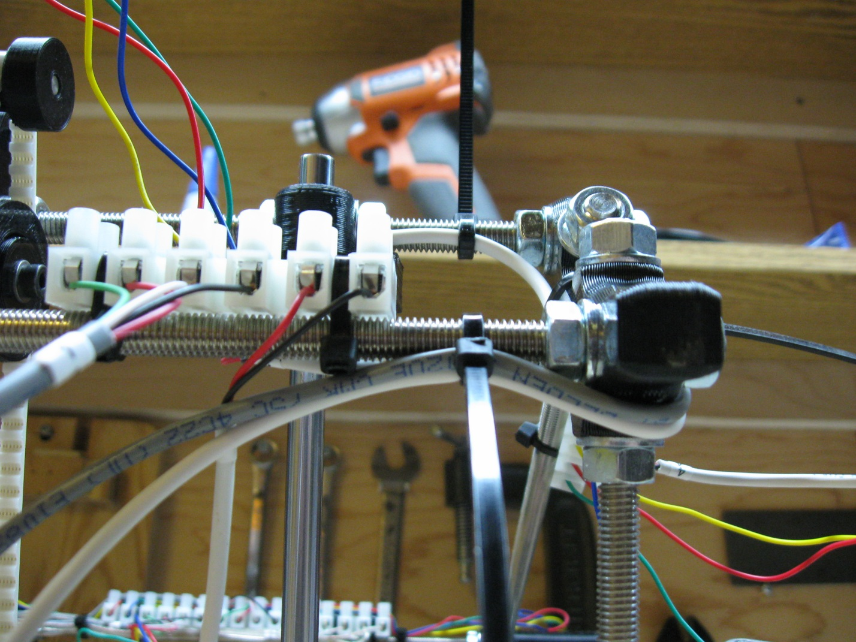

To complete the X and Y zip-ties, gently bend the Y-Motor control wire and the Y-Motor wires to the left and along the bottom threaded rod. You may want to weave the motor wires through the terminal block pins, but it is not a necessary step. The most important thing to remember is to keep all of the wires close together and running along the bottom of the threaded rod. The Y-Motor wires are rather long for the area, so the best thing to do is run then left from the motor and then double back to the terminal block as pictured below. If you can manage it, try and get the motor wires to sit slightly under the control wires just before zip-tying them; it’ll make things mush neater. You’ll be aiming to get something that looks like the picture below.

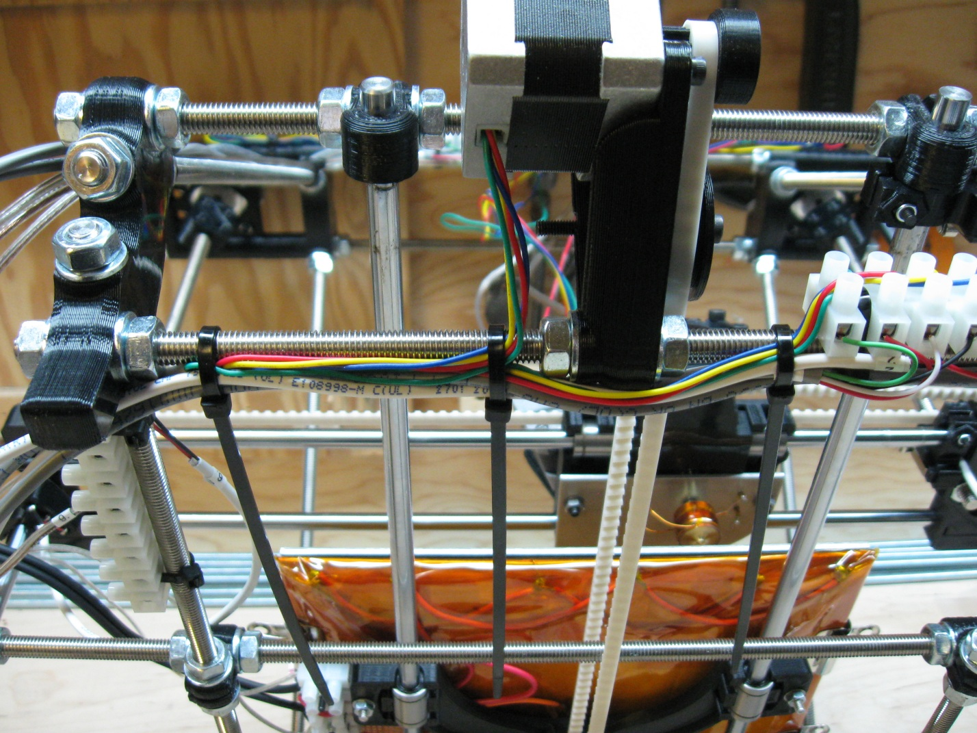

#### Step 8-3 – Zip-Tying the X Motor

The X End-Stop needs to be secured in such a way as to allow it to spiral wrapped along with the X-Motor wires and so that as the Z-Axis is lifted and lowered, no undue stress is applied to the wires. To accommodate these two factors, angle the End-Stop wire towards the point where the motor wires exit the motor, underneath the X-Motor itself.

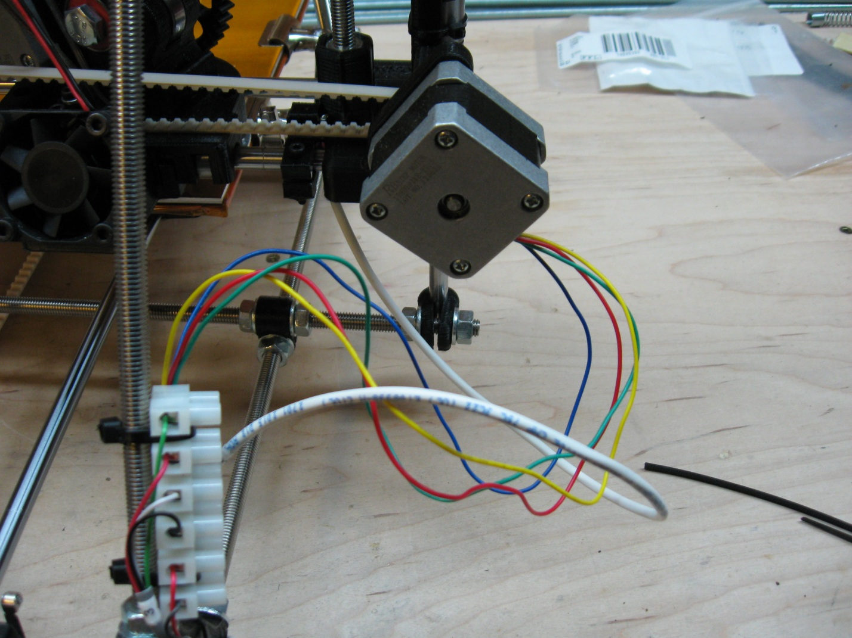

Then wrap a zip-tie around the motor, pinning the End-Stop wire to the motor and angled towards the motor wire exit as pictured below. When you are satisfied with the angle and placement of the wire, clamp the zip-tie down as tight was you can, it can be difficult to get the zip-tie tight enough, you may need to wiggle is back and forth a bit while pulling firmly.

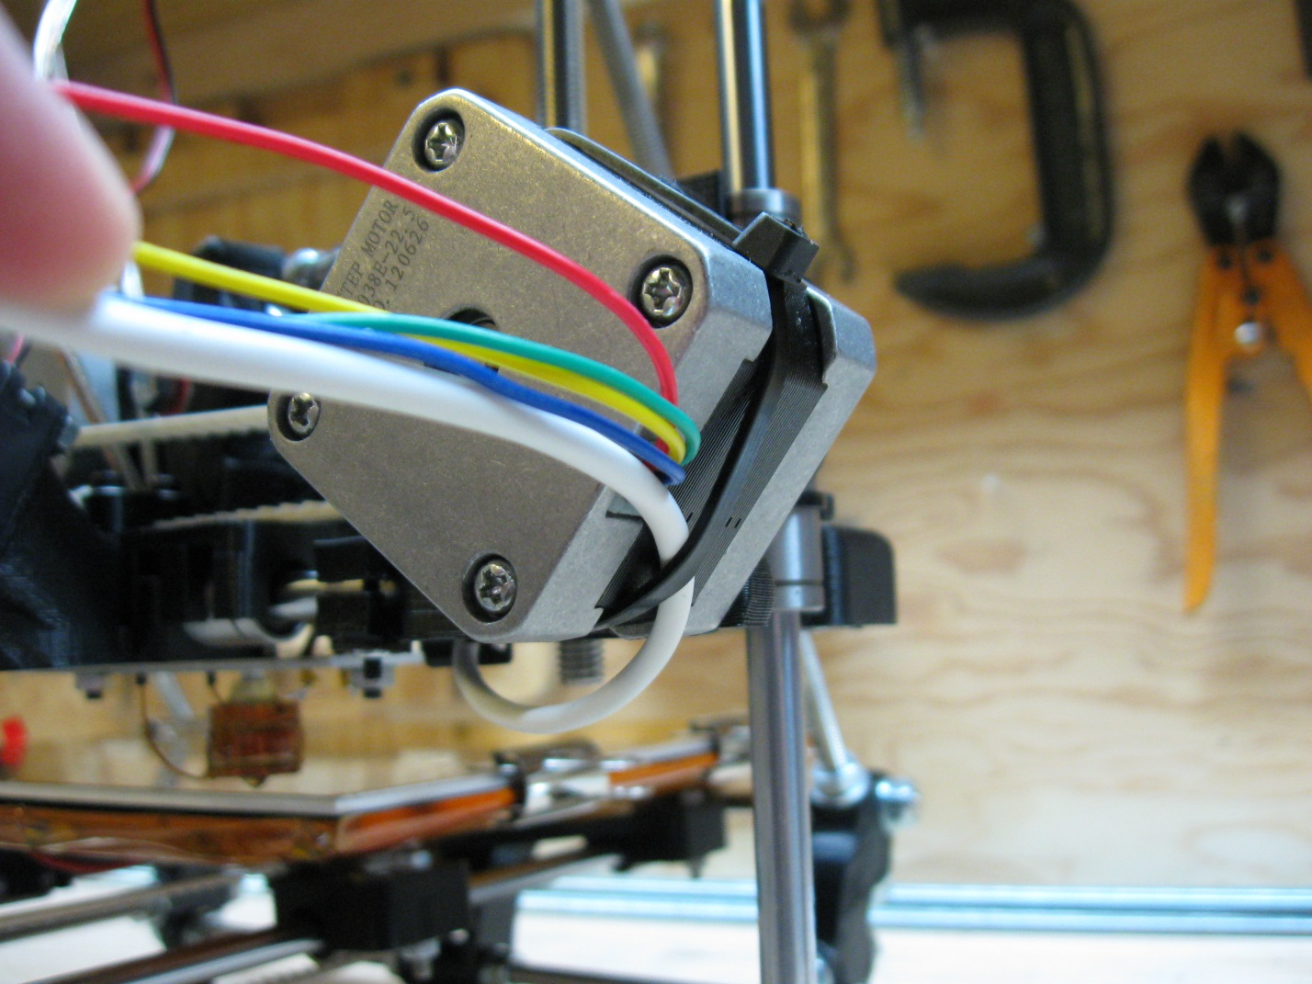

Now that the End-Stop wire is attached to the X-Motor itself, zip-tie the X-Motor wires and X End-Stop wire to the vertex threaded rod just above the terminal block. You can weave the wires between the terminal block pins as picture if you wish, but it is not a necessary step.

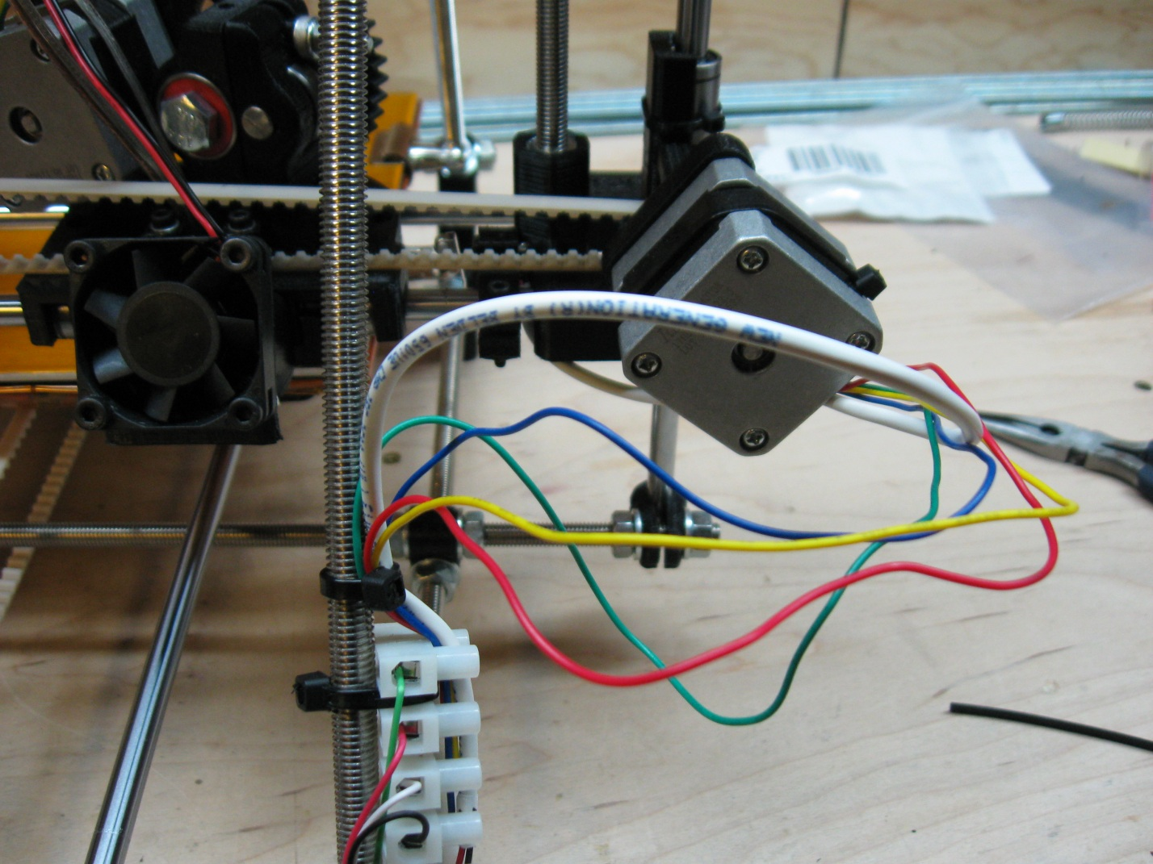

#### Step 8-4 – Zip-Tying the Z end-stop

The final wire to be zip-tied is the Z End-Stop. Start by running the wire along the two nearest threaded rods as shown below. Remember, the End-Stop is not in its final position yet, so you may need to leave some slack in the wire at the mounting point so that the End-Stop mount can be moved upwards if necessary.

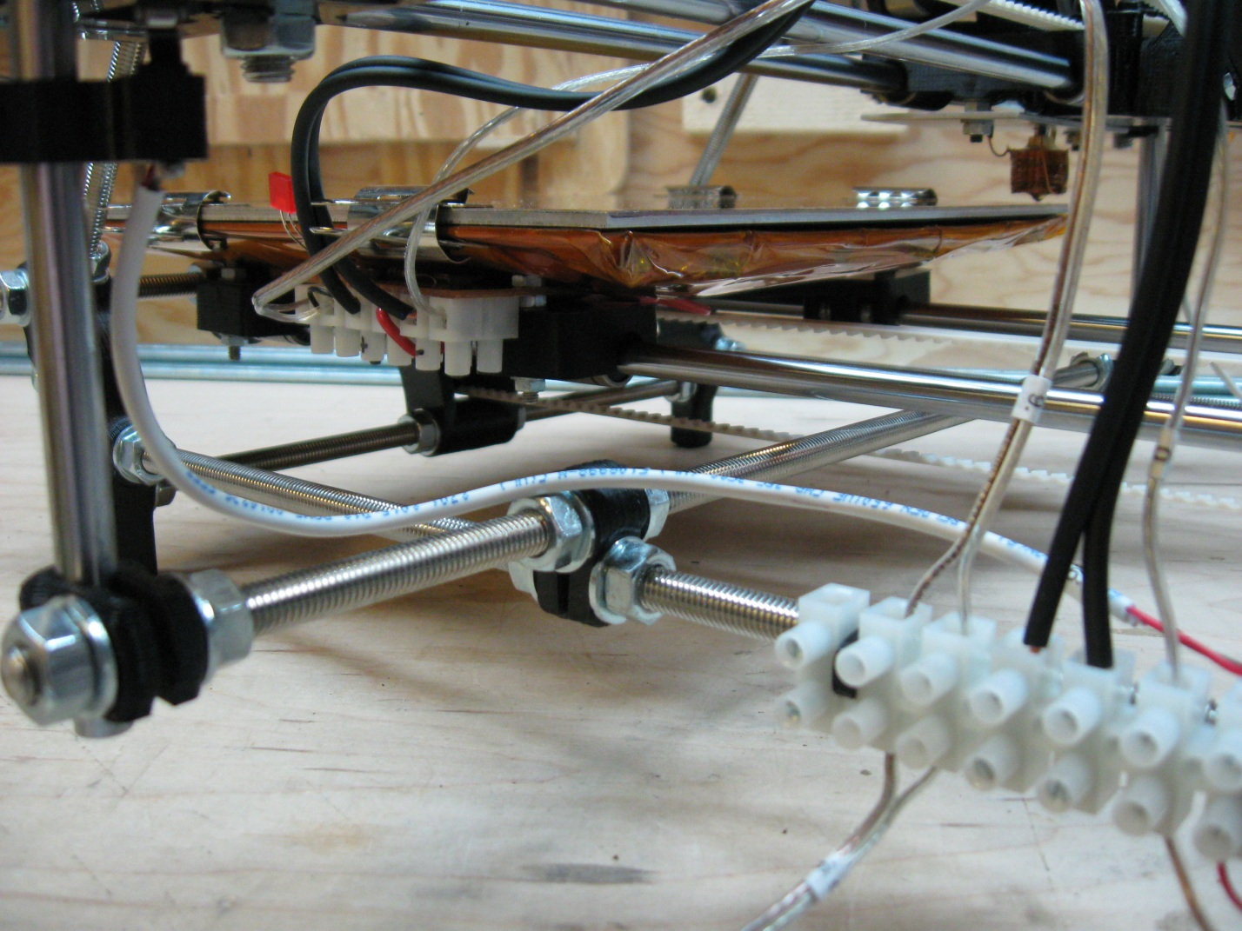

When you are happy with the placement of the wire, zip-tie it to the two threaded rods as pictured. Be sure that the wire runs along the back of the terminal block so that it is out of the way. With this wire zip-tied, you are finished zip-tying wires. All that is left is to wrap the wires in spiral wrap for protection.

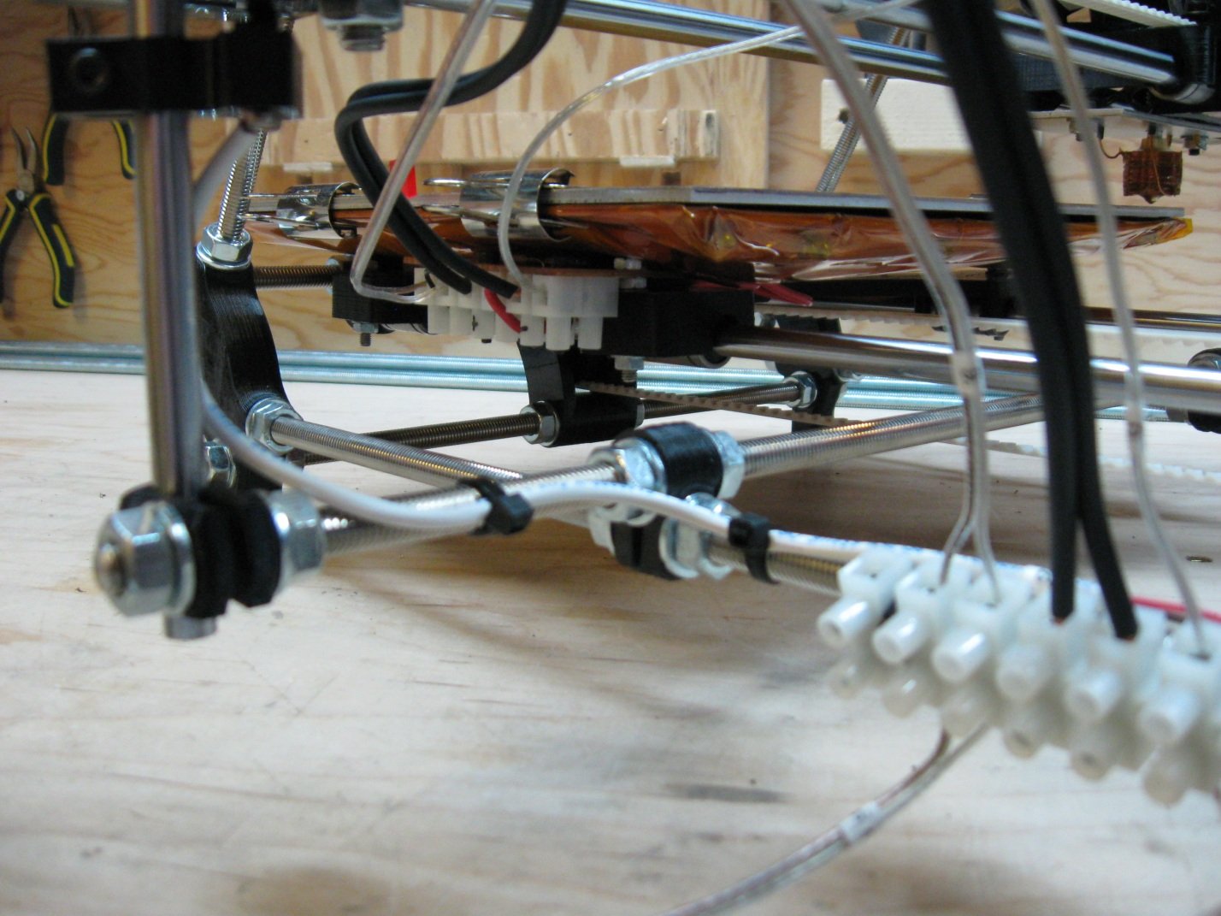

#### Step 8-5 – Applying the Spiral Wrap

Spiral wrapping your wires is an important step in the completion of your ecksbot. Not only does is provide some protection for some of the more susceptible wires, but it also helps take some of the wear and tear strain that the eckstruder wires are subjected to when the X-Axis is travelling back and forth. When applying the spiral wrap, I find it best not to cut the wrap until you have it wrapping the intended wire. You can try measuring the wrap and pre-cutting it if you want, just be careful to leave a bit extra just in case, especially if you are wrapping something that is larger than the inner diameter of the spiral wrap. The spiral wrap can wrap bundles of wire that are much larger than its normal inner diameter, but it will cause the length of spiral wrap needed to increase as well.

We’ll start by wrapping the wires that attach the X-Motor to the terminal block. First wrap 2 coils around the vertex threaded rod covering the wires as well. Then break from the threaded rod and wrap the wires only until you reach the back of the X-Motor. Be sure that the wrapping is loose all the way over to motor; it is possible to inadvertently tighten the wrap as you are applying it. If this happens, just twist more onto the wires and it will loosen all the way along.

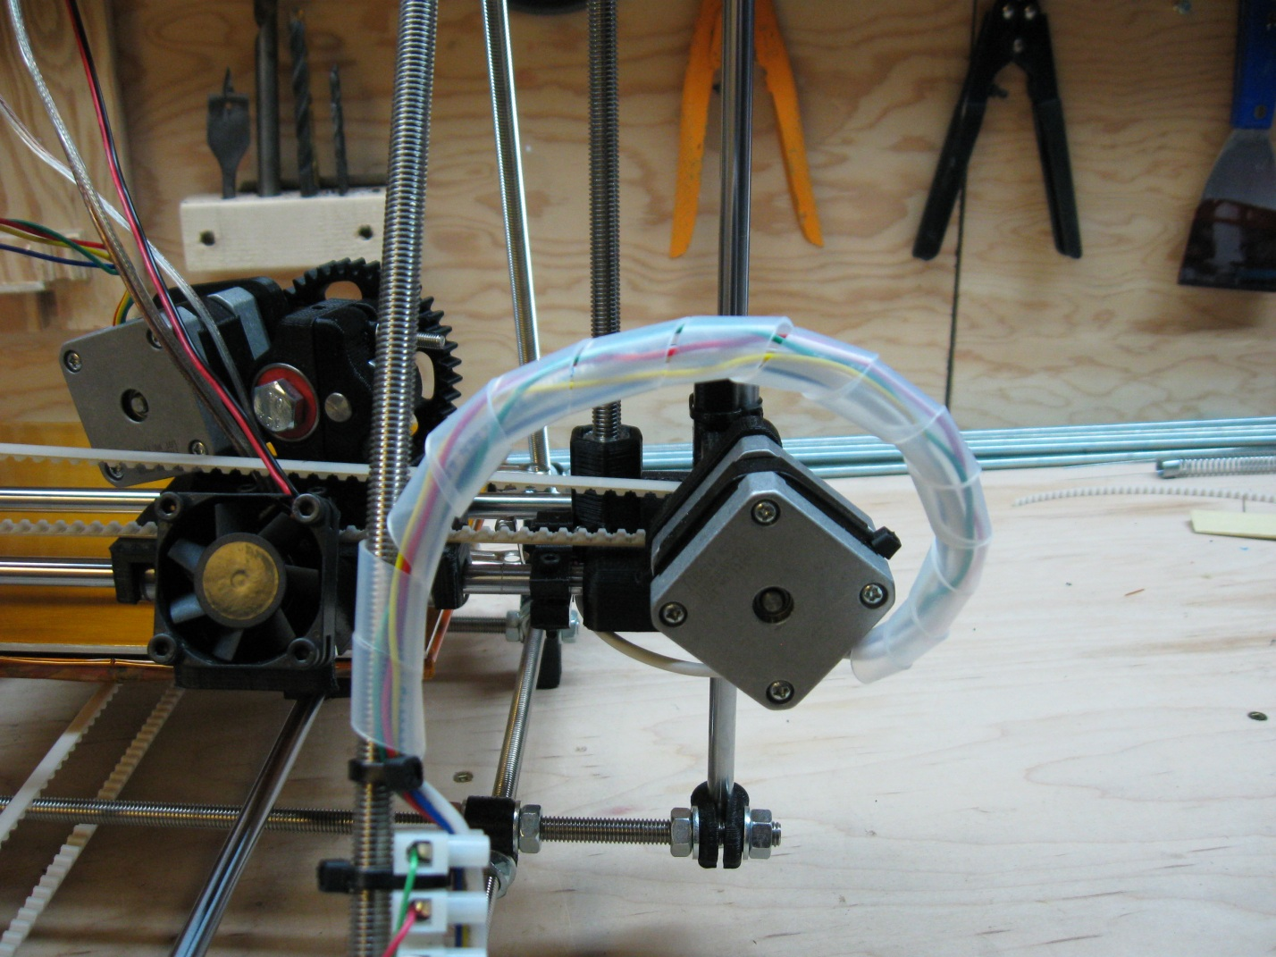

Next, apply wrapping to the eckstruder control wires that are zip-tied to the frame vertex threaded rod. This wrapping is only for protection and doesn’t need to move, therefor simply make sure that each reel of the wrapping is tight to the next to make a nice solid tube up the length of the rod.

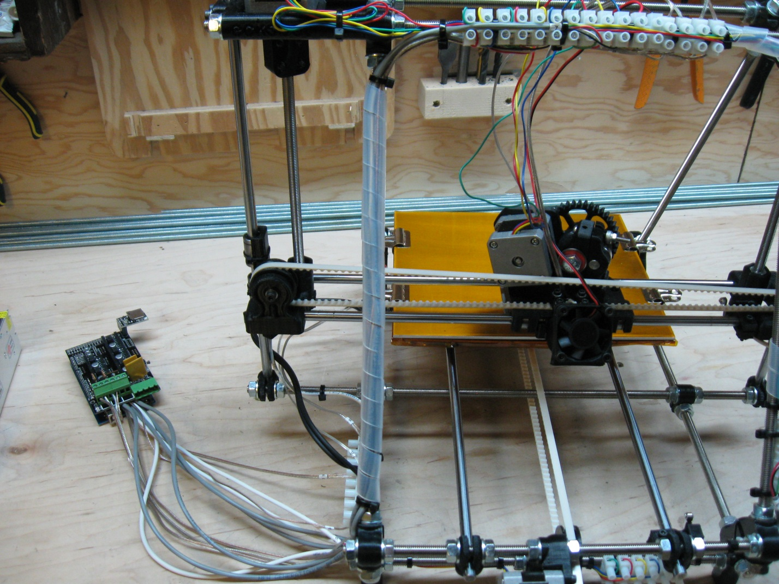

It’s not a necessary step, but you can use a bit of the wrapping to cover the Z-Motor wires on the right hand side of the machine when viewed from the back. It doesn’t take much wrapping and is a little more aesthetically pleasing than leaving the wires hanging loosely.

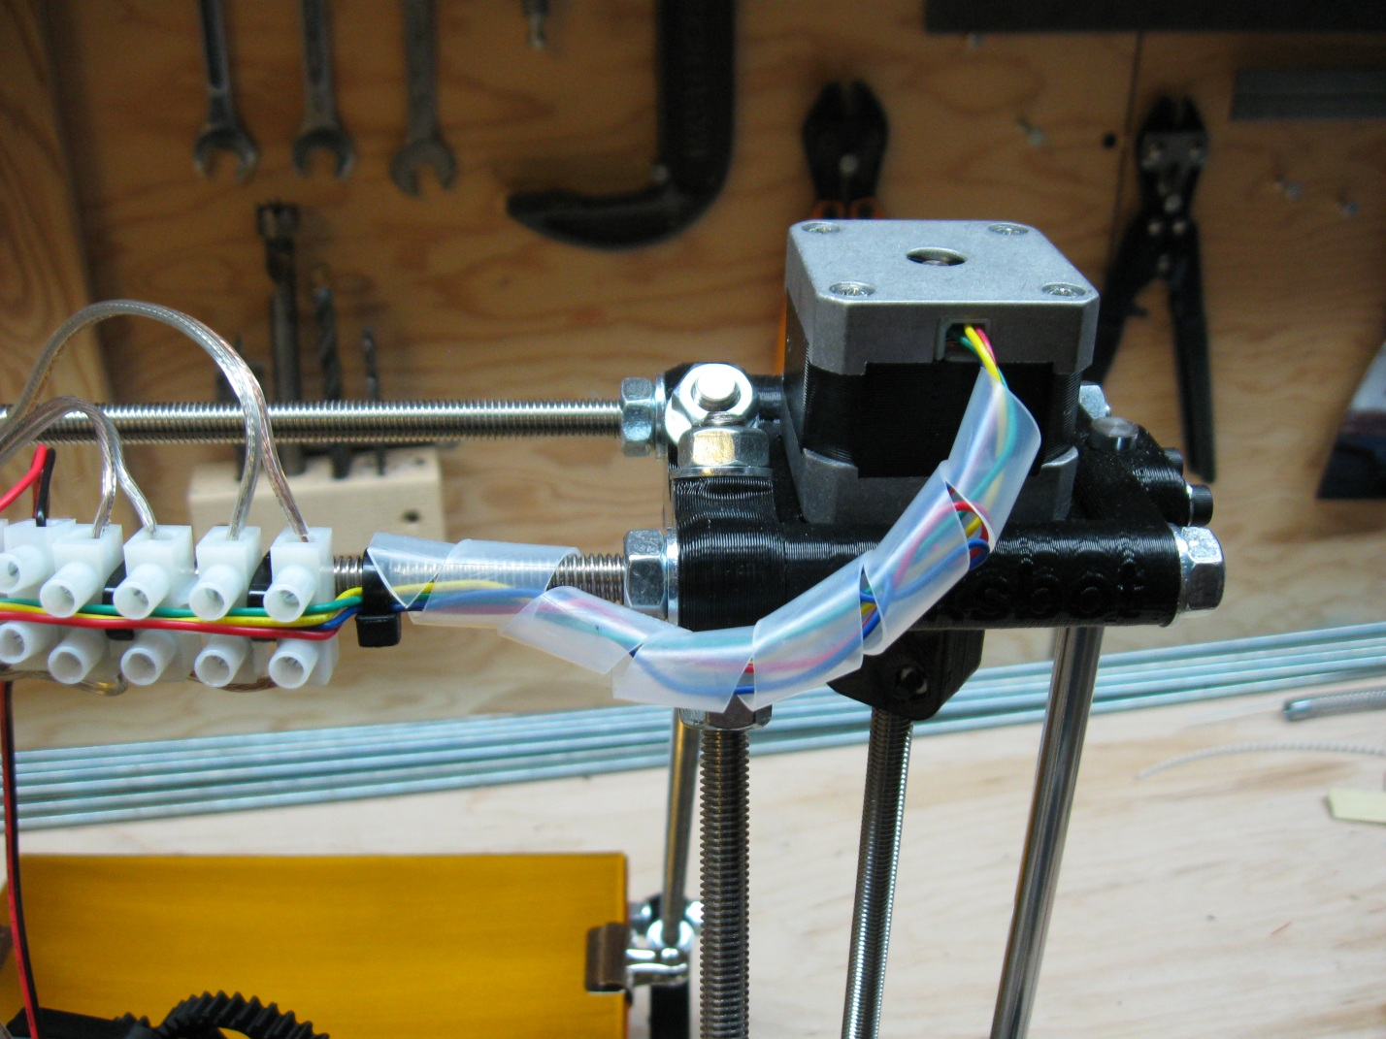

Wrapping the wires that lead to the eckstruder is the most important of the wrapping procedure. By wrapping these wires correctly you can reduce undue wear and tear on the wires and prolong the life of the connections. Start by loosely wrapping the wires part way up from the motor. With the wires partially wrapped, extend the end of the spiral wrap out towards the front of the machine and up against the eckstruder motor. Then wrap a zip-tie around the eckstruder motor to clamp the spiral wrap to the motor as pictured in the photo below. Be sure to tighten the zip-tie as tightly as you can as it will be under a bit of stress as your machine runs.

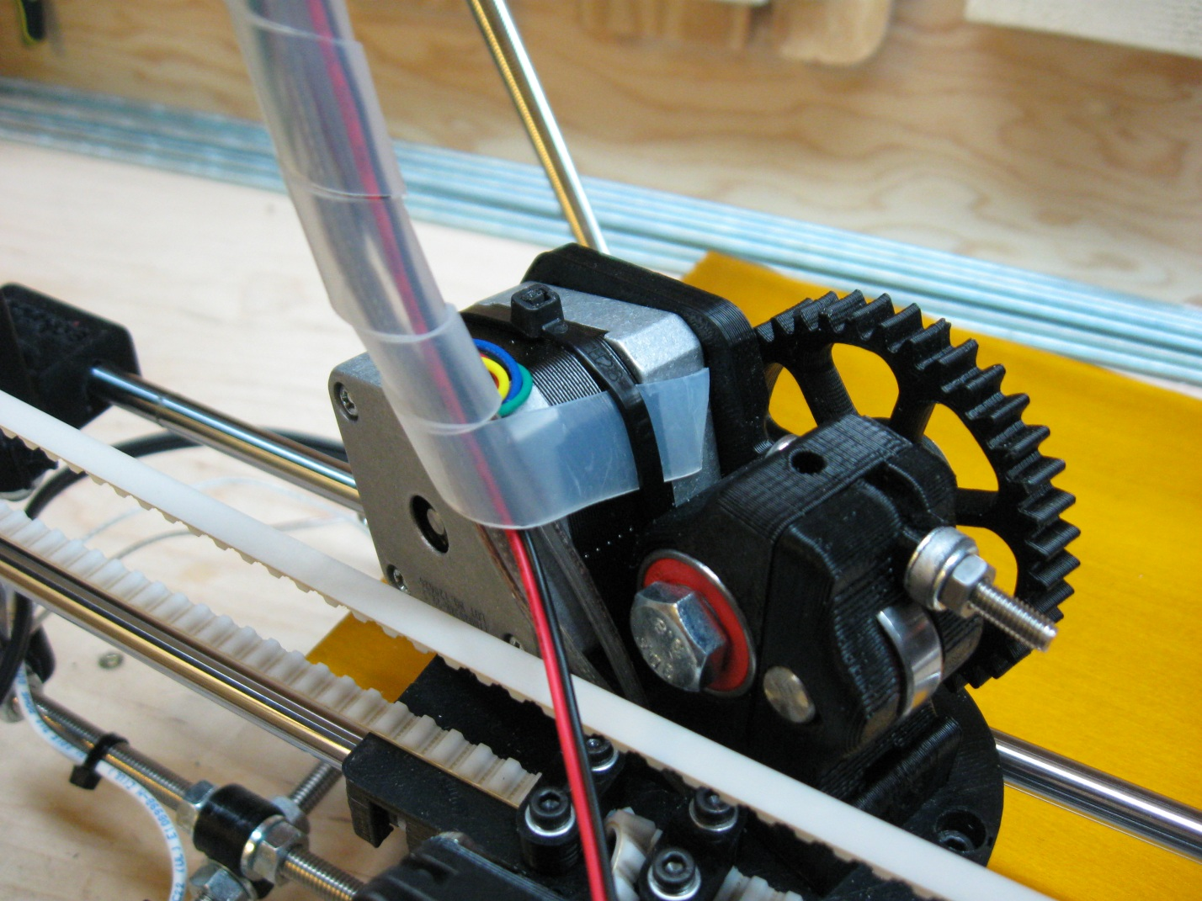

Now make sure that the Z-Axis is lowered so that the Hot-End is near to the HBP, and then move the eckstruder carriage all the way to the left, when viewed from the back of the machine. This will extend eckstruder wires to their fullest. Continue wrapping the wire until you are near to the terminal block at the top of the machine. Be sure that you have fed enough of the spiral wrap onto the wires so that it is not too taught. Then insert a zip-tie between the fan control wires and the eckstruder motor control wires. This zip tie must go under the wires but over the spiral wrap.

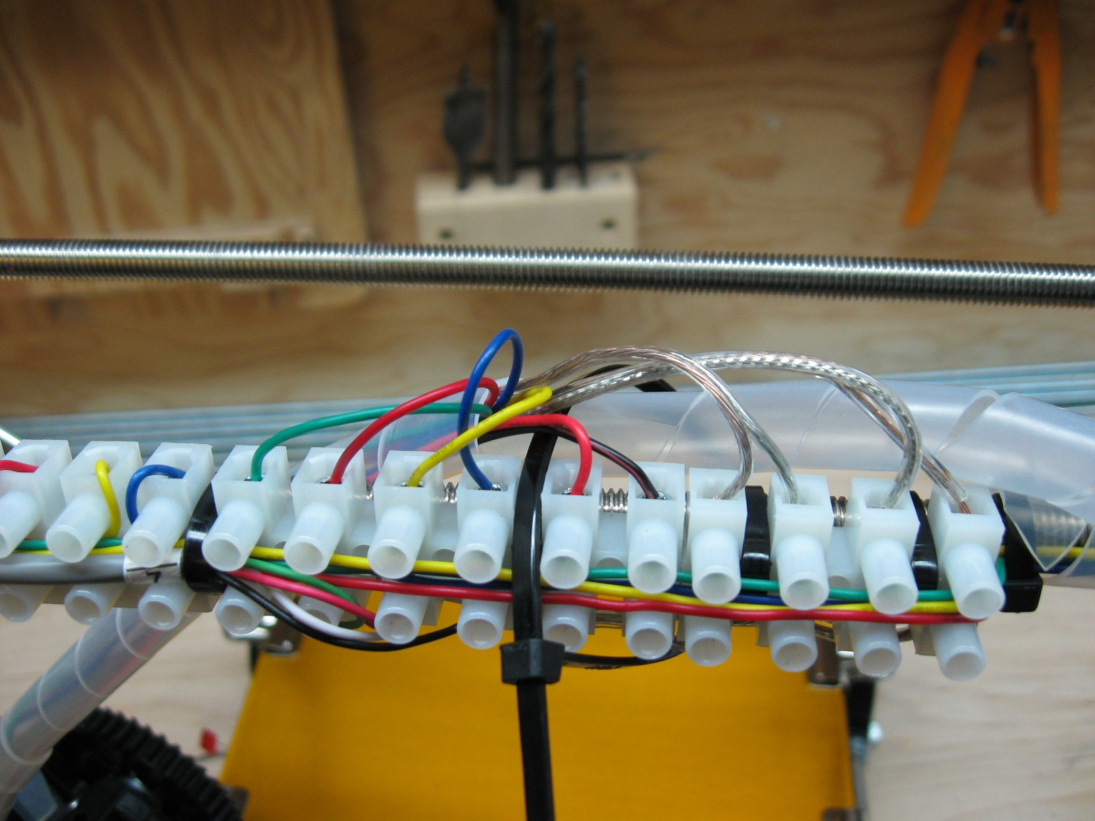

Now carefully tighten the zip-tie so that it pulls the spiral wrap between two links in the wrapping and clamps the spiral wrap very tightly to the top threaded rod as shown in the following two pictures. If done correctly, this is the point that will rock back and forth as the eckstruder carriage runs back and forth while printing.

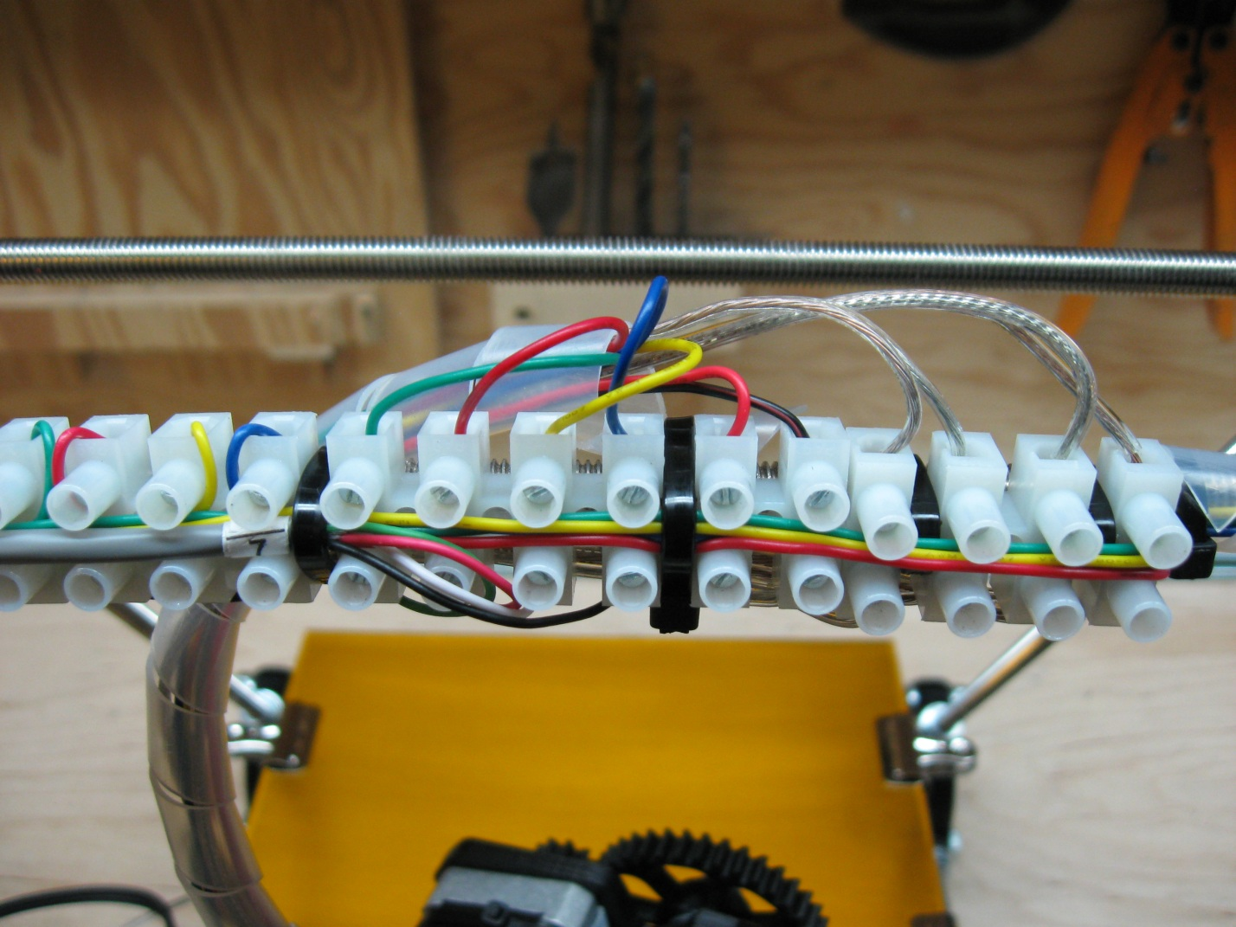

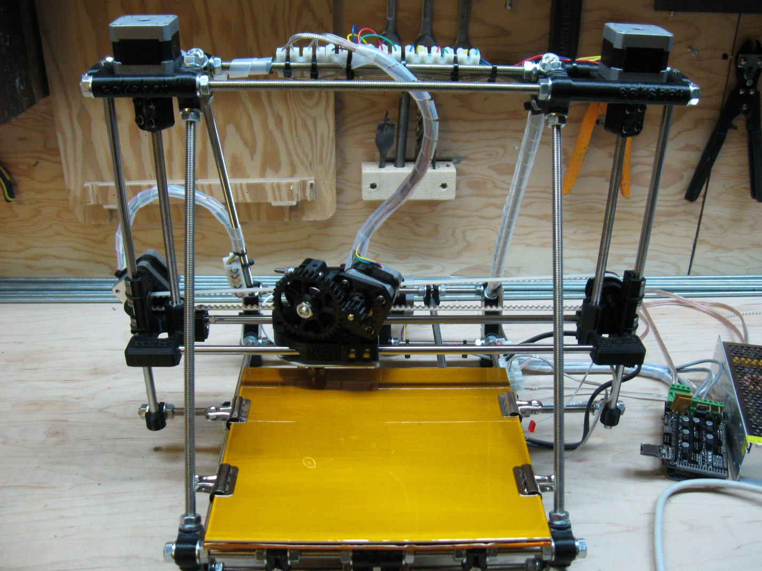

The final step is an easy one. Carefully wrap all of the control wires that lead from the RAMPs 1.4 to the ecksbot. You won’t be able to get them all as the small discrepancies in lengths will cause small loops and kinks in the wires the closer you get to their ends. You will also need to pick a spot to allow the HBP power wire to exit the wrapping. This part is totally up to you, do whatever you think looks best.

